SUPPORTING INFORMATION (Figures, Tables, Equations)

Specific equations, tables and figures for more detailed data and analysis are presented in the online supporting information.

Figure S-1. Trends in New York State milk production efficiency
Figure S-2. Soil and climate suitability for crop growth represented by the National Commodity Crop Productivity Index.
Figure S-3. Cost relative to production potential of bioenergy feedstocks in New York for 2020

Table S-1. Constraints applied to account for sustainability
Table S-2. Land use/land cover (LULC) in New York State
Table S-3. 2007, 2013 & 2020 actual and regression estimates of predominant NYS crops

Equations S-1 to S-4: Linear regression of agricultural and dairy production efficiencies
Equations S-5 to S-8: Projected yield and production of dedicated bioenergy crops

Figure S-1. Trends in New York State milk production efficiency

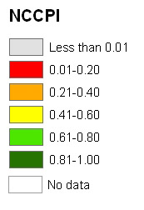
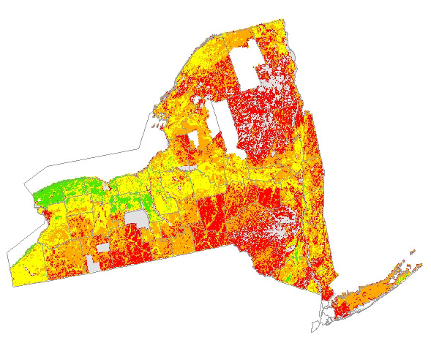
Figure S-2. Soil and climate suitability for crop growth represented by the National Commodity Crop Productivity Index (NCCPI)

Figure S-3. Cost relative to production potential of bioenergy feedstocks in New York for 2020.

Table S-1. Constraints applied to account for sustainability
 | Forest | Herb. Land | Water | Air | Other
NYS Forests will stay as forests  No forestland is converted | x |  | x | x | x
Existing herbaceous landcover will remain herbaceous |  | x
Not all herbaceous lands are practical to harvest (slope > 15% or field size < 5 acres) |  | x |  |  | x
Federal or State protected lands are not considered | x | x | x | x | x
Existing equine landuse is not considered |  |  |  |  | x
Idle and “Fallow” crop land is considered available (Note that “fallow” is included in the national database, but fallow is not important in crop rotations in the region) |  | x
Not all land landowners want to use their land for energy feedstock (Sustainable yield models related to site conditions and demographics = ~50% adoption across available lands, varying with population density) | x | x |  |  | x
Crop yield and dairy milk production efficiencies will increase based on analysis of existing trends |  | x |  |  | x
Existing use of crop residues are not considered | x | x | x |  | x
Only perennials will be considered to reduce erosion and N loss to air and water, and increase soil carbon storage and wildlife habitat. |  | x | x | x | x
Replacement P and K used to maintain soil |  | x
Forest harvest for existing wood products were maintained | x |  |  |  | x
Harvest of forest land never exceeds net annual growth rate in each county | x |  | x
Dead trees and 35% of tops were not collected to maintain nutrients and biodiversity | x |  |  |  | x
Stover harvest was reduced for soil and water quality |  | x | x |  | x

Table S-2. Existing Land-Use/Land Cover (LULC) in New York State.
Land Cover Type (from NLCD) ª | Land Area (hectares) | Land Area (%) | Existing Crop, Forage, and Hay LULC ^{b} (hectares) | Existing Non-Farm Equine LULC ^{c}  (hectares)
Forest land ^{d} | 6,759,119 | 53.7%
Pasture, Hay & Grass land | 1,866,636 | 14.8% | 794,245 | 323,099
Developed land | 1,096,093 | 8.7%
Crop land | 1,068,903 | 8.5% | 691,033
Wetlands | 993,055 | 7.9%
Open water | 411,919 | 3.3%
Shrub & Scrub land | 355,383 | 2.8%
Barren land | 23,718 | 0.2%
Other | 2,446 | 0.0%
TOTAL | 12,577,272 | 100.0% | 1,485,277 | 323,099
ª These land cover categories are aggregated from the National Land Cover Database (NLCD)¹⁹.
^{b} LULC categories are from the 2007 Census of Agriculture²³. Crop land includes grains, oilseeds, vegetables, and fruit. Forage land includes all forages used for livestock. Hay includes all types.
^{c} Equine land includes all land used for horses (399,424 hectares)²⁴ minus the amount of equine land on farms that is already counted elsewhere (76,324 hectares)
^{d} The value presented here for forest land is derived from the NLCD¹⁹ and is based on the area of forest cover in rural parts of the state. This database was used as a starting point for analysis of land cover. However, more detailed data on forest area are available based on survey data from the USDA Forest Service Forest Inventory and Analysis (FIA)² program, which conducts surveys of forests in cooperation with State agencies. For analysis of forest feedstocks, these more detailed FIA data were used.

Table S-3. 2007, 2013 & 2020 actual and regression estimates of predominant NYS crops
 | units | 2007 Census of Ag (actual) | 2013 NASS NYSª (actual) | 2013^{b} ^{c} calculated | % increase of actual from calculated | 2020^{b} calculated
Milk | kg/cow | 8,706 | 10,024 | 9,400 | 6.6% | 10,210
Maize grain | kg/ha | 7,925 | 1,420 | 1,414 | 0.4% | 1,549
Maize silage | Mg/ha | 37.9 | 38.1 | 41.0 | -7.0% | 44.6
Soybean | kg/ha | 2,771 | 3,231 | 3,127 | 3.3% | 3,542
Wheat | kg/ha | 3,820 | 4,577 | 4,037 | 13.4% | 4,289
ª Actual yield from National Agricultural Statistics Service⁸
^{b} Using regression analysis derived from historical Census of Agriculture data
^{c} To note, 2010 NASS actual production exceeded all 2013 calculated; specifically maize silage production was 42.6 Mg/ha.

Equations S-1 to S-4. Linear regression of agricultural and dairy production efficiencies
Where: (1 bushel maize = 56lbs or 25.4kg; 1 bushel soy/wheat = 60lbs or 27.2kg; 1 acre = 0.405 hectare; 1lb = 0.45kg)

Equation S-1.
Maize silage: y=0.229x -442.7 (R²=0.625) where y = yield in tons/ac and x = year
Equation S-2.
Soybean: y = 0.881x-1727 (R²=0.343) where y = yield in bushels/ac and x = year
Equation S-3.
Wheat: y=0.536x-1019 (R²=0.322) where y = yield in tons/ac and x = year
Equation S-4.
Milk Production: y=254.95x-492,509 (R²=0.9734) where y = milk production in lbs/cow and x = year

Equations S-5 to S-8. Projected yield and production of dedicated bioenergy crops
We used the draft NCCPI for maize to predict above-ground yield of maize, warm season grasses, and willow across a variety of soil and climate conditions (Equation S-5).
Equation S-5.
Maize grain yield in 2002 (bu/ac) = (50.5 + 119*NCCPI)
Where: NCCPI = average NCCPI value for maize
Regression Equation S-5 explained 60.4% of the variance. Maize yield was estimated based on average yields from 1998 to 2007, thus it represents the year 2002. To make a prediction of maize yield for years subsequent to 2002, yield should be increased by 1.275 bu/ac/yr based. Accounting for this yield trend, Equation S-6 shows the predicted yield for 2020.
Equation S-6.
Maize grain yield in 2020 (t/ac) = (50.5 + 119*NCCPI+1.275*18)*0.028
Where: Annual yield increase (bu/ac) = 1.275
Years after 2002 = 18
Short tons per bushel = 0.028
We adapted the maize yield model to represent aboveground biomass of grasses across the Northeast as shown in Equation S-7. Adjustments were made to account for aboveground biomass from grain yield data, and to account for reduced yields during the first three years of a projected 10-year stand life.
Equation S-7.
Grass yield 2020 (odt/ac) = (50.5 + 119*NCCPI+1.275*18)*0.028*2*0.845*0.825
Where: Years after 2002 = 18
Short tons per bushel = 0.028
Adjustment from grain to aboveground maize yield = 2 (harvest index of 0.5)
Adjustment from 15.5% moisture to oven-dry = 0.845
Adjustment for years 1 to 3 (10-yr stand life) = 0.825
Due to the high establishment costs for planting willow, we adapted the perennial grass model to represent willow yield adjusted to the 22-year stand life of willow with reduced yield during the first rotation as shown in Equation S-8.
Equation S-8.
Willow yield 2020 (odt/ac) = (50.5 + 119*NCCPI+1.275*18)*0.028*2*0.845*0.9273
Where: Years after 2002 = 18
Adjustment for years 1 to 3 (22-yr stand life) = 0.9273

