New York Brewing Industry Hits Its Growth Spurt
Bill Weldon
The New York brewing industry, long considered as the baby brother to New York’s well-established wine industry, has begun to hit its growth spurt. Now, more than ever, beer enthusiasts have the opportunity to merge into the New York wine trails and enjoy the products of this craft brewing revolution.
This boom has been fueled in large part by the passing of the Farm Brewery Law in 2012. Since its inception, total the acreage of planted hops has more than quadrupled and 106 farm breweries have opened their doors in New York. Under this license, farm brewers are permitted to have up to 5 satellite locations from which their beer and cider can be sold and consumed free of additional taxes. This privilege does come at a cost; any established farm brewery must use ingredients (hops, barley, wheat, etc.) consisting of at least 20% NY State grown goods.
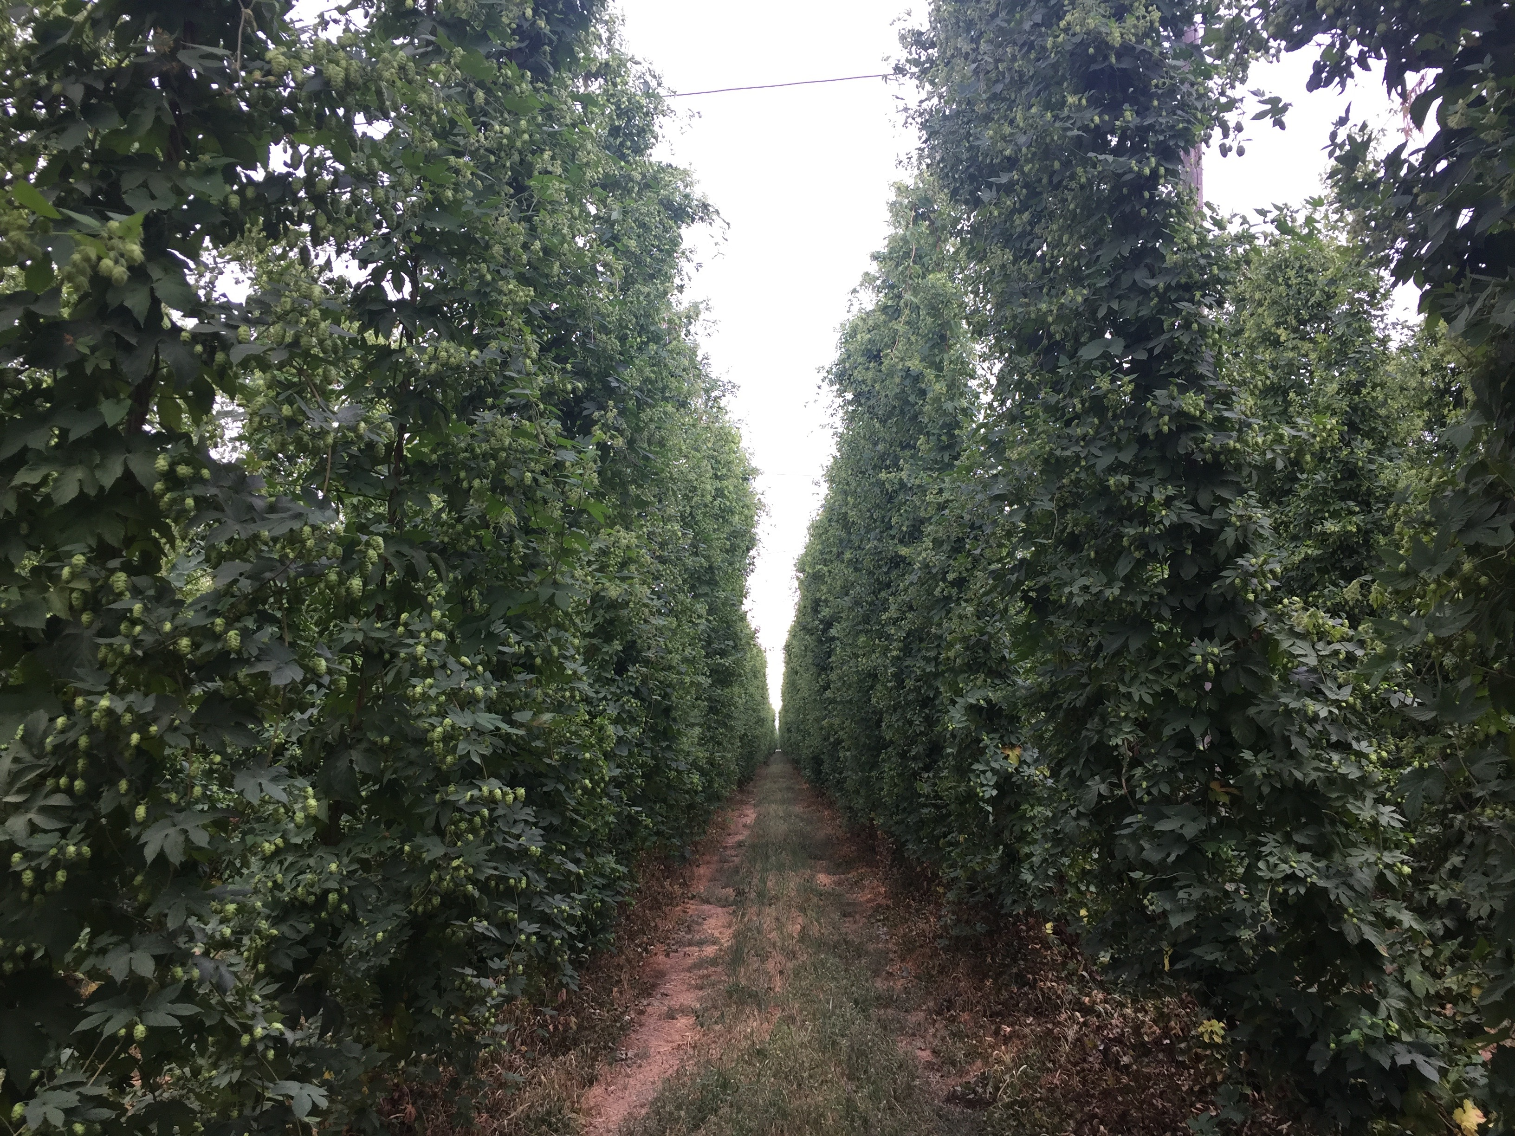
The bill has not only incentivized the establishment of over 100 new breweries across the state, but has also ushered parallel growth of the hop and malting barley industries. As more and more breweries open, the market for more NY state grown barley and hops emerges to meet the demand. “[The bill] is working, and we are on track for it to continue to work. More hops and malting barley go into the ground every year,” commented New York State Brewers Association Executive Director, Paul Leone. “It is working as intended. The sky is not falling.” This “sky” is in reference to the fact that the farm-brewing license was initially established at a time when the hops and malting barley markets were not yet large enough to fulfill the 20% NY state grown requirements. But, as the number of farm breweries has expanded, so has the acreage of hop yards and malting barley. Some breweries have even taken matters of growing hops or barley into their own hands, creating a direct “farm to glass” feel. As one Finger Lakes brewer stated, “we would like to be 100% estate grown, and most of our recipes are tailored towards the hops we grow here.”
Photo Credit: Bill Weldon
The “buy local” movement has also been a factor in this growth. “What’s driving this industry are millennials. They want local, and the Farm Brewing license is as local as you can get,” Leone stated. Although more and more attention is being given to where each ingredient is coming from, one local brewer reminds us the final product is what determines lasting success. “The local movement is there, but what trumps all is good beer.” However, it just takes one visit to a New York farm brewery to realize that good beer can, and is, being produced with local ingredients.
As New Yorkers continue to enjoy beer, more new breweries will continue to open. As new breweries open, the demand for high quality NY hops and barley will remain high. And as growers gain experience in producing these crops, NY labeled beer will improve in quality, which will only increase sales. The beer circle of life, what a beautiful thing.

