Chase Crowell
Willow Bioenergy article
Cornell Alumnus Keith Schiebel: Bioenergy with a sweet tooth.

Cornell Alumnus and local High School teacher Keith Schiebel, BS’84 MPS’85, is making waves amongst the sustainable agriculture community in New York State. He is doing so whilst simultaneously creating one of North America’s favorite tasty treats: Maple Syrup!

Keith is a local agriculture teacher and FFA advisor at Vernon-Verona-Sherrill High School in Oneida County. When given the chance to explore alternative education methods, Keith jumped at the opportunity to explore maple syrup production. “The best way to learn is to apply what you’ve learned to a task,” said Keith when explaining why he chose maple syrup. This began in 1992 and has been going strong ever since.

“When we first started, we were burning propane at a rate of 10$ per gallon of syrup produced.” Keith knew this was not sustainable economically or environmentally. As a hands-on man, Keith began actively searching for new ways to mitigate this economic burden.

This is where Dr. Larry Smart, Professor of Horticulture at Cornell comes in. “New York is one of the most energy efficient states, if not number 1 in the Country” says Smart. This is in part due to the expansion of so-called “second generation” bioenergy crops like shrub willow. Serendipitously, Keith met Dr. Smart at Empire Farm Days in 2007 where he learned of shrub willow as an alternate energy option to fuel the evaporators needed for syrup production.

After some serious investigation and risk taking, Keith jumped in headfirst! “If no one is willing to take the risk to try it, how do we know it won’t work,” says the crafty educator. He planted 8 varieties of shrub willow in 2009 on 3.3 acres and harvested his first crop of woodchips in 2012. Yet a few things became apparent in those formative years. They needed a new means of storing the wood chips and a new evaporator designed for biofuel burning.

No matter, this dynamic duo could not be stopped. With the aid of Dr. Smart, Keith applied and received a USDA grant in 2011 to fund a new maple syrup evaporator designed for wood chip fuel. Ever since, Keith has continued modifying his syrup evaporation process, integrating shrub willow cultivation into an interactive and lucrative educational program.

Keith remains humble about his involvement, saying there was “tremendous support from the agriculture community”. Yet, this enterprising program would not exist without his determination and creativity.
So the next time you pour a healthy serving of maple syrup on your flapjacks, smile knowing that your syrup is the fruit of creativity and sustainability right from your backyard.

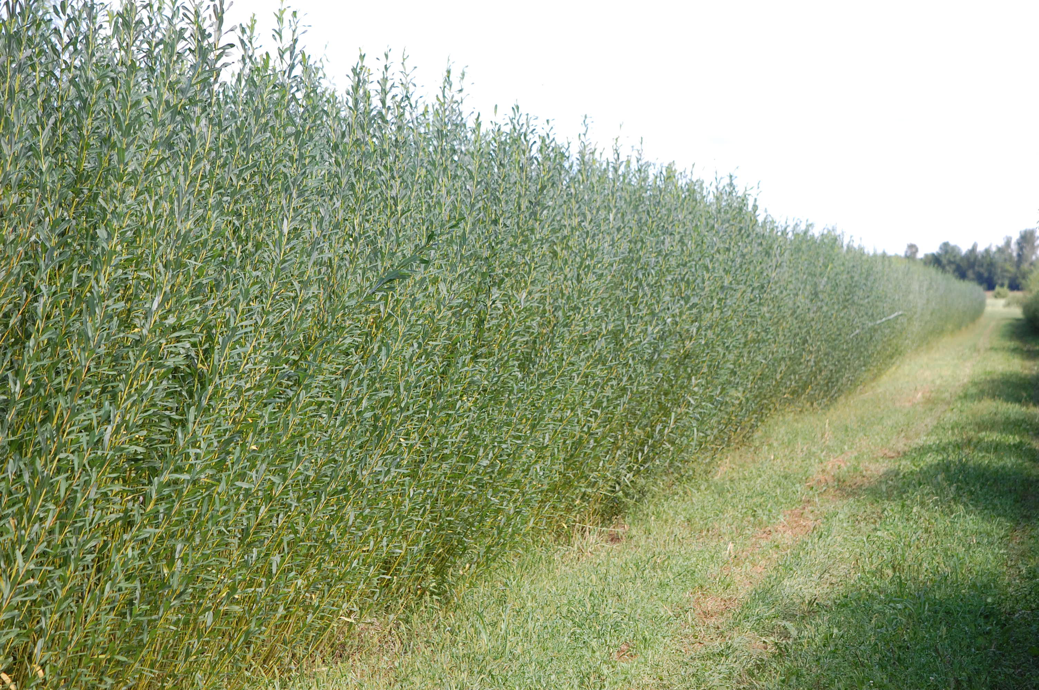
Shrub willow research field in Geneva, NY.
Picture by: Chase Crowell

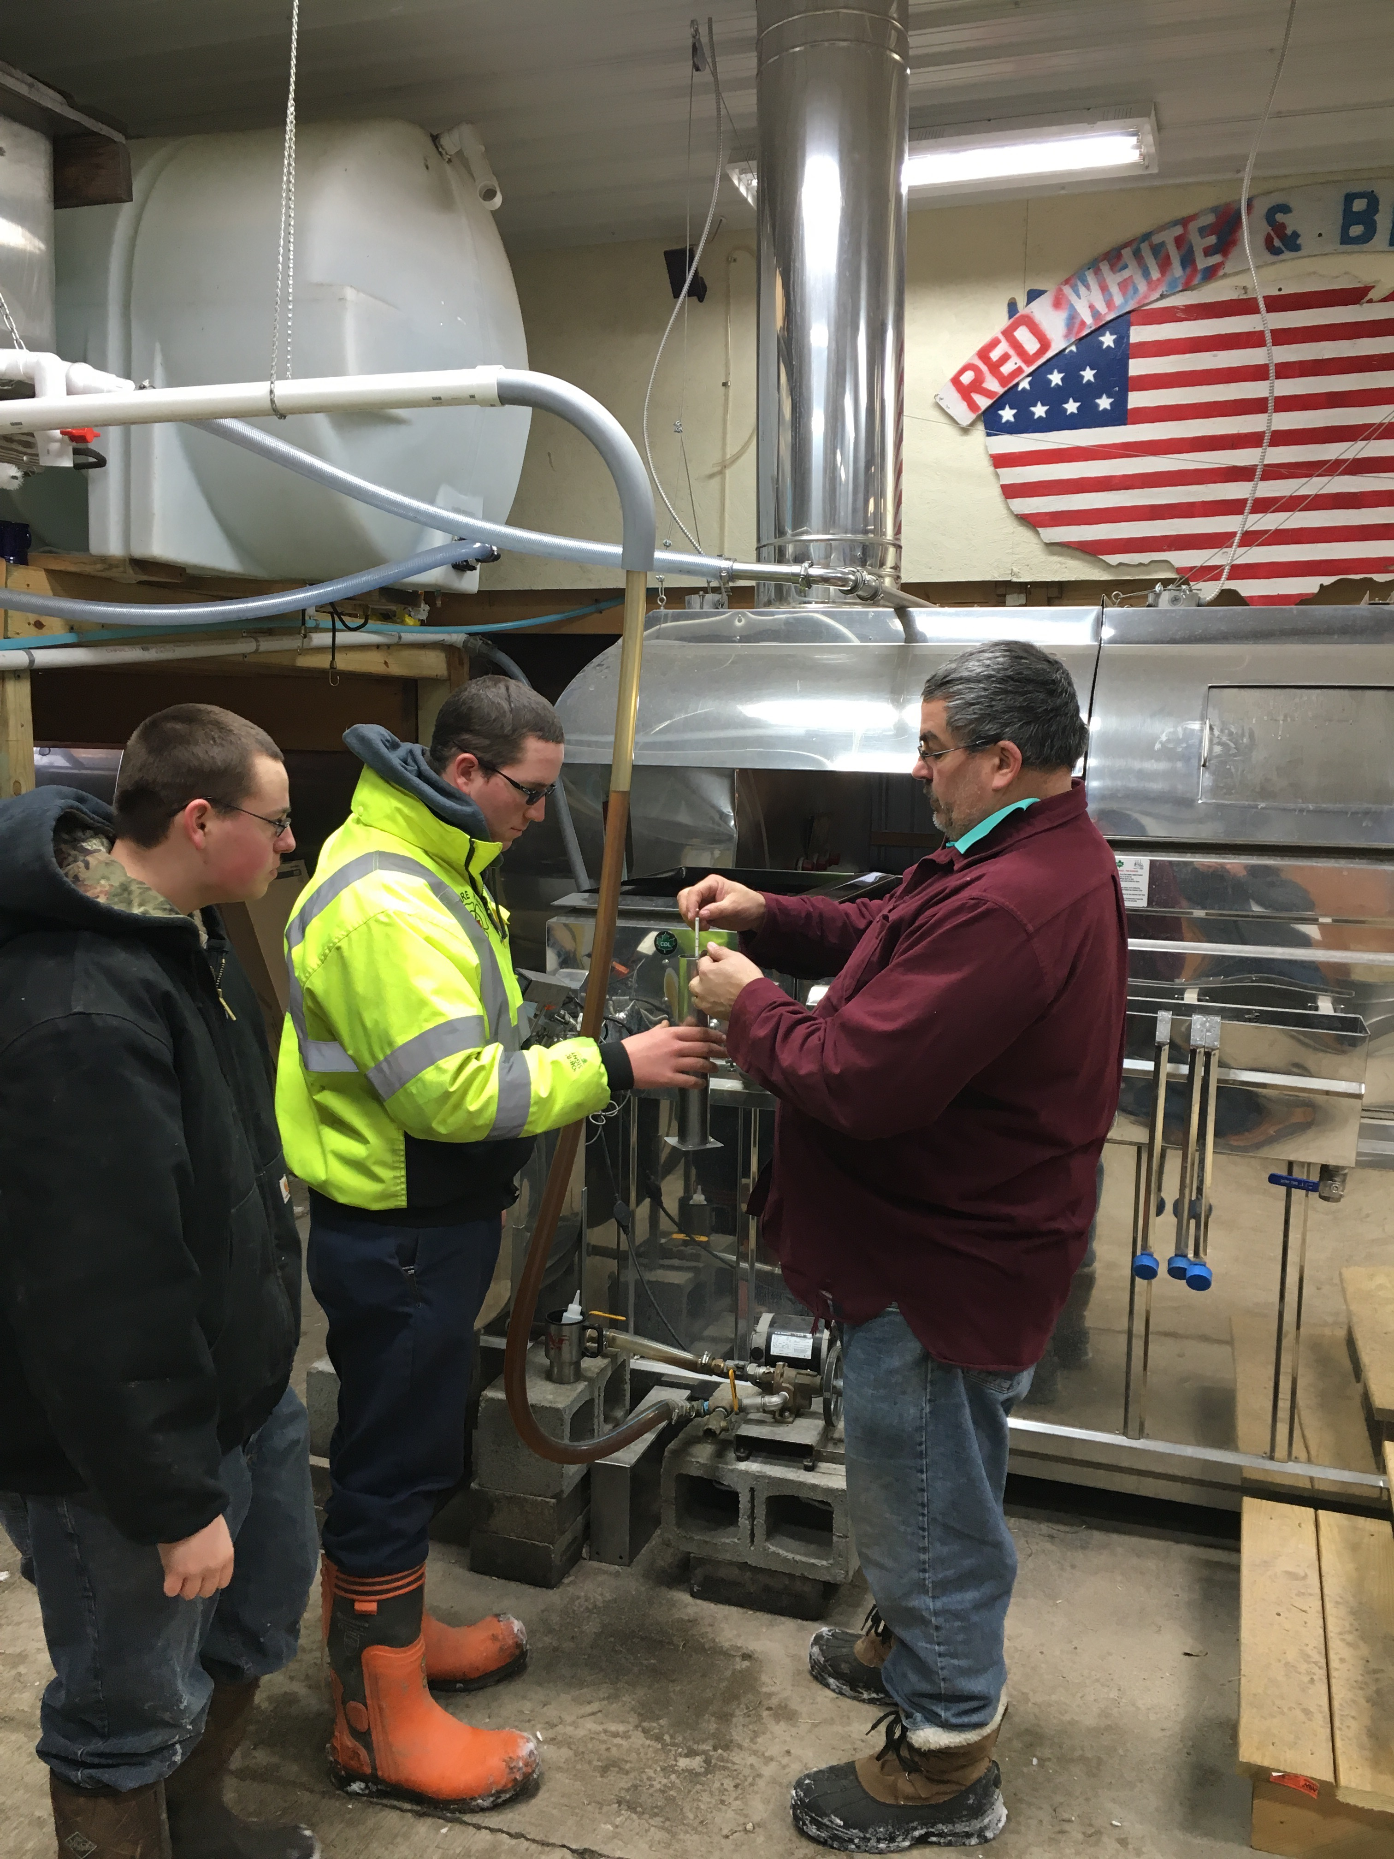
Keith Schiebel (right) showing two of his highschool students, Seniors Mike Maguire (left) and Alex Szkotak (middle), a maple syrup hydrometer in front of maple syrup shrub willow evaporator.
Picture by: Chase Crowell

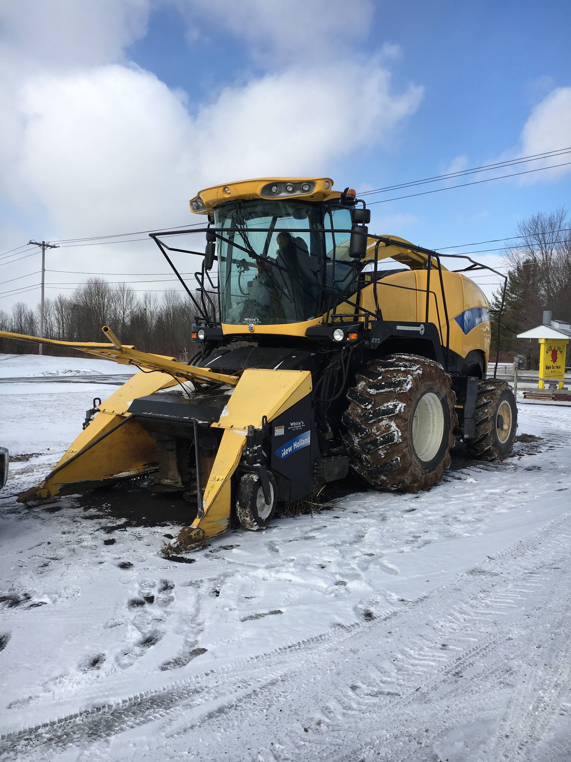
New Holland shrub willow harvester
Picture by: Chase Crowell

