Does Aircraft Forensics Intrigue You?
Wonder what the Black Box Contains?
Interested in the Science of an Airplane Crash?

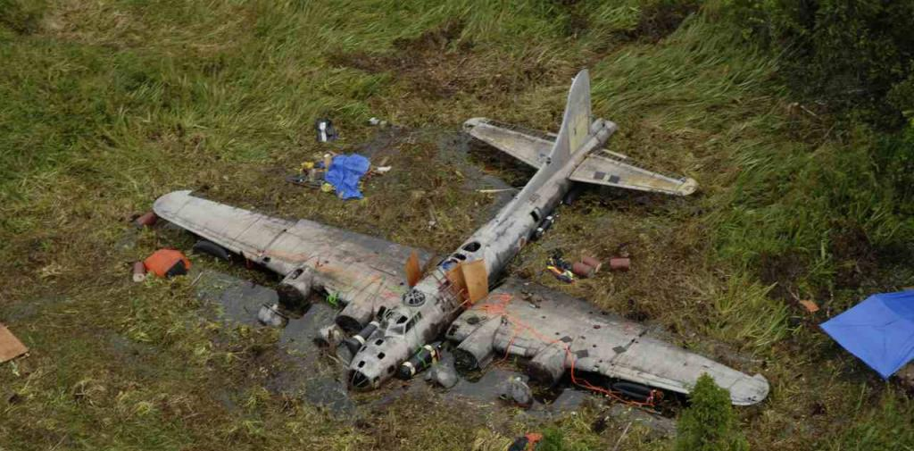
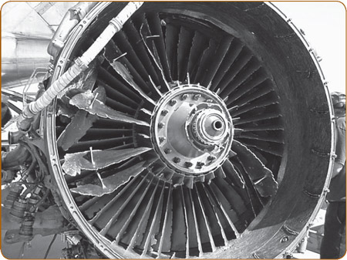

Then Come Meet Professor George Bibel:
Beyond the Black Box: The Forensics of Airplane Crashes

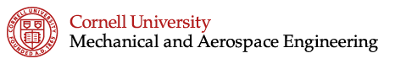
April 27th, 5:00pm at Phillips 403

