**Diversity Hosting Weekend and the Women in Engineering Weekend**

**Sign up today to host or volunteer for a chance to win an IPad Mini—**

**See details below!**

[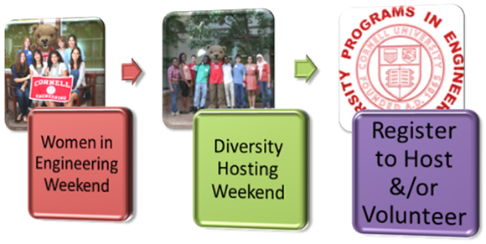](https://cornell.qualtrics.com/SE/?SID=SV_d6iVx6812WazDp2)

[**Host & Volunteer Opportunities**](https://cornell.qualtrics.com/SE/?SID=SV_d6iVx6812WazDp2)

**Diversity Hosting Weekend (DHW) — April 10-12**

**Women in Engineering Weekend (WIE) — April 11-12**

Diversity Programs in Engineering is looking for students that live on-campus housing to serve as overnight hosts and day time volunteers for the Diversity Hosting Weekend and the Women in Engineering Weekend

**HOSTING**

* These prospective students will spend the majority of their time in daytime and early evening programs and events so this will be a very small time commitment.
  + For example with DHW if you have a prelim on Thursday, April 10, you can still host!
    - Hosting will not affect your prelims as your guest will be attending a program until you pick them up between 9pm-9:30pm on Thursday, April 10.
  + WIE Host Matching & pick up is on Friday, April 11

**As an added incentive to serve as a host:**

·         All hosts will be entered into a raffle to win an IPad Mini (*Each hosting program has a separate raffle drawing)*

·         Cornell Tradition Students can earn campus service hours for hosting and/or volunteering for either of this program!

**VOLUNTEERS**

* We also need volunteers to assist us at each program registration, escort groups to labs, help coordinate ice breakers, greet the participants, setup rooms, etc.
* This is a great opportunity for those who reside off-campus or are graduate students
* Volunteers are eligible to earn service hours

**Sign up to Volunteer &/or Host at:** [**DPE Host & Volunteer Registration**](https://cornell.qualtrics.com/SE/?SID=SV_d6iVx6812WazDp2)

Campus visitation experiences have proven to be one of the most important factors prospective students consider when determining where they intend to apply and later enroll. Therefore, please volunteer your time and help us yield our next class of outstanding Cornell engineers!

·         **ALL MAJORS WELCOMED TO HOST!**

·         **YOU DO NOT HAVE TO BE AN ENGINEER TO HOST...SO PASS THIS ON TO FRIENDS!**

<http://tiny.cc/DPE-Hosting>



For more information please contact:  607.255.6403 or [JJ334@cornell.edu](mailto:JJ334@cornell.edu)

Best,

**Jami P. Joyner,** [Jami.Joyner@cornell.edu](mailto:Jami.Joyner@cornell.edu),  
Associate Director, Address: 146 Olin Hall  Ithaca, NY 14853

Diversity Programs in Engineering  
Cornell University, College of Engineering