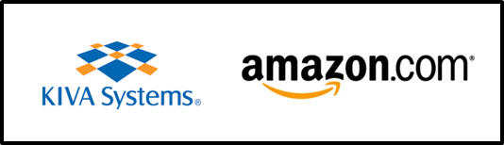

Information – Networking – Recruiting Night
April 16, 5:30pm to 7:30pm
Upson Lounge

Kiva Systems, headquartered just north of Boston, MA, is a wholly owned subsidiary of Amazon.com. Kiva is Amazon’s largest research and development organization on the East Coast, and we are growing fast.

What do we do? We do lots of cool stuff and we have fun. Kivans write really good software that scales, Kivans design complete solutions that deliver business value. Kivans create robots, work stations and other innovative hardware. Kivans manage a complex supply chain and build the robots and gear we design. Kivans support the solutions we deploy and ensure design performance is actual performance. We are a high tech juggernaut and a proud member of the Amazon family. We love a challenge, and we are looking for high energy team members.

The agenda for the Information – Networking – Recruiting Night is as follows:

5:30 – 5:45pm Welcome & Appetizers
5:45 – 6:15pm Presentation: Introduction to Kiva Systems
6:15 – 6:45pm Panel Discussion: Opportunities at Kiva / Amazon
6:45 – 7:30pm Free Pizza and networking with Kiva’s Leadership Team

Please join us for a fun and informative evening. Learn about Amazon / Kiva in Boston, and see if we are right for your future. Feel free to bring resumes. We are looking primarily for CS, EE, ME and Math majors for full time and intern positions, but if you are wicked smart and totally technical we should talk. We look forward to meeting you – the Amazon / Kiva Team.

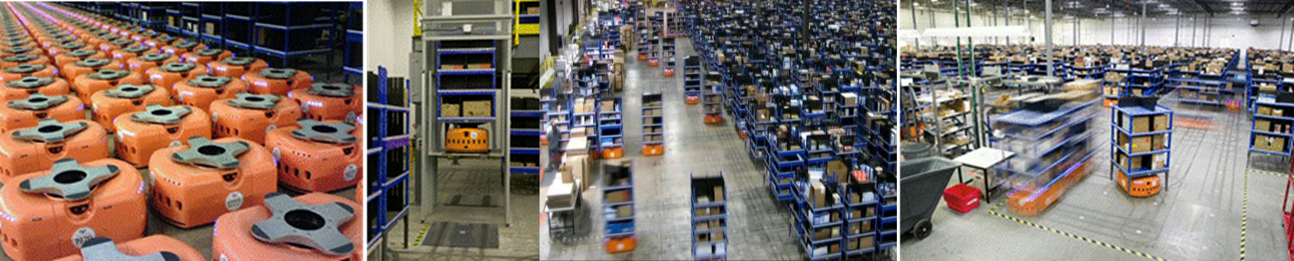

We will conduct on-campus INTERVIEWS on Thursday (4/17) morning – sign up at info session.

