Events with donations – Chrome workaround for landing page

When we have to modify the event landing pages registration button to point it to include the &dids, we need to modify the html on the page.

Create the new link as we have historically done by placing the new url manually in the system field.
We need to then modify the html

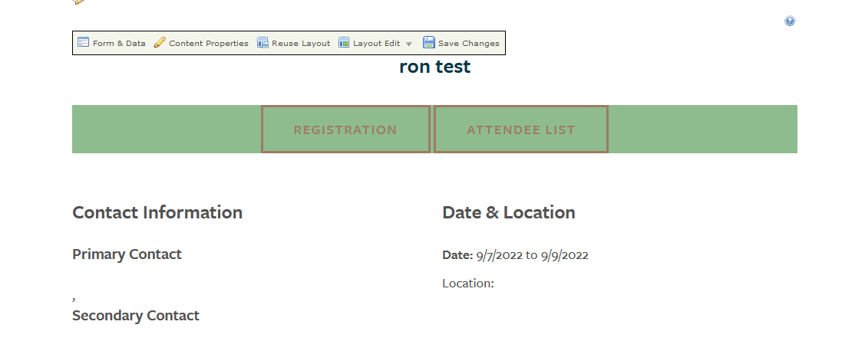

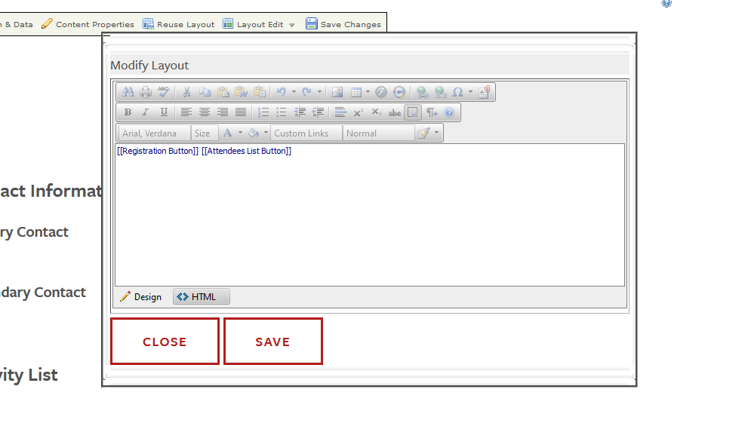

Select the html button…

Now you will see the html to modify

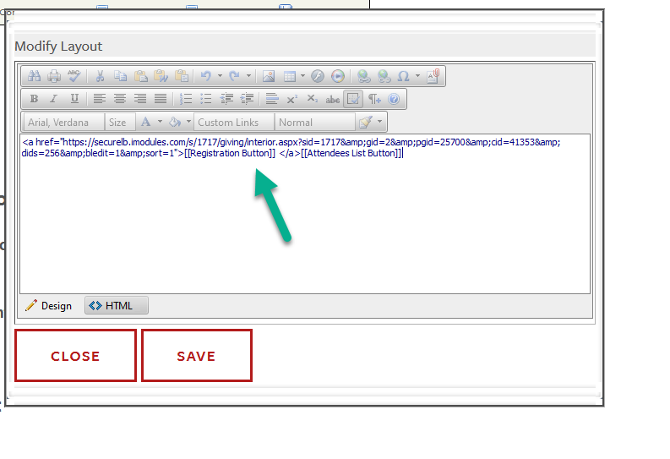

The as generated html will look like:
<a href="https://securelb.imodules.com/s/1717/giving/interior.aspx?sid=1717&amp;gid=2&amp;pgid=25700&amp;cid=41353&amp;dids=256&amp;bledit=1&amp;sort=1">[[Registration Button]]</a>
modified to look like:
<a href="https://securelb.imodules.com/s/1717/giving/interior.aspx?sid=1717&amp;gid=2&amp;pgid=25700&amp;cid=41353&amp;dids=256&amp;bledit=1&amp;sort=1" class="button">REGISTRATION</a>

Replace yellow with green.

