Integrating iModules events with the Cornell Alumni website (alumni.cornell.edu/event)

This document provides key steps for configuring an event in iModules to maximize its accessibility and visual appeal on the Cornell alumni website. Following these steps will ensure the best event presentation on our sites. Failure to follow these steps may result in an event page that does not appear in the alumni website or appears with incorrect information.
The Cornell alumni website utilizes an integration to pull event information from iModules before 8:00 a.m. Monday–Friday. When you create or modify an event in iModules, you should verify the event is correctly presented on the alumni website the following morning. If an event does not display as intended on the alumni website, verify that each of these steps were followed. If you still have questions, contact Ron Babuka or Leigh Stock with the event name, location, and start date.

Alumni website user experience:
From the alumni site, a person can search for events by date range and location.
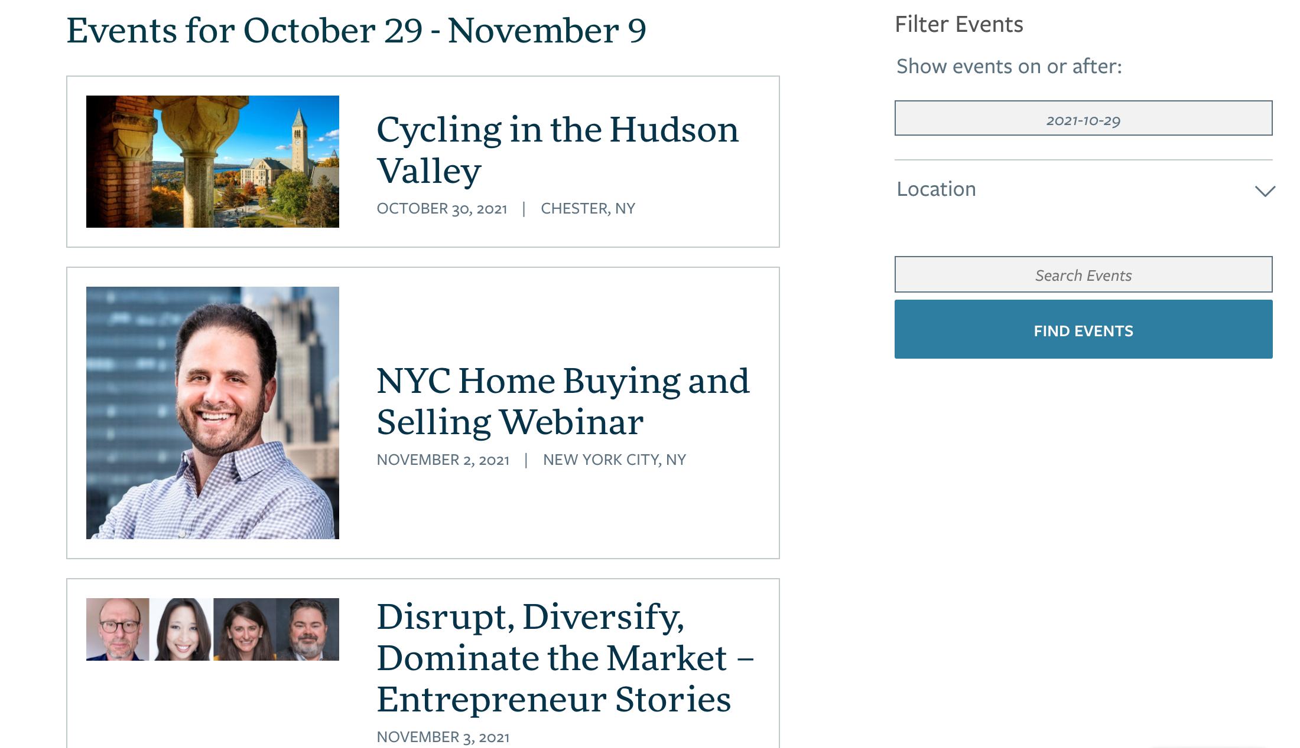

Each event box launches an alumni event detail page:

If the iModules event has an active registration page, a registration button will show below the event details at the top of the page. Clicking the registration button will take the user to the iModules landing page. This button cannot be changed.

Configuring an iModules event to integrate with the alumni website
iModules edit page:
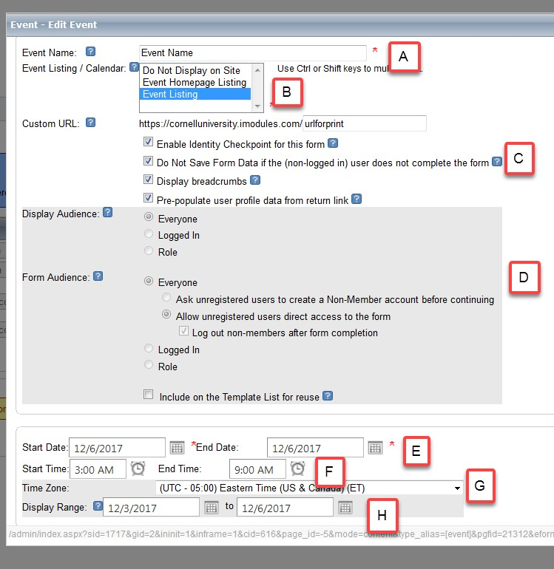

iModules fields:
Field | Field Name | Use
A | Event Name | The event name should be clear and concise. Do not use internal lingo such as abbreviations or NetIDs, as this field will be shown on the iModules landing page and alumni website. Please use the correct technical terms to describe online events. This is documented in the AAD Style Guide, under “Technological terms”:  https://cornellprod.sharepoint.com/sites/AAD-KB/SitePages/Topic--AAD-Style-Guide-KBs.aspx
B | Event Listing | Select “Event Listing” to have event shown on AAD site (public). Select “Do Not Display on Site” to NOT show on AAD site (private).  You can use the private setting while drafting the event and then switch to the public setting when you are ready to make it public.
C | Identity Checkpoint and Prepopulation | Select Enable Identity Checkpoint each time. Select Pre-populate user profile if you plan to promote your event with iModules email.  More information about member records can be found at:  http://blogs.cornell.edu/imodules/home/event/managing-nonmember-records/
D | Display and Form Audience | The form will be viewable to Everyone as the default setting. If you want to force people to login before registering for an event, reset Display Audience to the Logged In setting.
E | Start / End Date | The start and end date(s) of the event.
F | Start / End Time | The start and end time of the event. If the event is a one-day event, fill in the start and end time. If this a multiple-day event, leave blank.
G | Time Zone | The time zone for the event will default to Eastern Time. For both physical events and webinars, select the time zone for the location hosting the event.
H | Display Range | Select a date range when the iModules landing page is visible. This date has no impact on the alumni website integration.

iModules edit page:

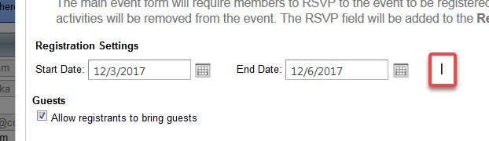

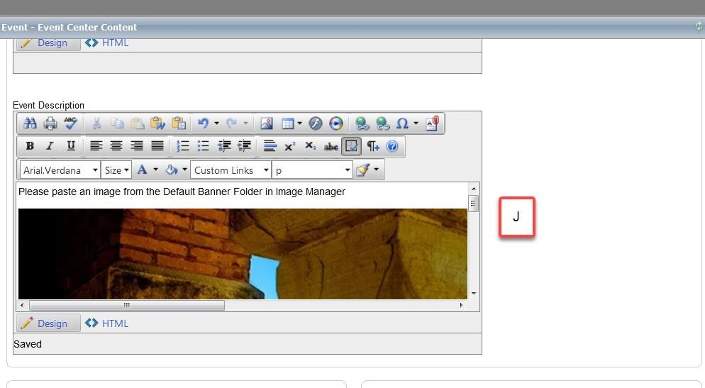

iModules fields:
Field | Field Name | Use
I | Registration Settings | The start / end dates control when the registration button will appear on the alumni website.
J | Event Description | Content from the event description block will be presented on the alumni site. See the special guidelines for this area.

Extended notes for (J) the iModules event description content block

Images
The first image is stored as a ‘featured image’ for your event page on the alumni website. For optimal quality on the site, this image should be approx. 840 x 560 px (72dpi). If you are including square or smaller images, a blurred background will be added to your featured image.
Use this tool to help crop and edit banner images. Use JPG, PNG (no transparency) or GIFs image types.
To change or remove a featured image, contact the Web Solutions and User Experience (WSUX) team to remove the image BEFORE changing it in iModules.

Text
IMPORTANT: You must use the default text, fonts, sizes, etc. in iModules for the best display fonts on the alumni site. Altering the fonts to your own style is not allowed. Style choices are aligned the Cornell Alumni brand identity and are added automatically when your page is published. Select the default body text (item 1) for your event description. You may use bold or italics with this default text.
If you need to create headings, use only h2 through h6. Do NOT bold or italicize headings, this will break the styling on the website. The h1 style is reserved for the your page title and will show up automatically. For proper heading flow, use H2 first, followed by H3, etc. You may also use the same heading level multiple times, if appropriate.
For all copy types, do not change font colors, and do not underline any text.
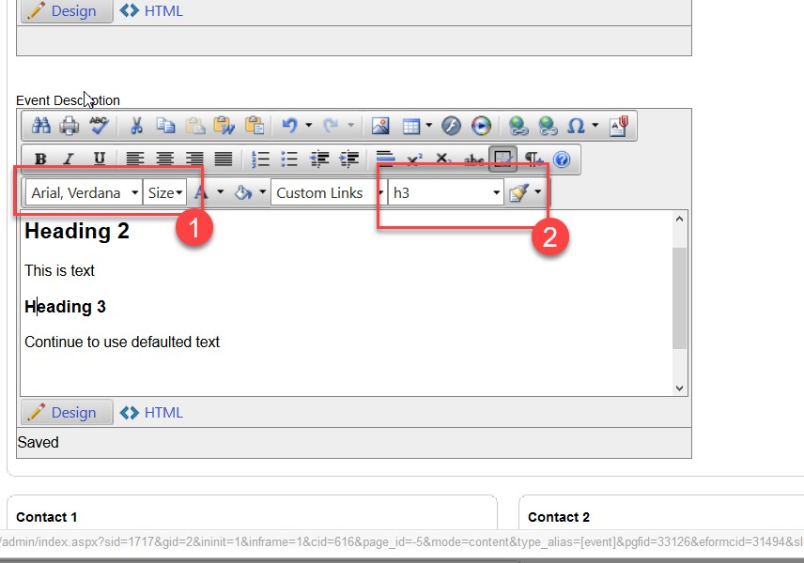

Contacts and locations
iModules edit page:
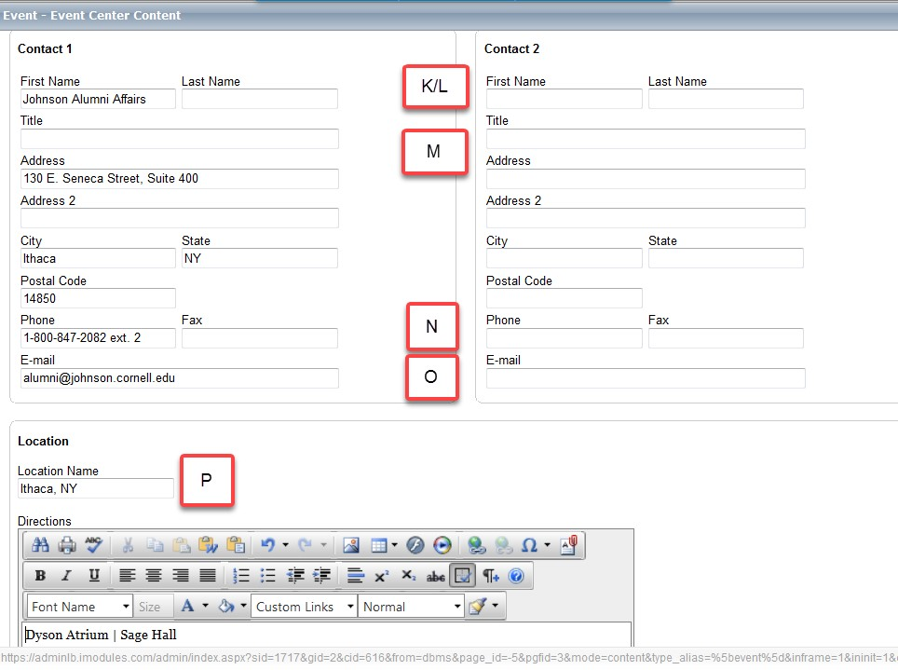
iModules fields:

Field | Field Name | Use
K/L | Contact First Name/Last Name | Add contact first name and last name for both contact 1 and 2. The integration will concatenate both names together including blanks
M | Title | This field can be used for a person’s title or any text that can follow a contact name
N | Phone | Contact phone number for both contact 1 and 2.
M | Email | Contact email for both contact 1 and 2.
O | Location Name | This is the location of the event. Event Locations in the U.S. should be city, two-character state code. Example: Ithaca, NY  Generic locations such as “Germany” will find all events with a location of “Germany” or German cities within 150 miles of the center of Germany.  If an event is online, enter the physical host location for the events.  This will ensure the time zone is correctly loaded.

The first name, last name, and email fields must all be populated for the integration to populate contact information to the alumni website.
Note: Address, Address2, City, State, Postal Code and Fax are not shared from iModules to the alumni web site. We recommend still populating all of the fields for iModules.

Removing events:
To delete an event, mark the event private to remove it from the alumni website. Wait one business day and verify the event is no longer on the alumni website, then delete the event in iModules.

Photography and video disclaimer:
Include language specifying if there will be photography and/or if the event will be recorded in any event marketing, and on your event landing page.

Sample event registration page language:
“By registering for this event, you consent to being recorded by video and/or photography, which may be used in future event promotions, marketing, and/or fundraising material. If you don’t want your photo taken, opt out below.”
Include an opt-out radio button or a check box:
Sample checkbox language: “I do not grant permission for Cornell to use video or photography of me.”

Opt-out response:
Include language to indicate we have recorded their preference regarding video/photography and if additional information will be available at the event

“Thank you for registering, we have recorded your video/photography preferences”
These preferences should be shared with the staff member printing nametags. A red dot or sticker should be applied to the name tags of those who opt out of video/photography.

