Opting out of iModules quick instructions. I get a lot of request as to why someone did not get an email. So here is a quick cheat sheet.

If a constituent says they did not get an email the first thing that should be done is to verify that they were in the audience to get an email. That could be as simple as looking at the list of emplids used in the email. If they are on the list you could then see if they were a recipient.
Go to the email tool, find the email in the History tab, then select the gear and “View Recipients” in the pull down menu.

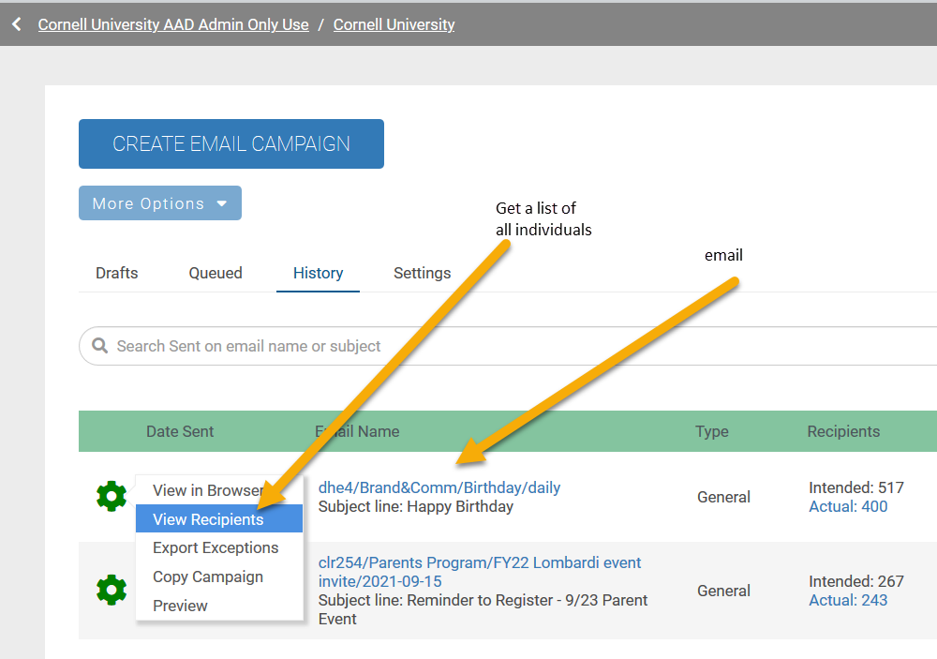

If they are on the list below, the email was delivered and they will need to check things such as social, promotion, or junk folders. We have no ability to control where an email goes once we deliver the email.
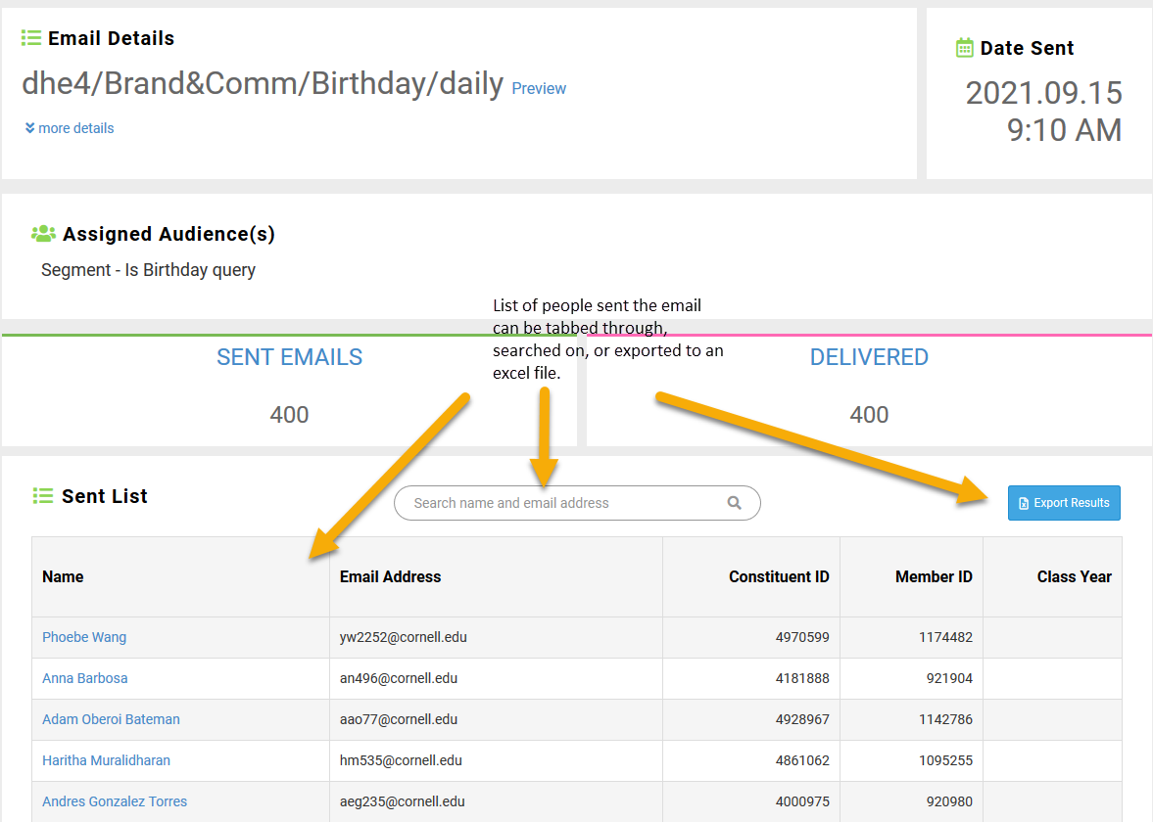

If they are not in the list of emails that were delivered, you can then check the exception report.
Go to iModules email, and select the history tab, then find the email. Select the gear wheel and “Export Exceptions” to launch a report.

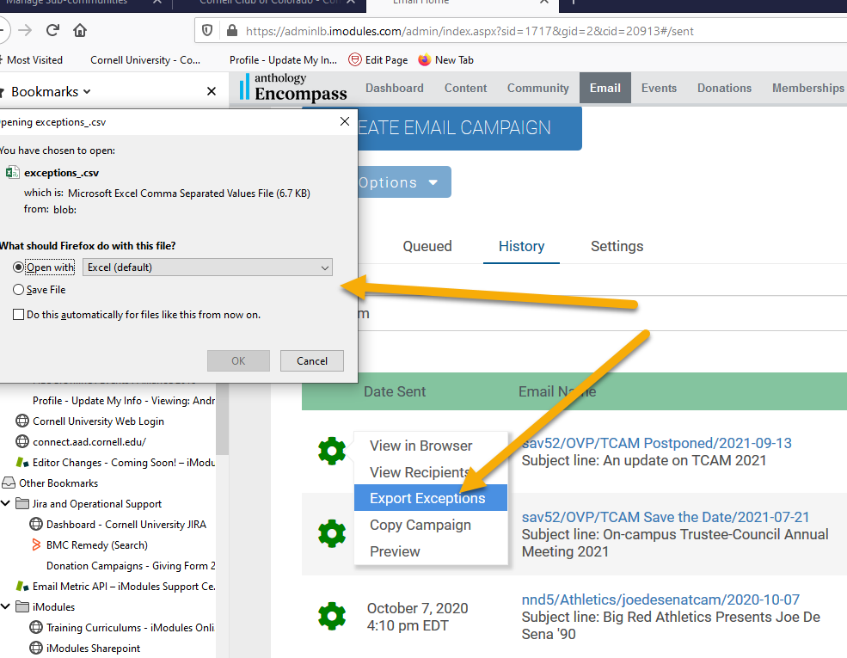

Once we have the excel report, determine if the constituent is in the report

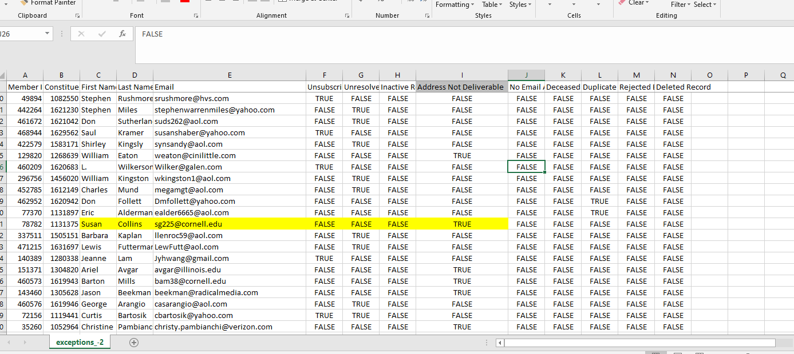

If they are, the column header will indicate why they did not get the email with a TRUE value.
If the column header indicates the address was not deliverable, contact myself or Leigh Robert and we can reset the field that indicates the email address is no longer valid. We have the ability to also determine why the email bounced that we can pass along to the constituent.

If they are in Column F or G, then they have opted out of getting the email category or all emails from Cornell, the Class, or the Club altogether. Opting out of a Cornell email does not opt you out of a class or club email and vice versus.

The preferred way to correct an opt out of emails is to have the constituent do it themselves through the directory. This is teaching the person to fish and maintain the emails they want to receive.

Direct the Alumni to go to alumni.cornell.edu and select “Update your contact info”
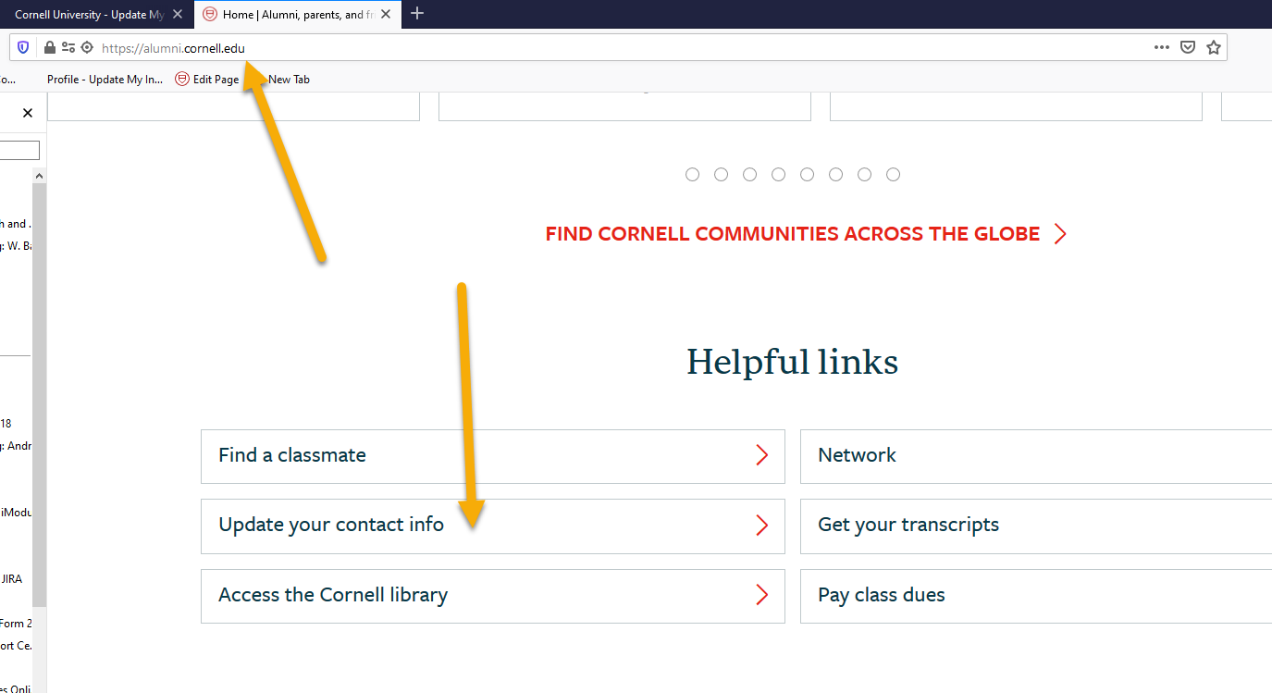

They will be taken to the directory

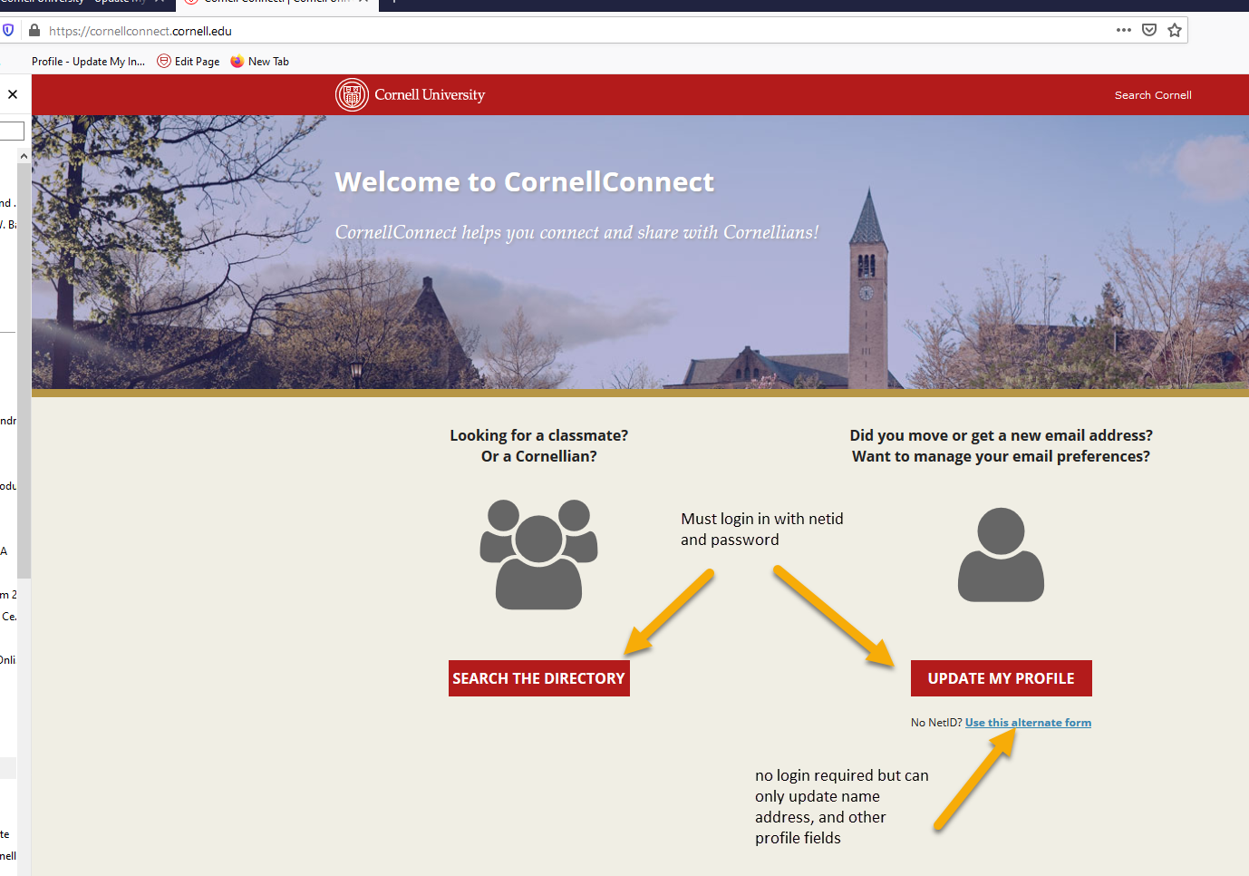

They MUST login with netid and password. This protects their data.

Select email preference.

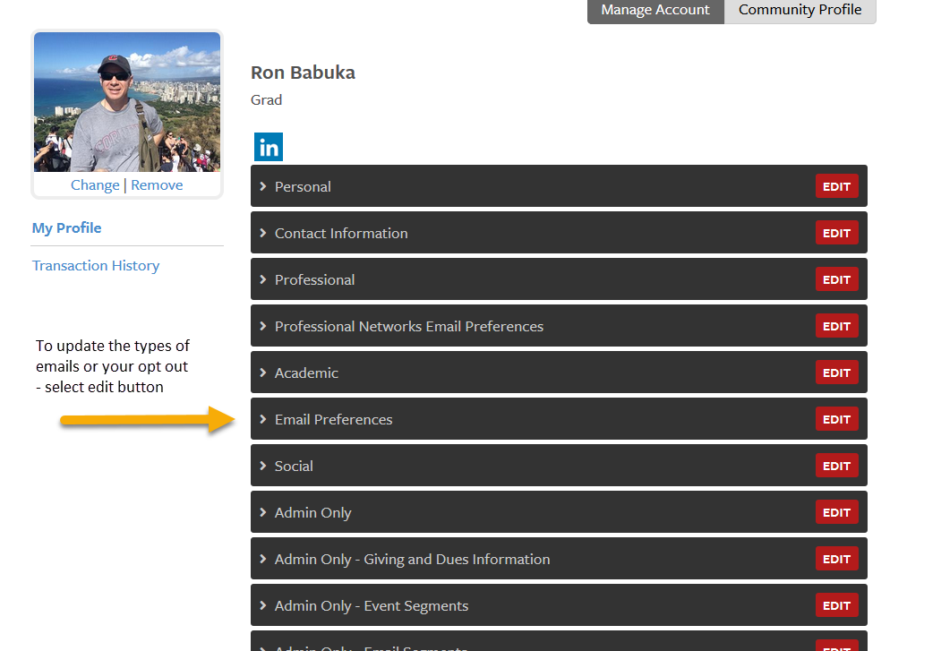
There the constituent can manage their email preferences and opt out per each type of email they get (Cornell, class, club)

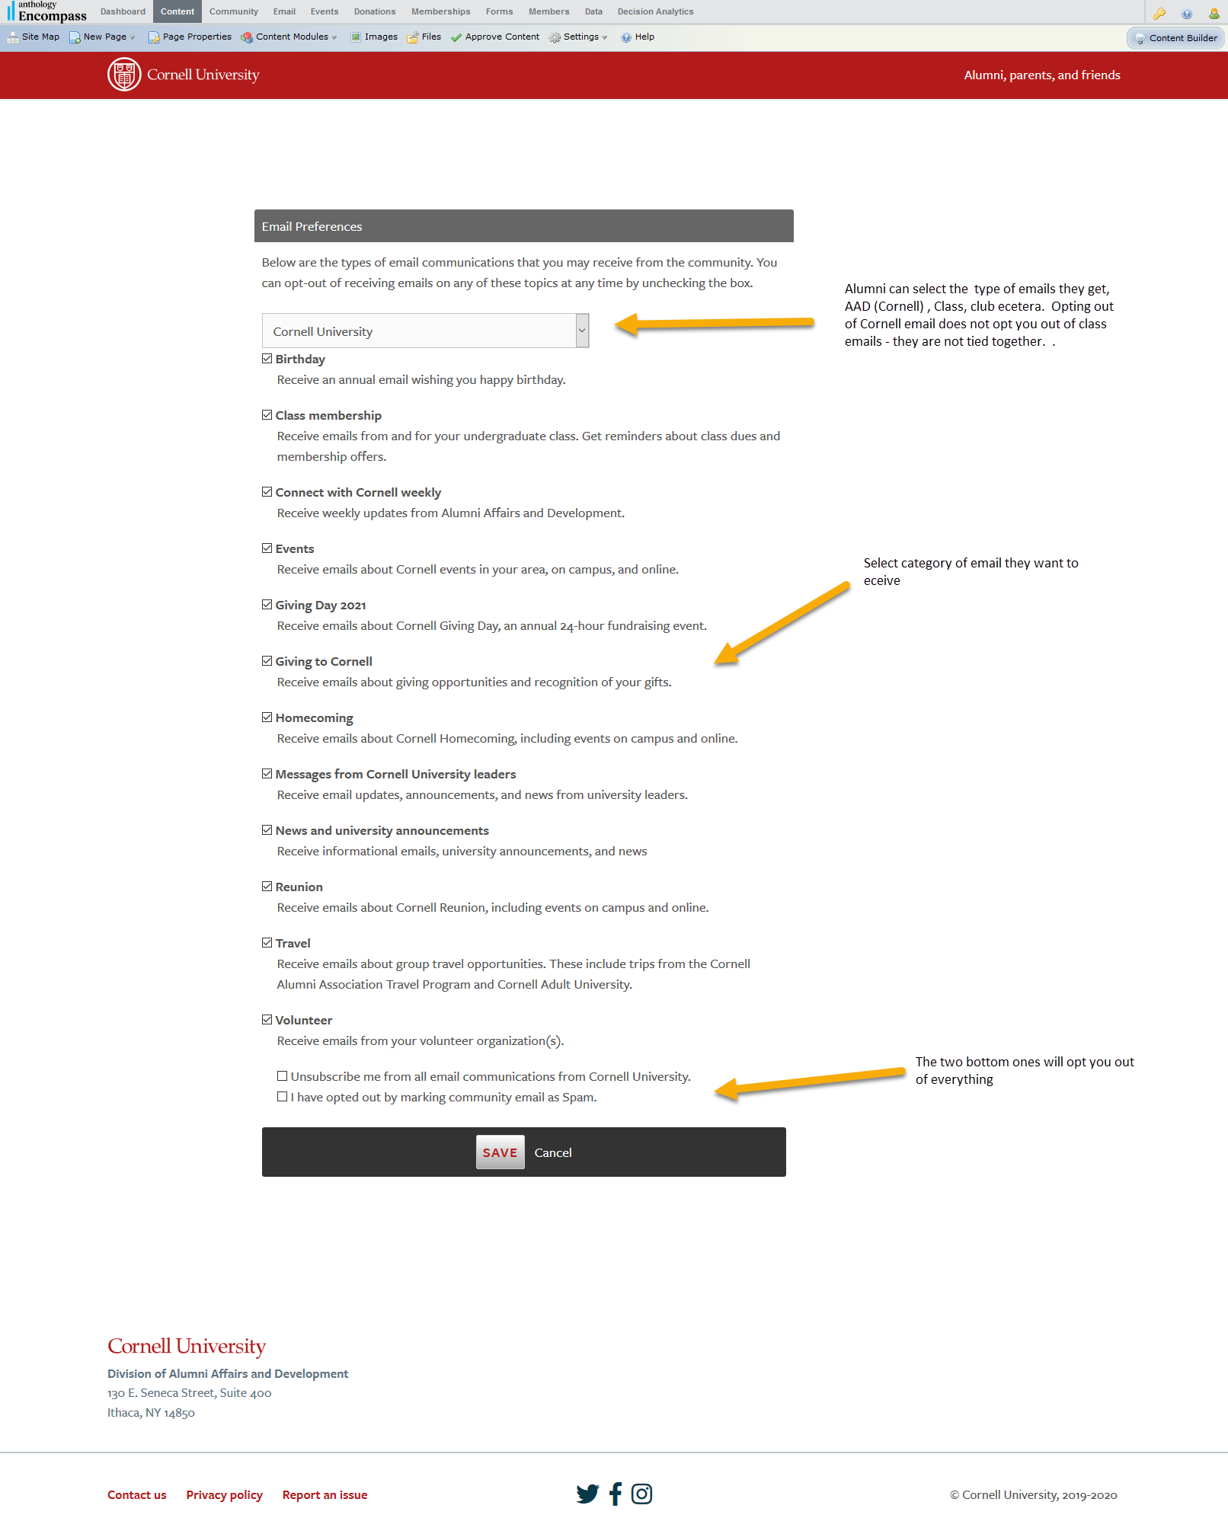

If the alumni does not know their netid and password, I can also update the same information.

One important piece… if the person has opted out of Cornell email as SPAM (Column G in spreadsheet), then I must have an email from them asking to receive emails again. I will need to forward that onto iModules.

