Creating an Event in iModules

Log in to iModules
Under the EVENTS tab select “Create New Event”

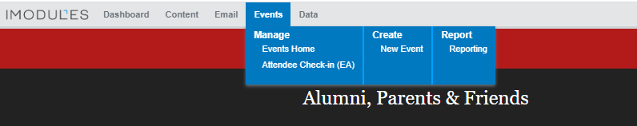

1. Enter Event Name (cannot exceed 75 characters)
For online events, include “Digital” in the title (e.g. Digital Big Red Sprint Football Town Hall) and still include Ithaca, NY in the location field even though the event will be hosted online).
Tip: for events that occur annually, include the year in the title (e.g. Big Red Athletics Homecoming Reception 2020).

2. Event Listing/Calendar:
Do Not Display on Site – this makes it so the event does NOT show up on the alumni events calendar (Select this option if your event is private, invite-only, and you DO NOT want it displayed on the alumni event calendar)
Event Homepage Listing- don’t use this option
Event Listing – select this option if you want your event to display on the Cornell alumni events calendar

3. Custom URL box (You can use this feature to create a custom URL for your event)

4. Click on “Toggle Advanced Mode”
Check all 4 Boxes
  - Enable Identity Checkpoint (you will need to check this one)
  - Do Not Save Form Data (this one should already be checked)
  - Display breadcrumbs (this one should already be checked)
  - Pre-populate user profile (you will need to check this one)

5. Gray Box: Display Audience & Form Audience- leave these settings how they are.

6. Event Date: Include start date and end date of the EVENT (this will be the same for a one-day event)

7. Time: Include start time and end time. This will always be Eastern time.

8. Display Range: controls when the landing page will be visible- this should be from the date you want the event to be live, to the date of the event.

9. Upload an image- skip this section

10. Event Registration Model
NOTE: for most events, unless it’s a simple RSVP, use option #1. FORM-DRIVEN
You CANNOT change the event registration model after you hit create.

Form-Driven: this is the most flexible template and should be used for most events
Fee-Driven: in order to register, registrants have to pay a fee
Activity-Driven: registrants who sign up for any activity are considered registered for the event; you don’t have to purchase a ticket to attend, but you can add fees
Simple RSVP: use for simple RSVP that does not require any registration fees; this option is very restrictive, you can’t add any activities – it’s just a simple, are you coming, yes or no?

11. Registration Date: Enter the start date and the end date for the REGISTRATION period. This is the period of time that you want individuals to be able to register/pay or RSVP for your event. Once the registration period expires, the REGISTRATION button will disappear from the event page (e.g. registration is closed), but the event details on the landing page will still be visible.

12. Guests: UNCHECK “allow registrants to bring guest” – if you do NOT want registrants to be able to bring guests.

13. Gray Box: Registration Settings
If you have to cap attendance, you can limit the number of guests overall and/or limit the number of guests that each primary registrant can bring.
Under the Features section, leave settings how they are.

14. Detail Page Layout: Leave setting as is.

15. Gray Box: Add Commerce Identifier & Commerce Identifiers: Leave settings as is.

16. Hit “Create”

17. Landing Page: this is the “home page” for the event which includes the event description and other pertinent details you want registrants to know.
Skip the “Event Preview” box.
In the Event Description box, include the name of the event, the date, location, and time, and a short blurb describing the event. For example:
Join us as we celebrate and honor some of Big Red Men's Basketball greats, including the 1988 (11-3) Ivy League Championship Team that took CU to the Big Dance (its first appearance since 1954) and the 2010 Sweet 16 Team, a No. 12 seed that knocked out both Temple (No. 5) and Wisconsin (No. 4), ranked #17 in the nation.
Saturday, February 8th, 2020
Biotechnology, G10
(Biotechnology is behind Teagle Hall)
4:00 pm- 5:45 pm

Guest speakers include:
Steve Donahue, Former Big Red Coach, and current coach of the Penn Quakers
Andy Noel, The Meakem*Smith Director of Athletics and Physical Education
Brian Earl, The Robert E. Gallagher '44 Head Coach of Cornell Basketball
Josh Wexler '89
Jeff Foote '10 & Louis Dale '10

Formatting Tip: To single space your text, hold down the shift key and hit enter. You can use
this to single space between paragraphs, or if you want to single space certain lines, like the event name, date, location, and time.
For Digital Zoom Events: And a sentence stating: “Once you register, you will receive a confirmation email which will include the Zoom link. If you don’t receive the confirmation shortly after registering, please check your SPAM, Clutter, or Junk folders.”
Three Rules About Adding Content to the Landing Page:
- Never copy and paste an image into the box (see instructions below)
- Never copy and paste text from Word; use plain text or copy and paste from Notepad
- Never copy and paste an URL; use the hyperlink button

Adding Images:
NOTE: you have to upload the image to the iModules folder before you can insert it on your landing page. There are many subfolders under the “athletics” folder so upload your image in the appropriate folder. You can also create a new folder under the “athletics” folder if needed.
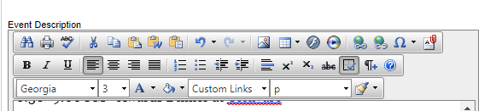

Click on the image button. Double click on the “athletics” folder. Find the folder in which you want to upload your image. Click on the green Upload button.

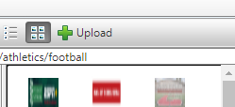

Click the “Select” button. Find your image file on your computer and then click “Open.” Click, upload and your image will be saved to the folder you selected.

Find your photo in the folder, click on it, and then select “Insert.”
Images should be 600x225 pixels.
To view image properties, after inserting the photo, right click on the image and select, “properties.” You can then view the width and height and adjust accordingly.

Inserting a URL
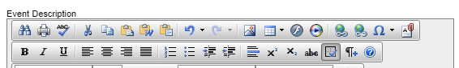

Click on the hyperlink button. Paste your link into the URL field. Delete out the “http://” before pasting in your link. Always double check to make sure your links work.

Tooltip: Enter text here if you want to include a message about your link. E.g. “Click here to learn more!” When you hover your cursor over the link you will be able to view the message.

18. Contact Info: After completing the Event Description, add the contact information for the point person for this event. Always include name, title, and email address.

19. Registration Page: Once you hit “Next” it will bring you to the registration page. Here you will insert fields for the information you want to collect.
The default information collected on the registration page is:
  - Preferred First Name
  - Preferred Last Name
  - Email
You can add other fields as desired. Some fields, such as Preferred Cornell Class Year, are already in the system as an “existing field.” Other fields that may be unique to your event, you will have to insert as a “new field.”

Add an Existing Field
To add an existing field, such as class year, you would following these steps:

Click on “Manage Category” (in the blue heading above Preferred Name) and select “Add Existing Field.” Type in class year in the search box and then select “Preferred Cornell Class Year” from the options below. After highlighting it, click on the “Add Selected Fields” and that field will be added to your registration page.

There are many existing fields already in the system, so always search for the field first, before adding a new one.

Add a New Field
Click on “Manage Category,” and select “Add New Field.” In the Field Name box, enter the name of the field. This name will not be visible on the registration page, but only on the admin side.
Note: If you try adding a new field that you or another colleague has used before, such as “Dietary Restrictions” you will get an error message. The field name box has to be unique, so you can add the year or program name. For example, “Dietary Restrictions Rowing.” Make sure the Display Name (the field visible to registrants) just says “Dietary Restrictions.”

The Display Name is the field that will be visible on the Registration page.

For example, if you wanted to include a field where registrants could submit questions for a panelists before the event, the field name could be “Question for ATH Panelist,” and the Display Name could be “Have a question for our panelist? Submit it here.”

Always check the “Show Advanced Options” tab.

Tip: To make your Excel Spreadsheets cleaner (when you download the registration reports) delete the title from the Export Column Header Name. You can leave the rest of the settings in that box as is.

Audience: The default is that everyone will see every registration field. If you only want certain registrants to see certain roles, then you have to assign roles to your audience. For example, if you had an event where individuals had the options to register only, register and sponsor, or sponsor only, you can assign the registrant a role so that he/she only sees the fields that are relevant to him/her.

Data Field Type: select how you want to collect the information. For submitting a question, you would select, “Text Box” so the registrant can type in his/her question.

After selecting your data field type, hit “Next.”

Whenever you add a new field, it will display below any existing fields on the registration. Drag the “Preferred Class Year” field below the Email Field. You can drag a field by hovering your mouse over the field name, and then using the Green Arrows on the right-hand side
Drag the “Please do not show my name on the attendee list” box down to the bottom of the registration. It should be the last field.

Adding Registration Fees/Commerce Items: If you are charging a registration fee, and/or including an option for registrants to sponsor the event, you need to add the “Registration Fees/Commerce Items” field under the “Mange Category.

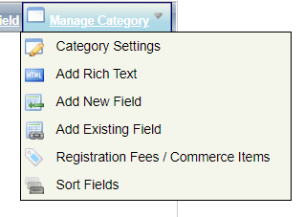
On the next screen, click on the “Add Commerce” button. You will then need to add the Field Name (e.g. Tailgate Ticket), the Display Name (e.g. Purchase your Tailgate Ticket), and select the Data Field Type.

If there is only one price, you can use the Commerce Amount Field and enter the registration amount. If there are several prices (for example, if you had a young alumni ticket price and a regular price), you can use the Commerce Dropdown option and use the Add Price/Fee button to add each ticket price. If you want registrants to have the option to purchase more than one ticket, use the Commerce Item Field option and enter in the ticket price.
If you want to give registrants the option to sponsor the event at different levels, use the Commerce Dropdown option and enter the different sponsorship levels. For example, Bronze $150, Silver $500, and Gold $750. Look at the Fencing Spring 2019 Banquet as an example.

20. Payment Gateway ****DON’T FORGET THIS STEP****

For any event where you are collecting registration fees and/or accepting sponsorships, you need to link the event to our Athletics account so the funds are transferred directly into Athletics’ clearing account. (Note: if you are only accepting gifts and you have directly inserted the giving link on the registration page, you don’t need to set-up the payment gateway. Always check with Ron Babuka before adding a direct giving link to a registration page.).

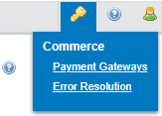

After clicking on Payment Gateways (located in the top right-hand corner of the page), click on the Events tab.

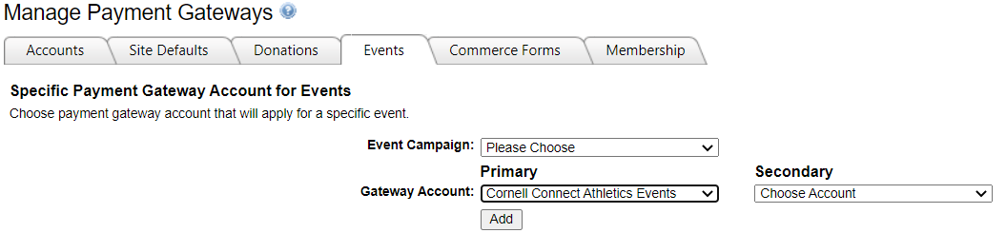

Under the Event Campaign tab, find your event in the drop-down menu. Under the Gateway Account tab, select “Cornell Connect Athletics Events” and hit “Add.” Any funds that come in via your registration page will now be directed into Athletics’ Clearing Account. At the beginning of every month, you will run a “Settlement Report” which will include any transactions that hit this account the previous month.

21. Member Confirmation Email
Under the Manage Form tab, select, “Member Confirmation Email.” This is the email the individuals receive after they submit their registration. It includes the details of the event. You can edit the text if you want to personalize the message, but DO NOT change any of the information in [ ] such as [FORM NAME], [iCalURL] etc.

Make sure to hit “Save” when making any changes to the email confirmation.

22. Admin Confirmation Email

FOR ZOOM EVENTS:
After the “You have registered for [Form Name] sentence, delete the sentence: “The details are below” and include the Zoom instructions.

Copy and paste the Zoom instructions into Notepad and then copy and paste into the email confirmation.

To NOT receive the confirmation email every time someone registers, click on the “Manage Form” tab and select “Admin Confirmation Email” from the list. Remove your email from the email box and uncheck the “check here to add others” box.

23. Making Changes to the Registration Form:
If you ever need to make changes to the registration form, use the “Content Properties” tab.

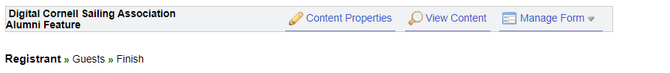

24. Making Changes to the Landing Page Layout:
If you need to make changes to the LAYOUT of the landing page, use the “View Content” tab. For making changes to the description, use the “Content Properties” tab above).

Under the “View Mode” tab, select “Layout Edit” from the dropdown menu. This will allow you to make changes to the layout of the landing page. For example, if you only want to list one contact for your event, you can delete the Secondary Contact by clicking on the Contact Information box and deleting out the additional lines.

Make sure to click the “Save Changes” button after making any edits to the layout.

25. Attendee List Settings:
For all events, registrants have the option of having their name, class year, etc. displayed on the Attendee List. The information that is included and made public on the attendee list is up to the event builder. You determine what fields are displayed.

To manage the attendee list settings, first find your event in the imodules list of events. Click on the down arrow to the right of the gear. Select “Attendee List.”

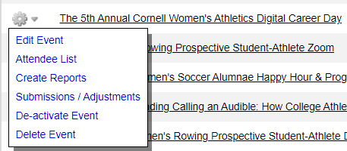

On the next screen click on the “Member View” tab and scroll to the bottom and click on “Manage Columns.”

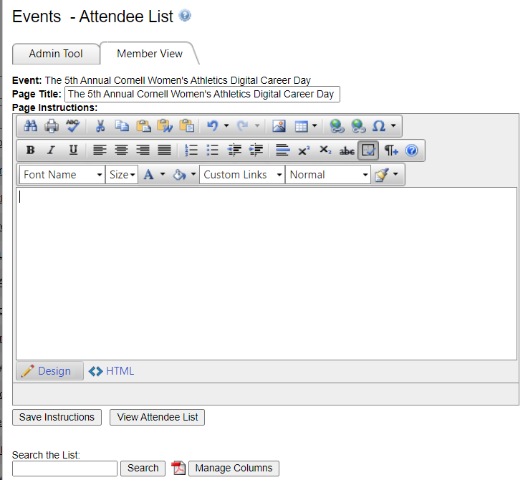

Find your event under the “Add Fields” column and select which fields you want displayed by clicking on each field. NEVER display private information, such as email address, home address, and/or phone number.
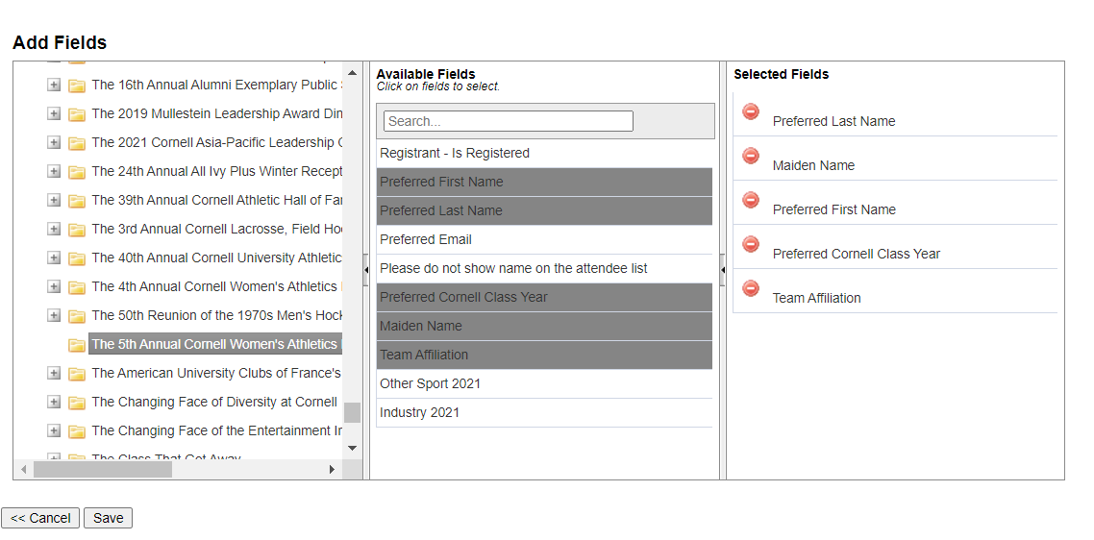

Once you have selected the fields you would like to display, click “Save.”

The Attendee list will then display all the fields you selected. See example below.

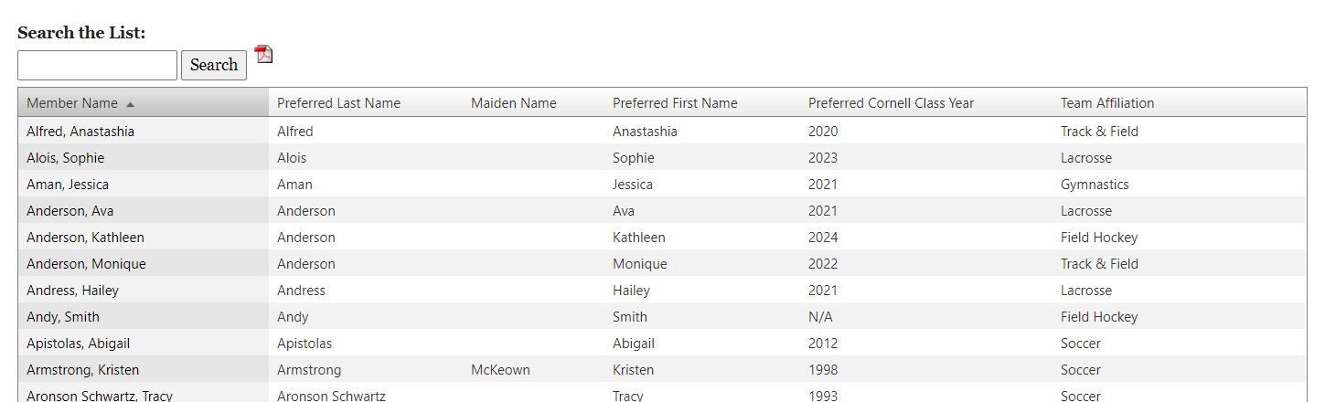

The Attendee List button is visible on the Landing page. Once the first person registers, that button will appear on the page.
