Ending the age old argument regarding of including Preferred Class Year or Preferred Cornell Class Year (or Preferred Class Year).
In the example below, you can see where either existing field can be placed on an event. Field 1 is the “Preferred Class Year” and Field 2 is the “Preferred Cornell Class Year”.

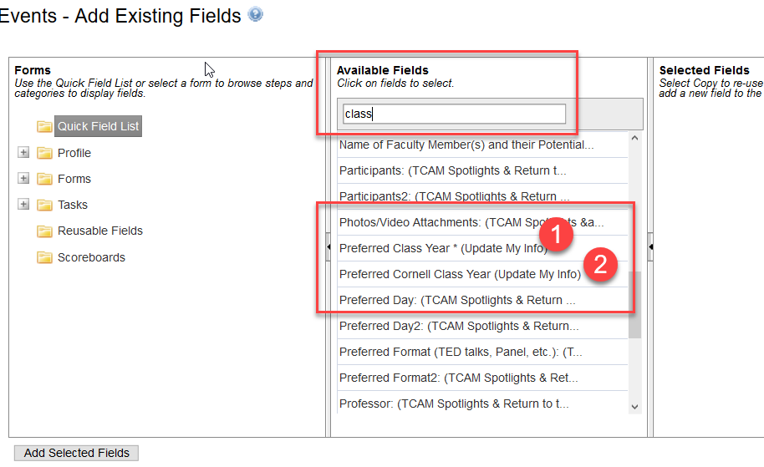

For example sake I have placed both forms on a test event where I am registering a member of the Class of 2005.

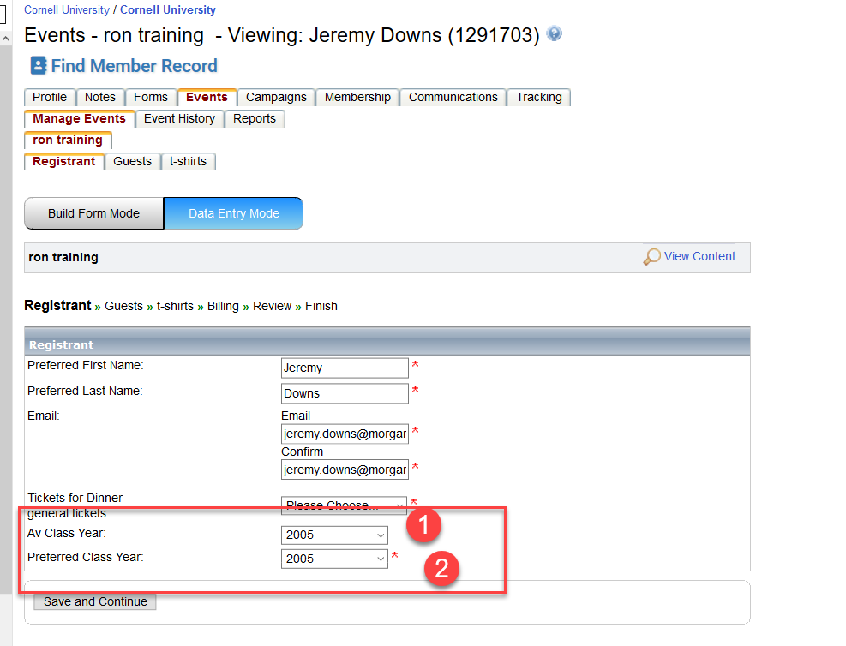

Both fields 1 and 2 have been placed on the form.

Field 1 (“Preferred Class Year”) has a couple of traits:
  - It is prepopulated from PeopleSoft when used in conjunction from an email originating from iModules and the event is configured for prepopulation.
  - It will be blank if the event is launches as a cold page.
  - An interesting and curious display name (that is something we may address in the near future).
  - It is not required.
  - Any values changed in here will be fed back to a PeopleSoft report where the Data Operations folks on the 4th floor MAY (or MAY NOT) change and update PeopleSoft to reflect the values entered by the alumni.

Field 2 (“Preferred Cornell Class Year”) has a couple of interesting traits:
  - It is prepopulated from PeopleSoft when used in conjunction from an email originating from iModules and the event is configured for prepopulation.
  - A more intuitive display name.
  - It will be blank if the event is launches as a cold page.
  - It is required to be entered when placed on a form but does have an option for N/A
  - This field is not fed back to PeopleSoft so an alumni updating this would not see the change possibly reflected in PeopleSoft.

Most importantly there is rolling associated with Field 2 (“Preferred Cornell Class Year”) for Young Alumni. So you can do things like make a ticket price only accessible to Young Alumni.

Create the ticket field.
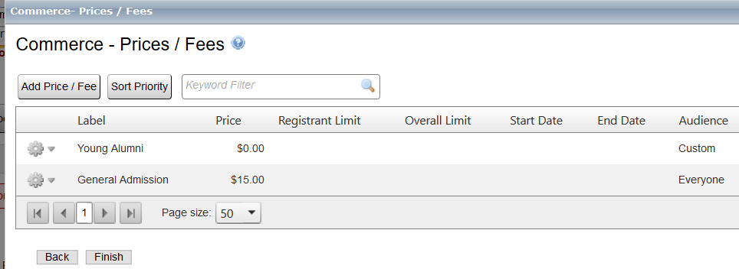
And set that price to be rolled to a traditional Young Alumni.

So for the examples above, I am not a big fan of field 1.

However, there is another field 3 that could also be used.

When adding an existing field you can also not select the quick field list, but instead select Profile > Edit My Info > Academic

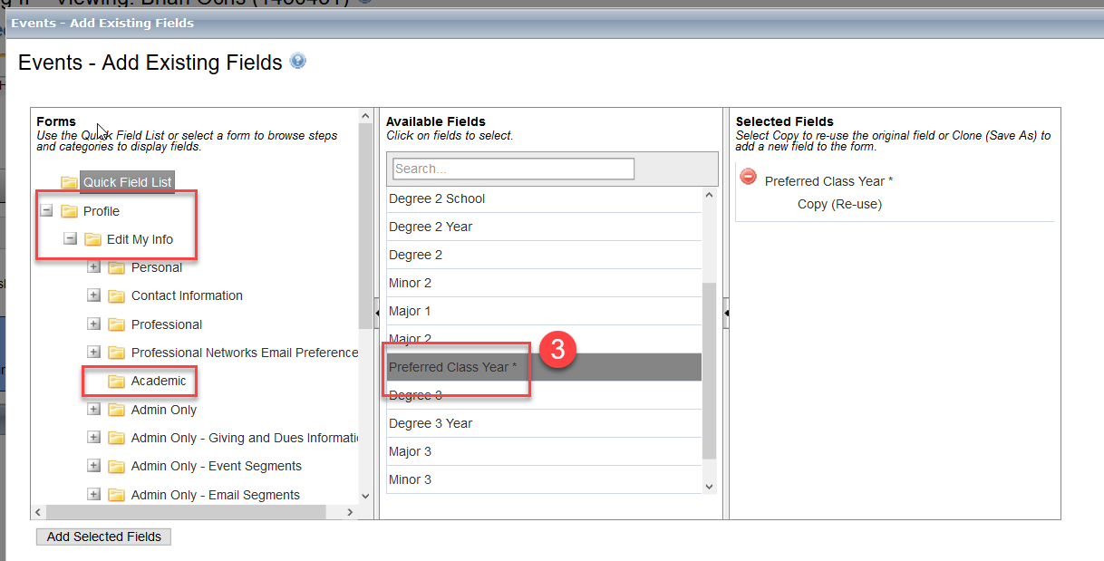
Select the Preferred Class Year field, which will be field 3.

This field has all the same properties as field 1, however it has a much better name when displayed.

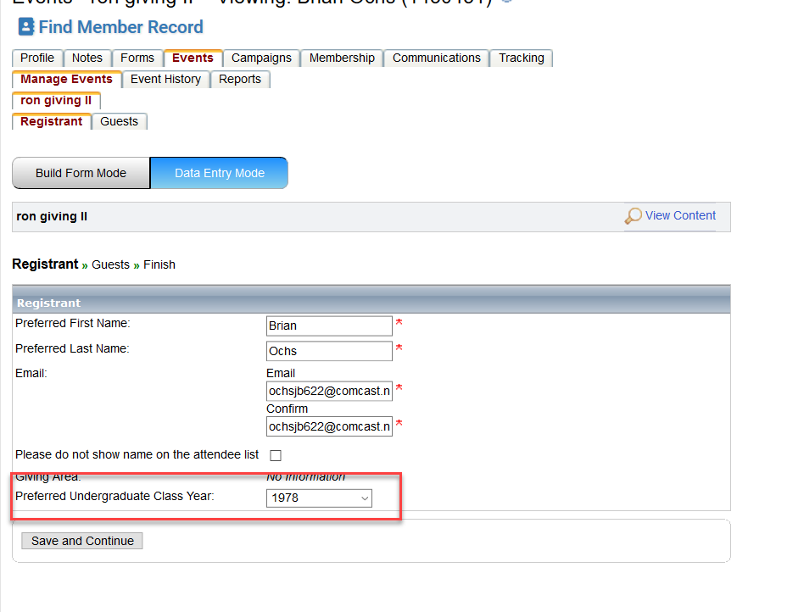

So in the end my suggestion is to deploy either field 1 or field 3 depending on what you need.
There are a lot of options with class year, If you have more questions just contact myself or Leigh
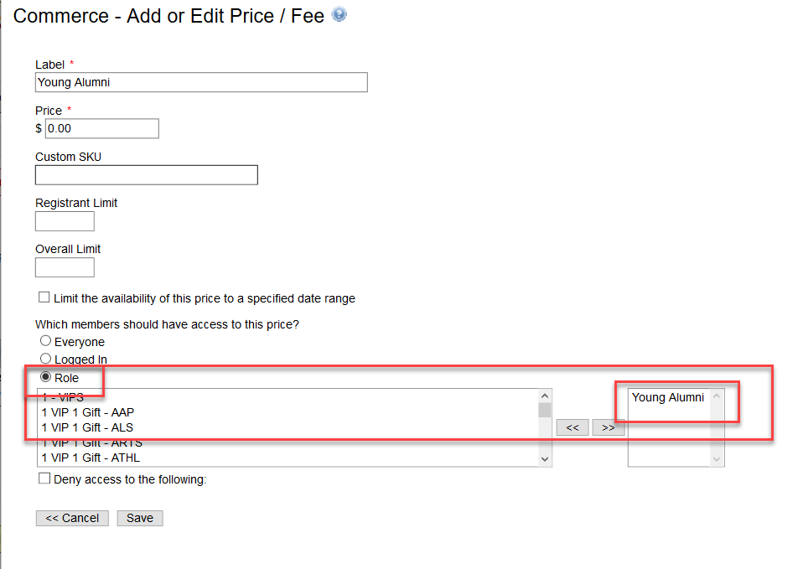

Regardless of if the Field 2 (“Preferred Cornell Class Year”) is prepopulated or entered by the registrant, the young Alumni pricing will only appear if they are within 10 years of graduation.

One note is that you should ALWAYS test rolling first to ensure it works. Feel free to contact Leigh or myself to discuss testing options.

