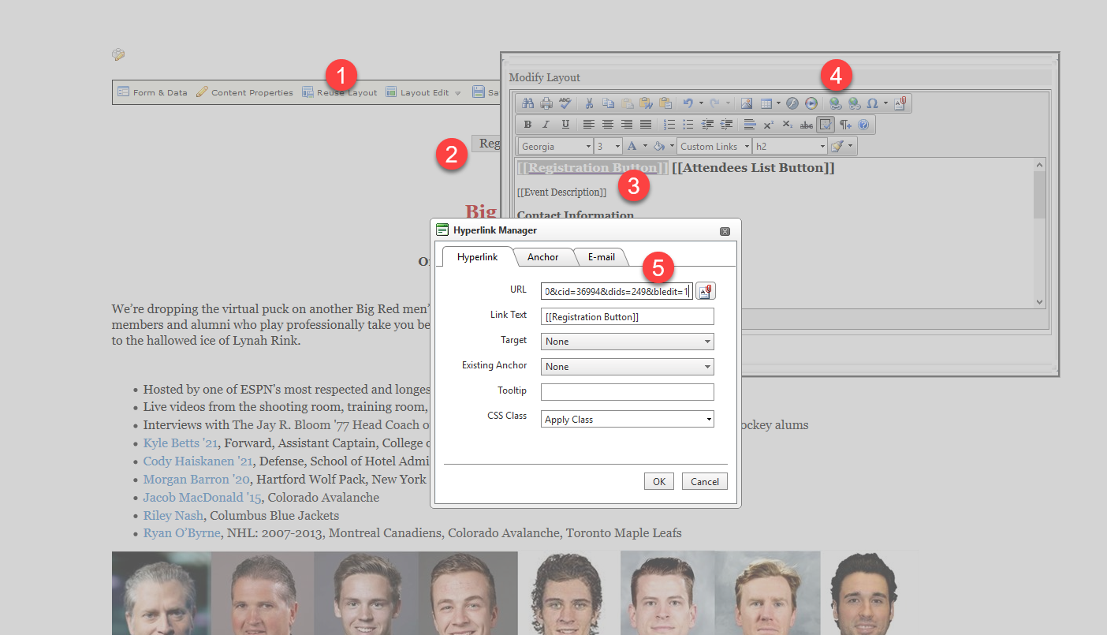

- Open landing page and select layout editor
- Select Registration Button line
- Select Registration Button field with brackets
- Select hyperlink tools
- Add in &dids=nnn&bledit=1&sort=1

