Best Practice for iModules Event Configuration for Integration with the AAD Alumni.Cornell.EDU Events Site

Purpose of this design document:

This document intends to provide best practices for configuring an event in iModules. Following these best practices will provide for the best event presentation in the AAD site (https://alumni.cornell.edu/event/) under the events tab. These practices should be especially followed for public events.
Failure to follow the practices may result in an event that does not appear in the AAD site or may have incorrect information. It is suggested that private events also follow the practices as a whole in case the private event is made public later.
The alumni.cornell.edu site utilizes an integration to pull event configuration data from iModules before 8:00 am Monday through Friday (Cornell Working Days). When an iModules event is created or modified, the event builder should verify the following morning that the event is correctly presented on the AAD site.
If an event does not display as intended on the AAD site, verify that practices were followed. If there are still questions regarding the event, contact Ron Babuka or Leigh Stock with the event name, location, and start date.
This is a living document and will be updated periodically.

Using this design document:
This document will show two images
- An iModules edit page
- An AAD web site for comparison.
Fields on the iModules image will be labeled in red. The corresponding fields will be shown on the AAD page will have fields displayed in black.

AAD Site User Experience:

From the AAD site, a person can search for an event:
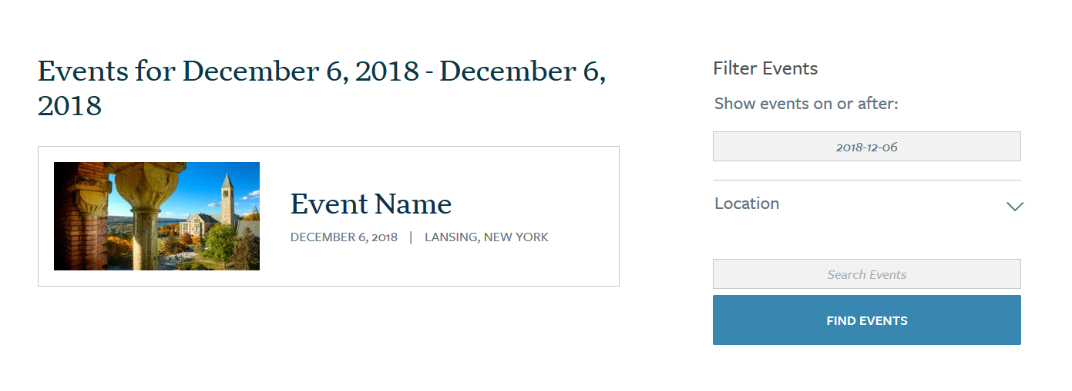

To access more information on the event, they click on the event box to launch an AAD event detail page:
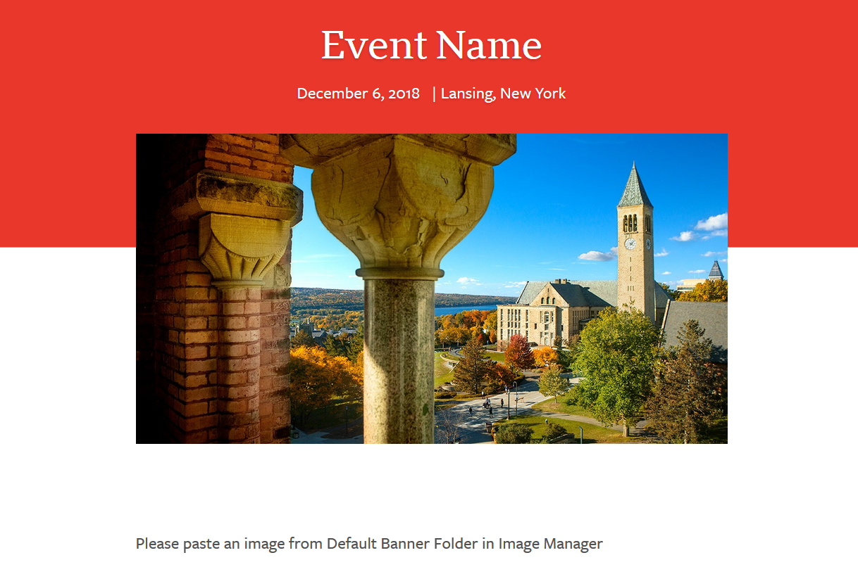

If the iModules event has an active registration page, a registration button will show below the event name and date.

Selecting the button will take the user to the iModules landing page. The button cannot be changed.

Configuring an iModules event to integrate with the AAD web site
iModules Edit Page:
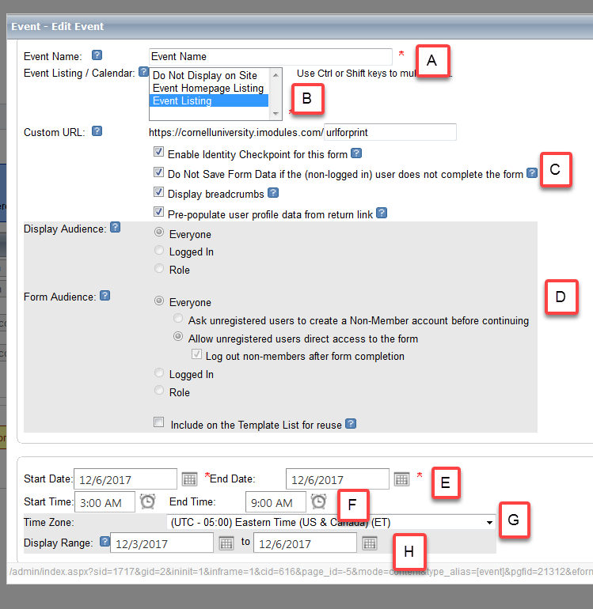
iModules fields:
Field | Field Name | Use
A | Event Name | The event name should have meaning. Do not use things such as netids, as this field will be shown on the iModules landing page and AAD site
B | Event Listing | Select “Do Not Display on Site” to have event NOT shown on AAD site (private). Select “Event Listing” to have event shown on AAD site (public).  Apply the private setting while creating the event and then switch to a public setting when the event is ready to be made public.
C | Identity Checkpoint and Prepopulation | Please check ‘Prepopulate’ if the event will be publicized by an iModules email. Please check Identity Checkpoint also. More information can be found at http://blogs.cornell.edu/imodules/home/event/managing-non-member-records/
D | Form Audience | This is the default setting for who can access an event form. If registrants are requested to log in to register for an event, reset Form Audience to match this setting.
E | Start / End Date | The start and end dates of the event.
F | Start / End Time | The start and end times of the event. If the event is a one-day event, fill in the start and end time. If this a multiple day event, leave blank.
G | Time Zone | The time zone for the event will default to EST. For both physical events and webinars, this should be the time zone for the location that that is hosting the event.
H | Display Range | The date range when the iModules landing page is visible. This date has no impact on the AAD web integration.

AAD Search Website:

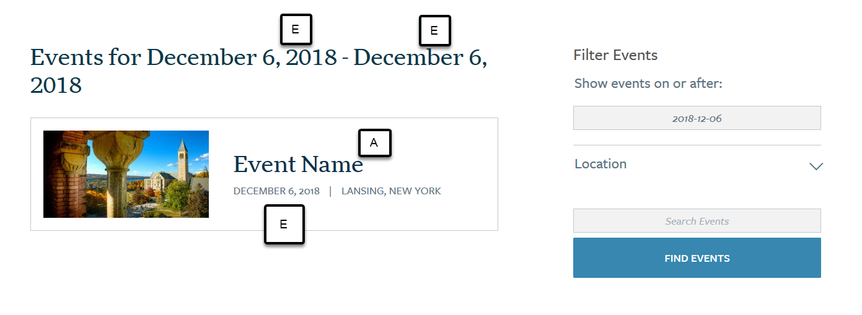
AAD Event Detail Site:
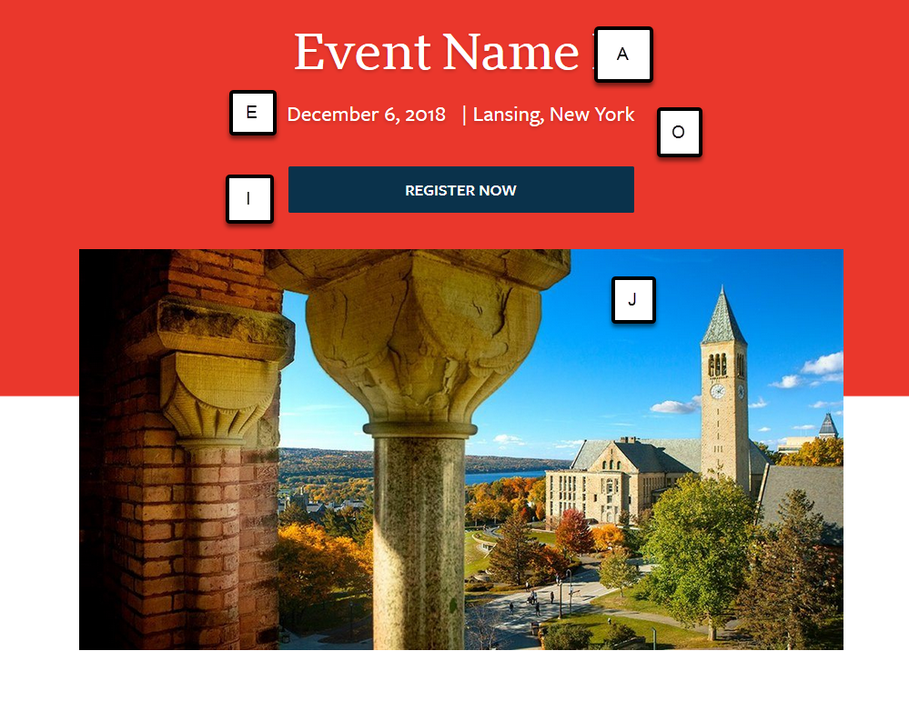

iModules Edit Page:

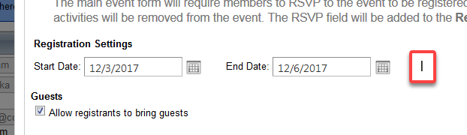

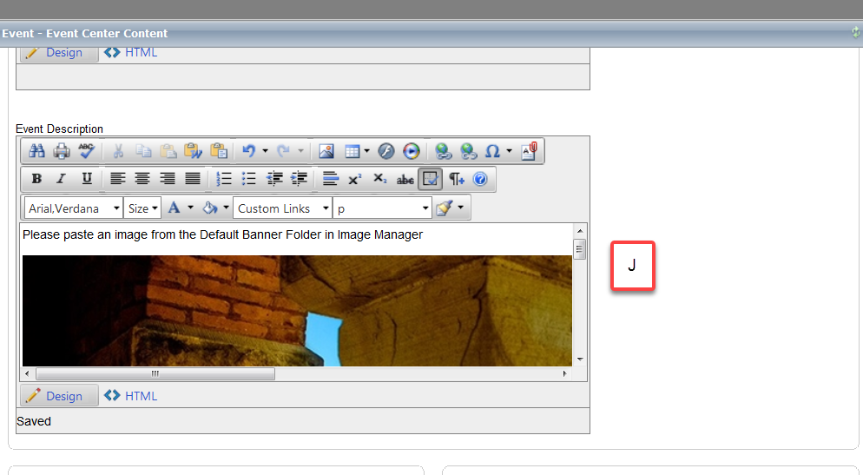

iModules fields:
Field | Field Name | Use
I | Registration Settings | The start / end date control when the registration button will appear on the AAD web site. Selecting this button will launch the iModules landing page.
J | Event Description | Content from the event description block will be presented on the AAD site. See the special guidelines for this area.

AAD Event Detail Site:

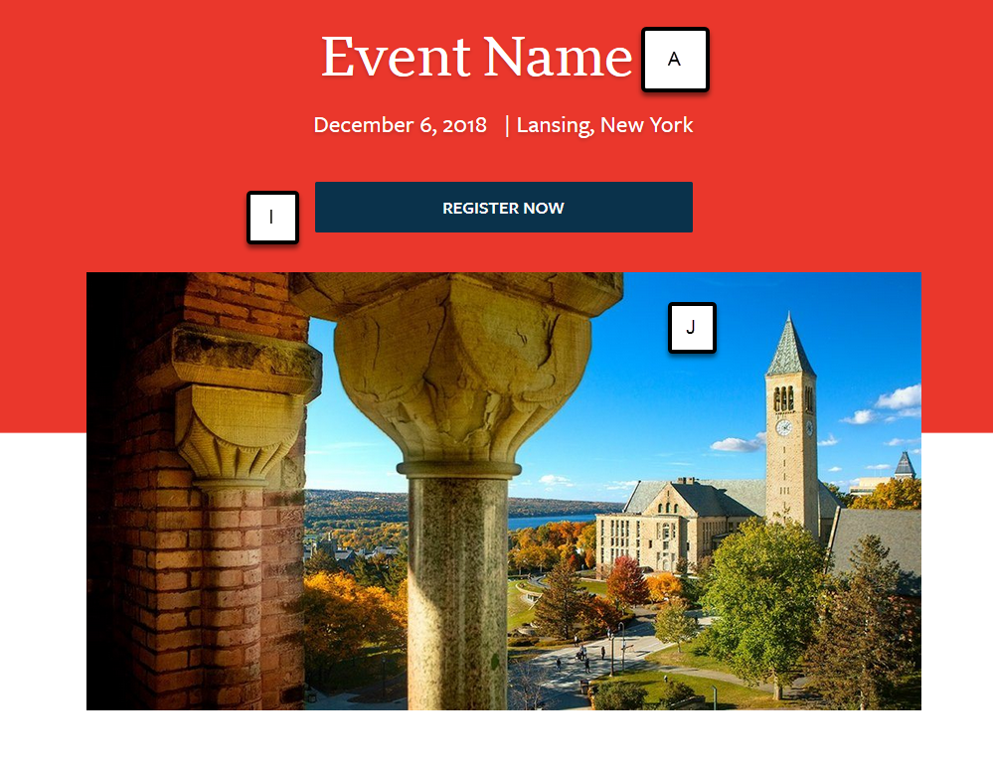
Extended rules for (J) the iModules Event Description Content Block

Images
The first image is stored as a ‘featured image’ for the AAD web site. This featured will be the image displayed on the AAD web site. The first image must be approx. 840 x 560 pix (72dpi) for optimal quality on the site. If you are including square images or smaller images, you will need to add an 840 x 560 pixel (72 dpi) image BEFORE the other images in the event description. If this is not done, the AAD integration will most likely stretch and manipulate the image, adversely affecting the appearance on the AAD website.
Anticipating this, the web team will be making several suggested banners available in the Image Manager in the “Default Banner” folder.
If a feature image needs to be removed, contact the Web Services and User Experience (WSUX) team to remove the featured image BEFORE changing the image in iModules.
A tool is provided thyat can help manipulate images that will create a nice banner image.
While iModules allows various image types to be used, use JPG, PNG (no transparency) or GIFs image types.

Text
When adding text, only the defaulted text (item 1) provided by iModules. You may use bolding and italics.
When using headings (item 2) use only H2 through H6 and do NOT Bold or italicize. You will see in the example that I have heading 2 used and then when I want to further head, I can use the next increment to for proper heading flow. I can also use the same heading level if appropriate.

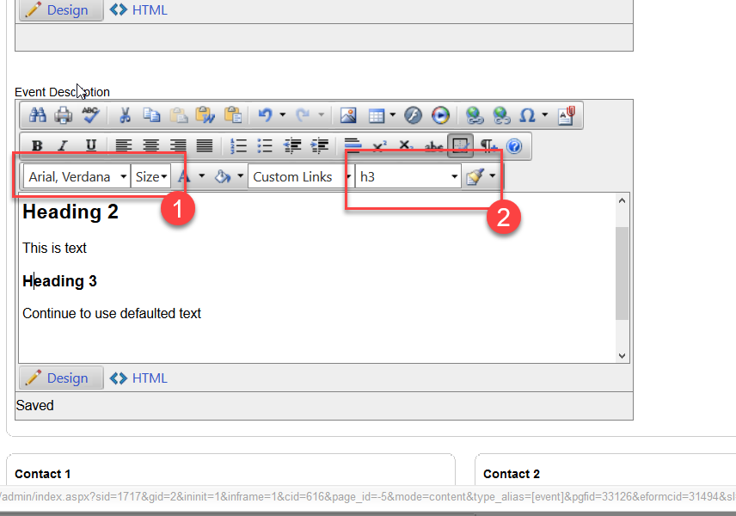

Do not use background fonts, colors and do not underline.

Online Events
The word “webinar” should be included in the title. Searching on the text ‘webinar” will result in the event being returned. The physical host location for the webinar should be entered in the location. This will ensure that the correct time zone for the webinar will be assigned. Avoid using the words “online” to describe the event as that would be confused with any other use of the word on-line (such as “online payment”).

iModules Edit Page:
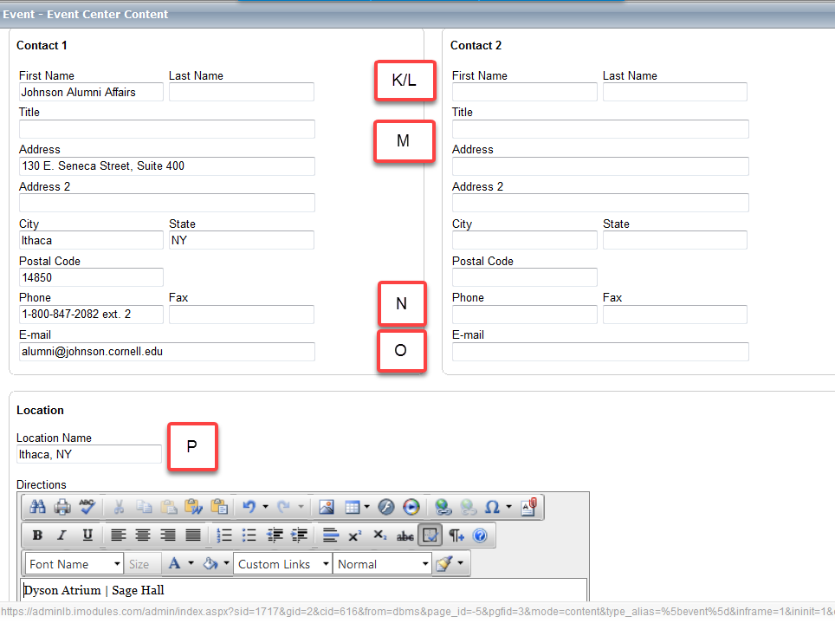
iModules fields:

Field | Field Name | Use
K/L | Contact 1 First Name/Last Name | Contact first name and last name for both contact 1 and 2. The integration will concatenate both names together including blanks
M | Title | This field can be used for a title or an text that can follow a contact name
N | Phone | Contact phone number for both contact 1 and 2.
M | Email | Contact email for both contact 1 and 2.
O | Location Name | This is the location of the event. Event Locations in the US should be city, two character state code. Generic locations such as “Germany” will find all events with a location of “Germany” or German cities within 150 miles of the center of Germany.  If an event is online, enter the physical host location for the events. This will ensure that the correct time zone is correctly loaded.

The first name, last name, and email fields must all be populated for the integration to populate the contact information to the AAD website.
Note: Address, Address2, City, State, Postal Code and Fax do not integrate from iModules to the AAD web site.
It is suggested that if you any one of the K through M fields, you should populate all of the fields.

AAD Event Detail Site:
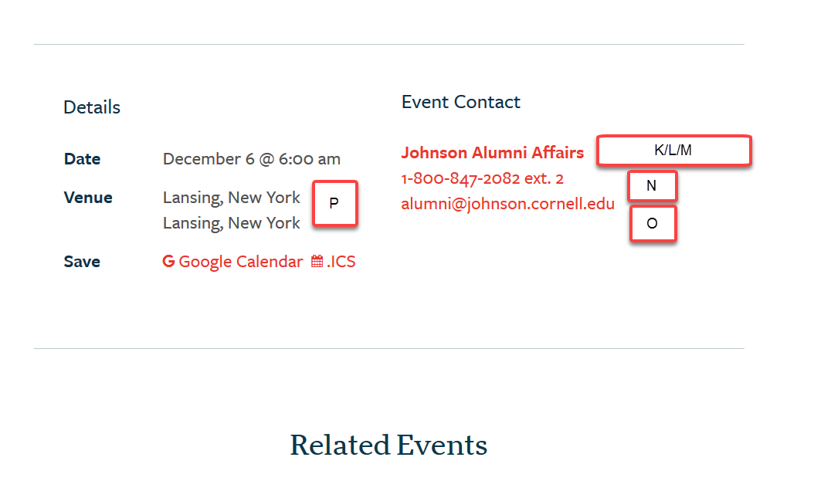

Deleting events:
If an event needs to be deleted, mark the event private to remove it from the AAD web site. Wait one business day and verify that the event is no longer on the AAD website and then delete the event in iModules.

