How to add a non-member record. This is for a person that we have no info on, cannot find but want to register in iModules.

- Go to link - YOU MUST ACCESS THIS LINK IN PRIVATE MODE ON YOUR BROWSER
http://cornelluniversity.imodules.com/NonMemberRecord
- Enter information for new person
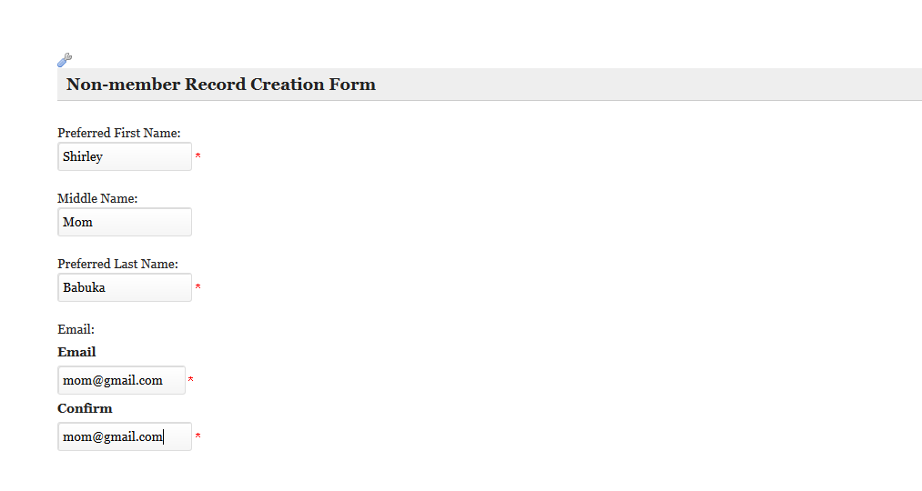
- Search and find

