Unregistering an attendee from an event.

Find the event, select the cog to the left of the event, and select “Submission/Adjustments”

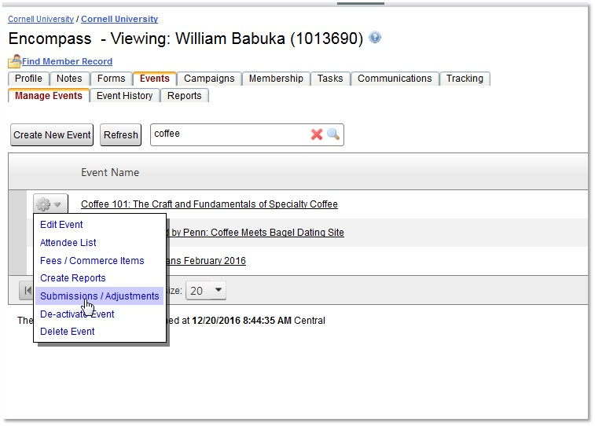

Find individual to deregister, select the cog to the left of the event, and select “Adjustments”

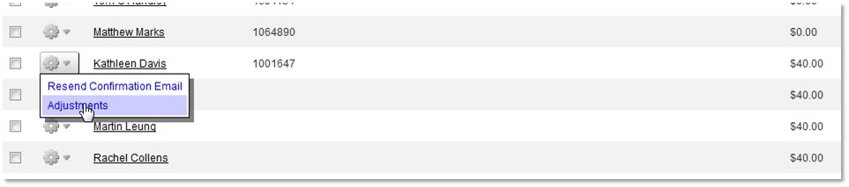

Select the Adjust button

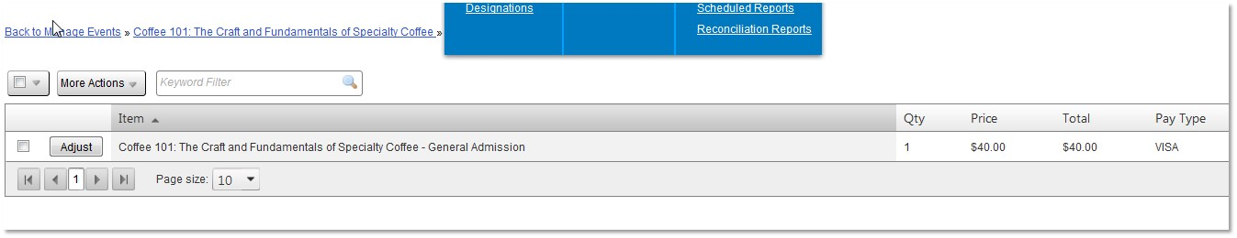

Select ‘Confirm’

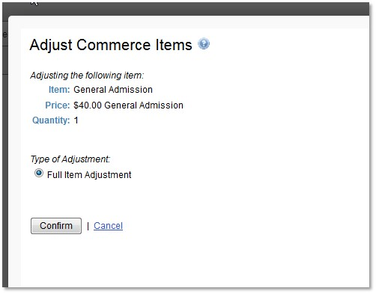

The individual is unregistered

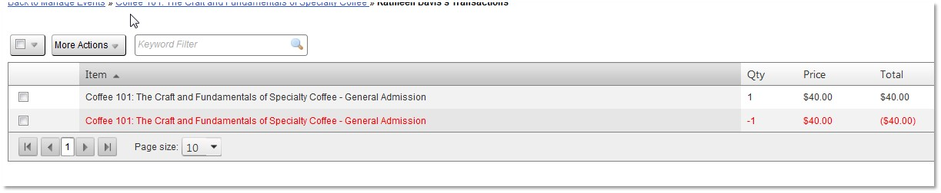

The refresh button may need to be selected, if the counts do not change.

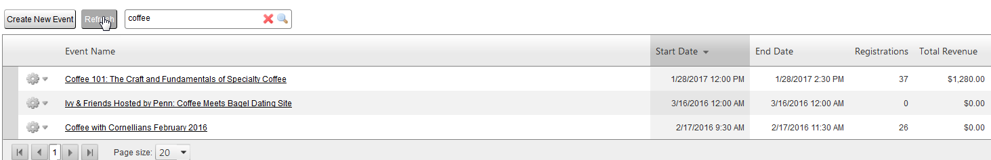

If the person has paid a registration fee, you also need to copy and send a screen shot of their confirmation to send to Kathy Davis for a refund.