Customizing an Event Attendee List

Access the event tool, select the event, and “Attendee List”
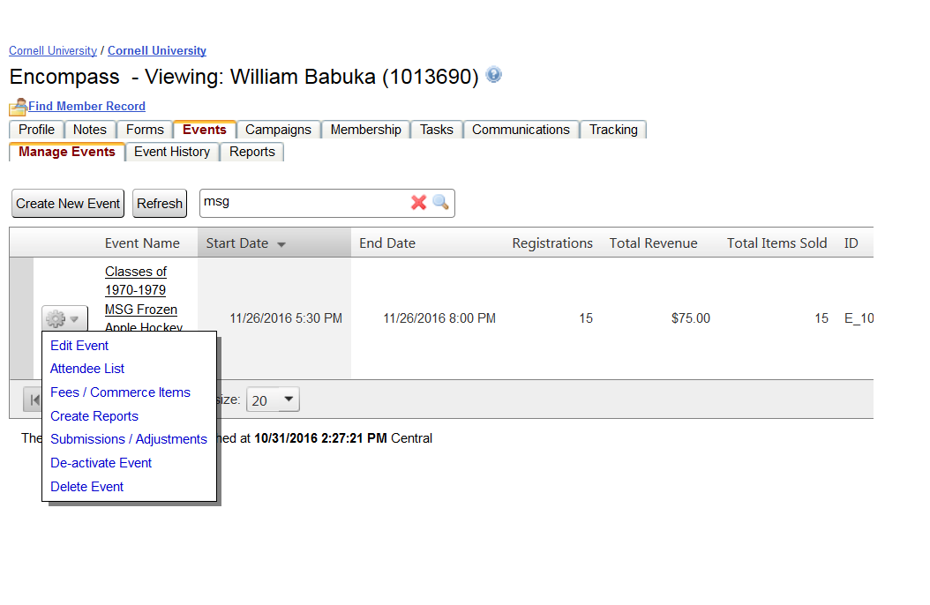

For the view that alumni would see, select the Member View

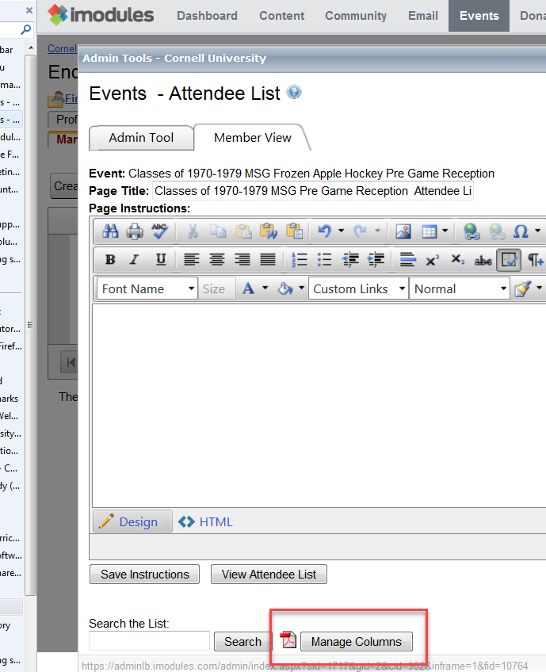
Select the Manage Columns button

Navigate the “Add Fields”, to find the event and page (step) where the field lives

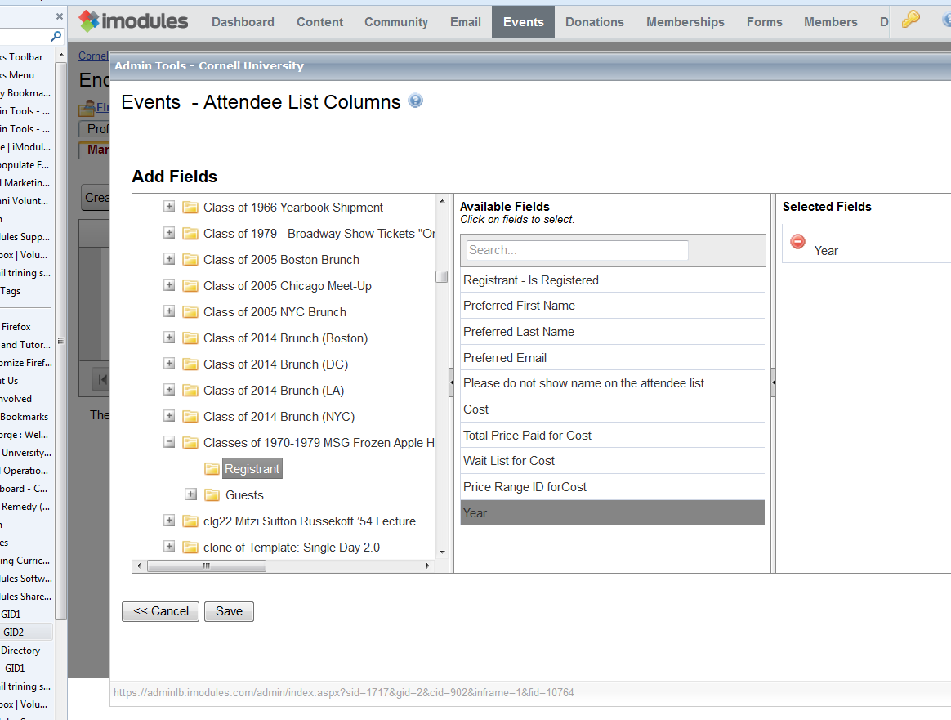

Select the field to be displayed and save

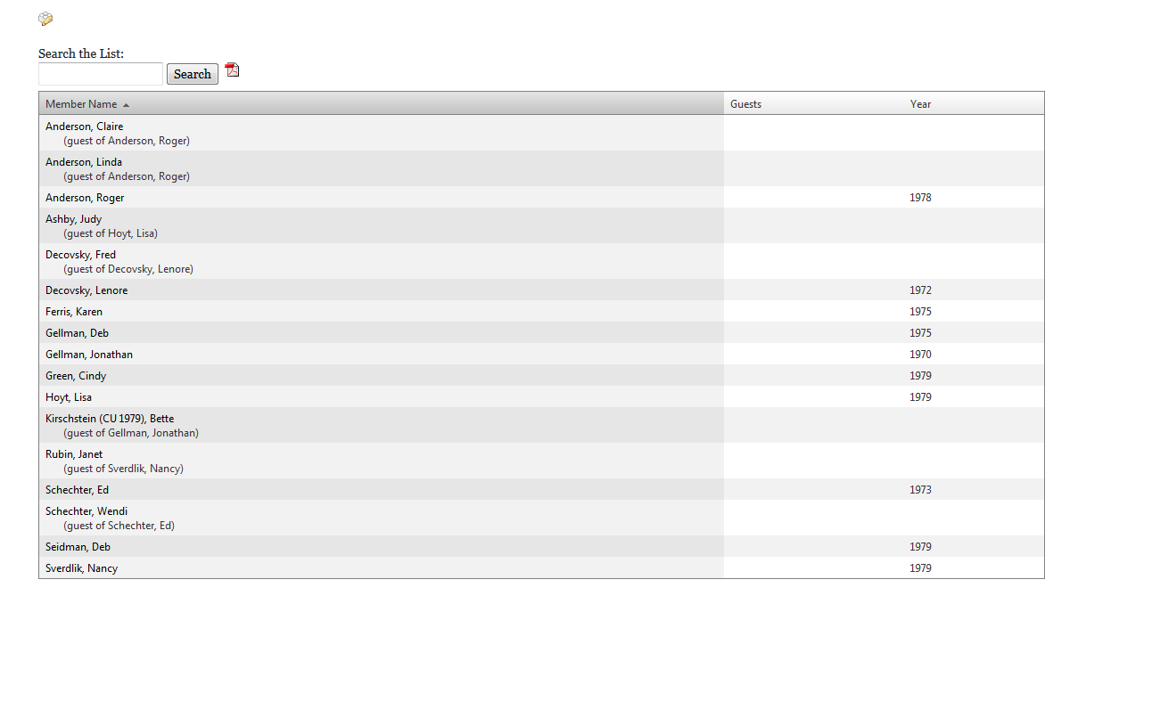

The “Attendee” list will show the added field.

