Steps for creating an e-mail.

Navigate to the Email tab, select “One-Time”
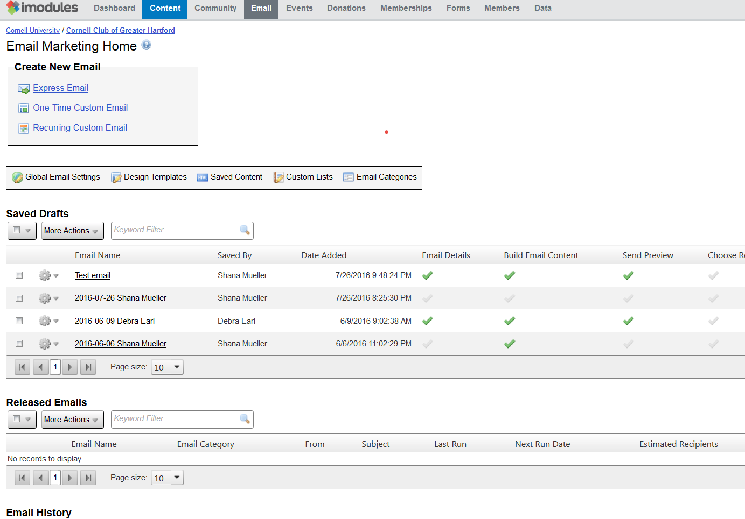

Step 1 - E-mail Details
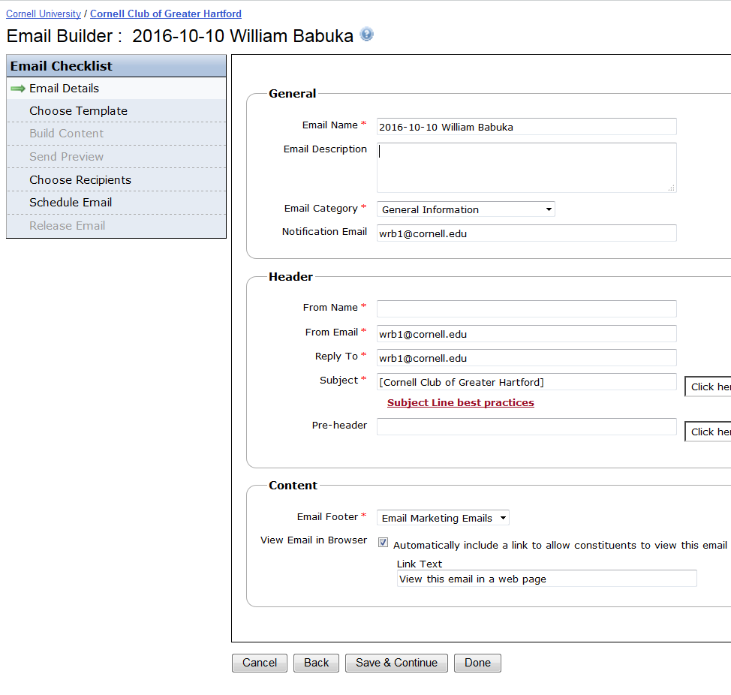

The first step in the process is to fill in basic information about the e-mail itself.

This window is broken down into three sections. By default, most fields are pre-populated with your email address and name.
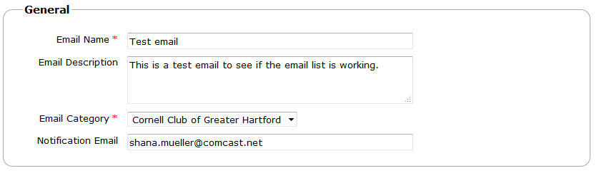
Email Name: | Enter a name describing the email. You can also include the date, to help other administrators or yourself to retrieve this email easily. This will not be the subject line of the email.
Email Description: | Similar to the name, this is not seen by recipients, and is up to you to decide what information you want to list here.
Email Category: | Choose the appropriate category from the dropdown list. The category is linked to the opt-out option. Recipients will be able to unsubscribe from emails of this category from your community, or from all emails from your community with an unsubscribe link placed at the bottom the email. It is suggested to select the class/club name category and refrain from using the ‘General’ category.
Notification Email: | Email address to which a notification will be sent when the email has been sent to recipients. This field is optional.
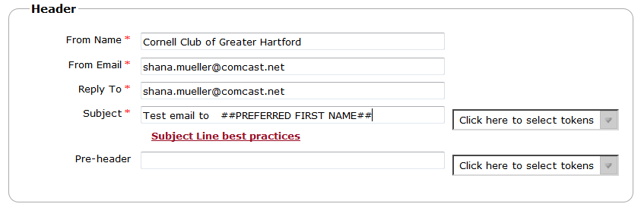
From Name: | Name displayed as sender when the message is received by the recipients. It is better to have the From Name and the From Email reference the same person
From Email: | Email address displayed when the message is received by the recipients.
Reply To: | Email address that will receive replies when recipients use the Reply to function.
Subject: | Contains the name of your sub community in brackets, by default. The brackets will be displayed, so you will need to remove them before sending. You can create your own subject line (i.e. Message from the Cornell Club of Greater Hartford) or you can use tokens from the dropdown list. Tokens can be used but it is suggested to limit them to Preferred First Name and/or Preferred Last Name. Please contact the iModules support team if you have more questions regarding tokens.
Pre-header: | Short summary of the email that is used by email clients and mobile phone apps when displaying the delivered e-mail. If let blank, the beginning of the message text will be used.
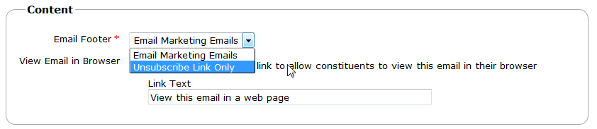
Email Footer: | “Unsubscribe Link Only” will uses a one line footer with an unsubscribe message.  “E-Mail Marketing Emails” will include an unsubscribe message along with the Cornell AA&D branded footer. Either option is applicable for an e-mail.
View Email in Browser: | Adds a link at the top of the email to allow recipients to display the email in their Internet Browser.  If you leave the box checked, you should setup a Pre-header (see above) with custom text.  You can also choose the text displayed as link to the browser version of your email.
Once you are done, click Save & Continue to move on to the next step. If you click Done, your changes will be saved and you will be redirected to the Email Marketing Homepage.

Step 2 – Choose Template
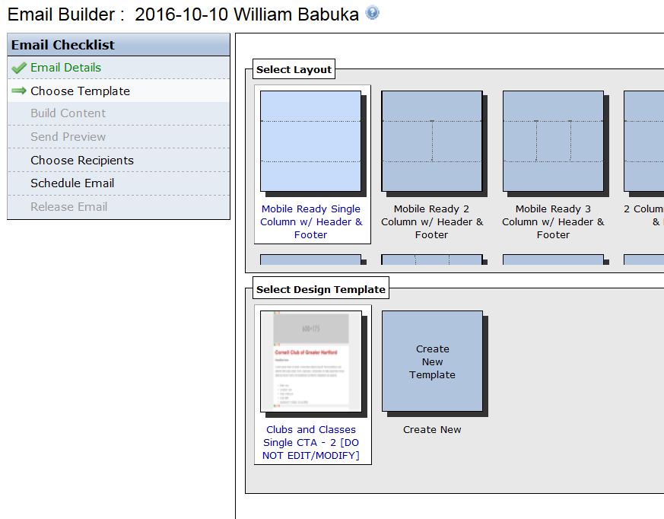

All colleges are provided with a multiple template that all have “DO NOT EDIT” in the name. These should be used as it will be maintained and validated for use with most mail applications and providers.
Select the Layout first, then the template.
Select “Save & Continue” to move on to the next step.

Step 3 - Build Content
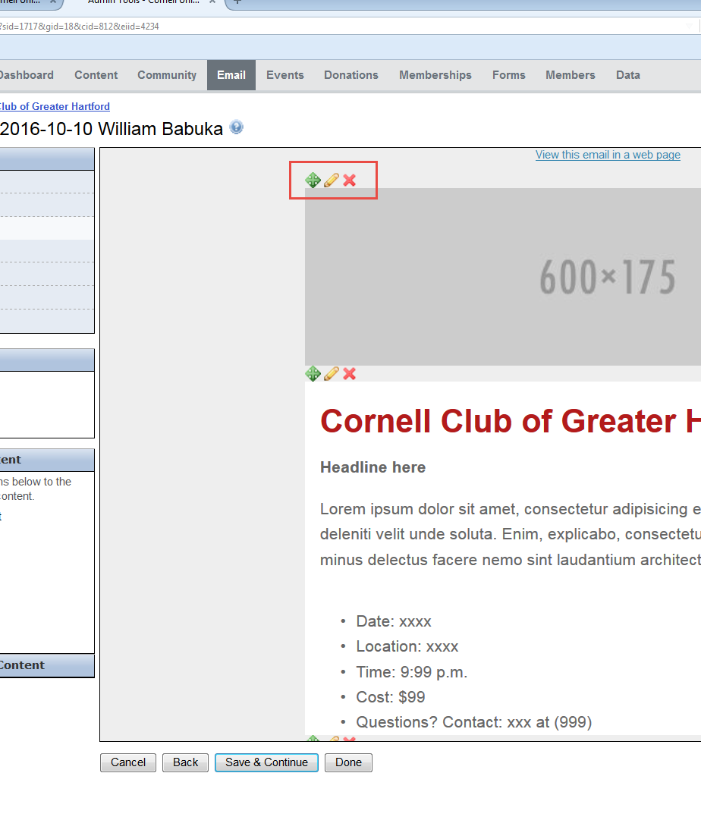

Once your template is loaded, you can start building the content of your email.
You can rearrange the blocks of content with the icon . You need to click and drag the block of content to its new position before releasing the mouse button.
You can delete a block of content with the icon .
To edit a block of content, click on the icon . In the pop up window use the icon to edit the default version of the content previewed on the right. You should only use the Default for everyone version of the content, as displayed on the left

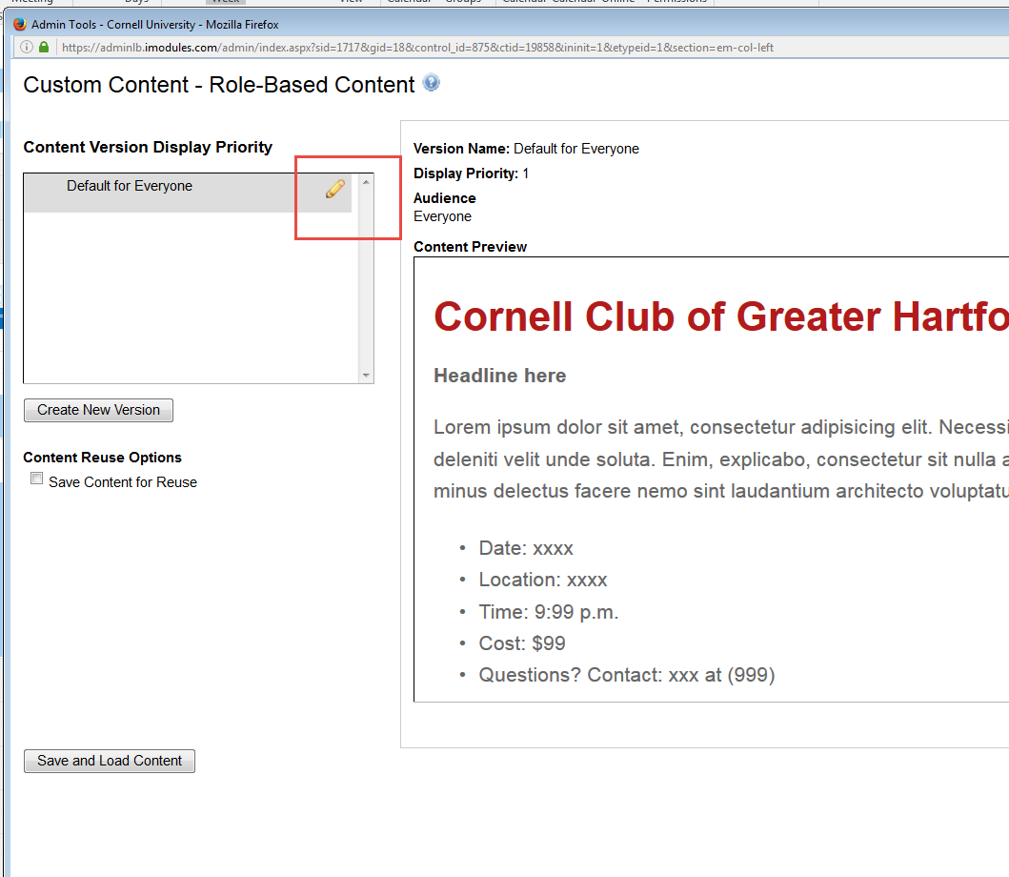

You can now start by modifying the content.

The optimal method of adding content is to enter manually into the content window. If you are going to copy content from another application (Mail or Powerpoint, ect.) you will want to copy the text into a text editor such as Notepad or Textpad. Copy from the text editor into iModules should remove any application specific formatting. The content editor tool also provides a tool icon to paste that will allow you to past in a Word document and remove any background formatting.
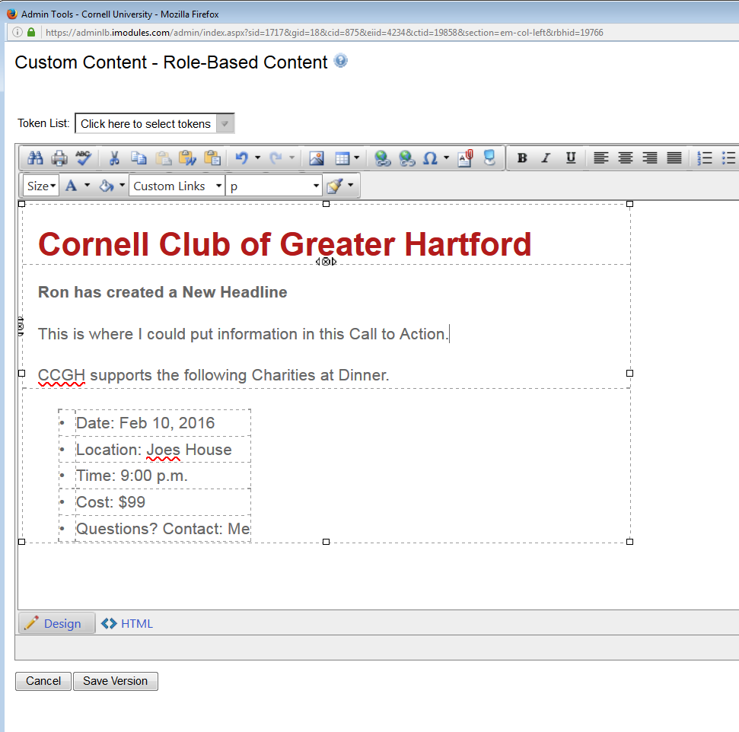

Tokens can be added for personalized (just as was done for the subject) hand as suggested they should be limited to names. Please contact the iModules support team for additional information on tokens. Text can be modified as needed. Table formatting (the dotted lines) can be deleted as needed.
The Hyperlink Manger must be used for inserting hyperlinks into the body or icons on an e-mail.
The Image Manager should be used to store and place images. Images on e-mails should not be copied directly into the template.

Select an image form your own device then upload
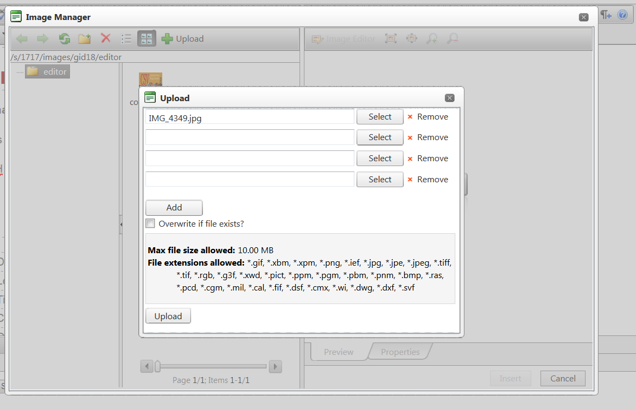
Select Upload
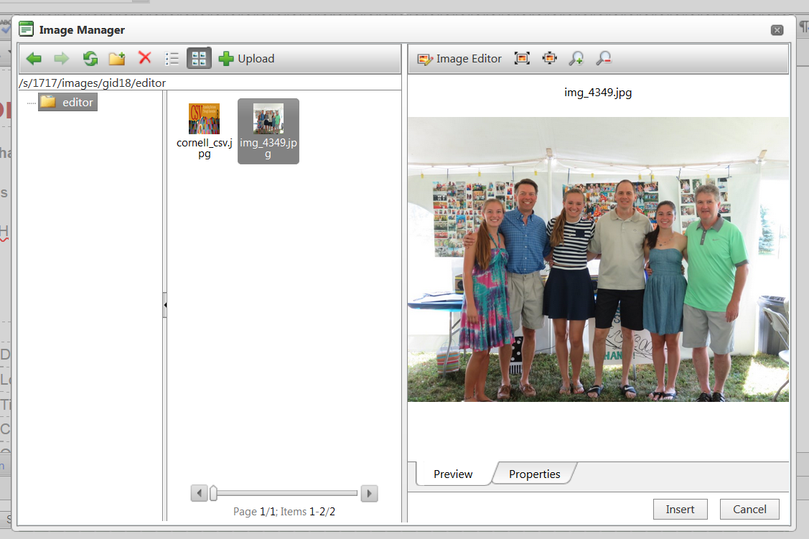

Images will then be stored, and can be inserted into the e-mail.

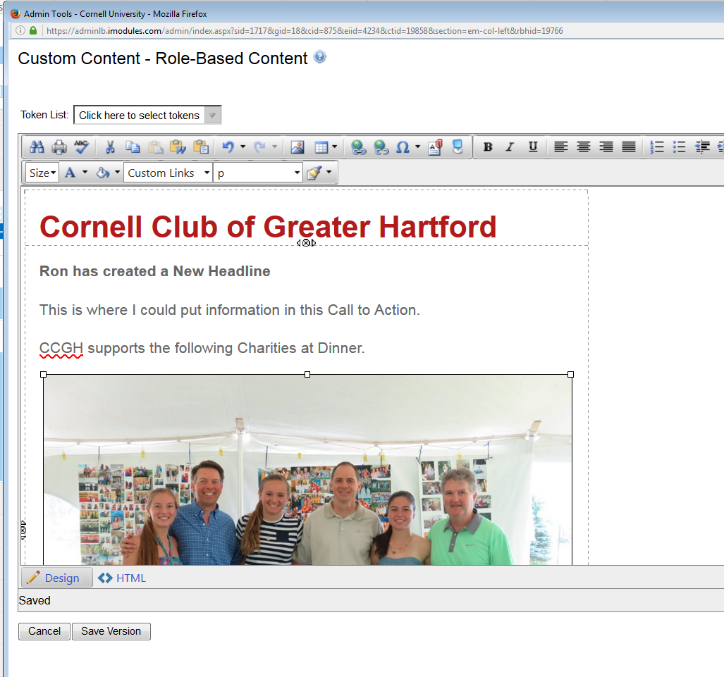

Save the version

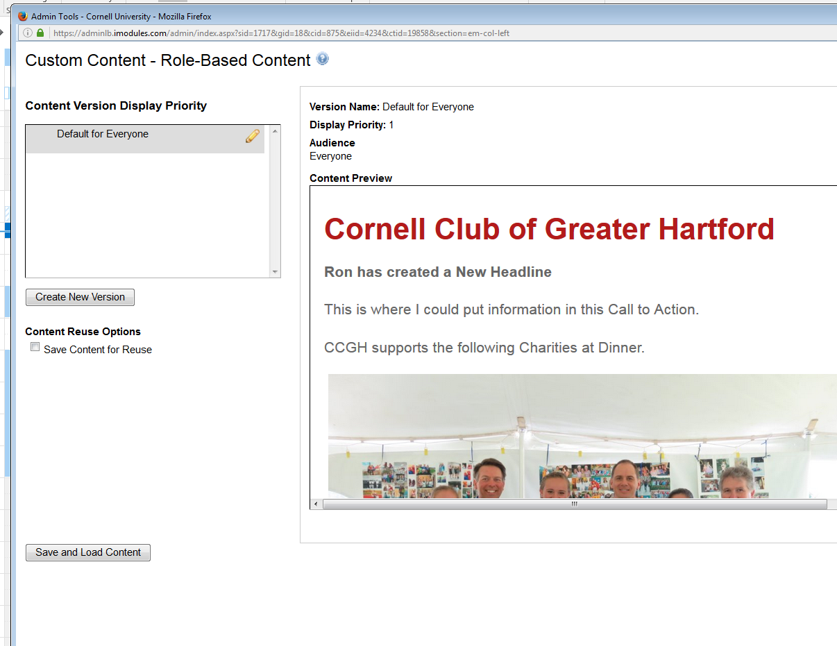

And then Save and Load Content.

The e-mail can be previewed when in a completed state. The previews can be sent to numerous e-mail addresses for validation and signoff.

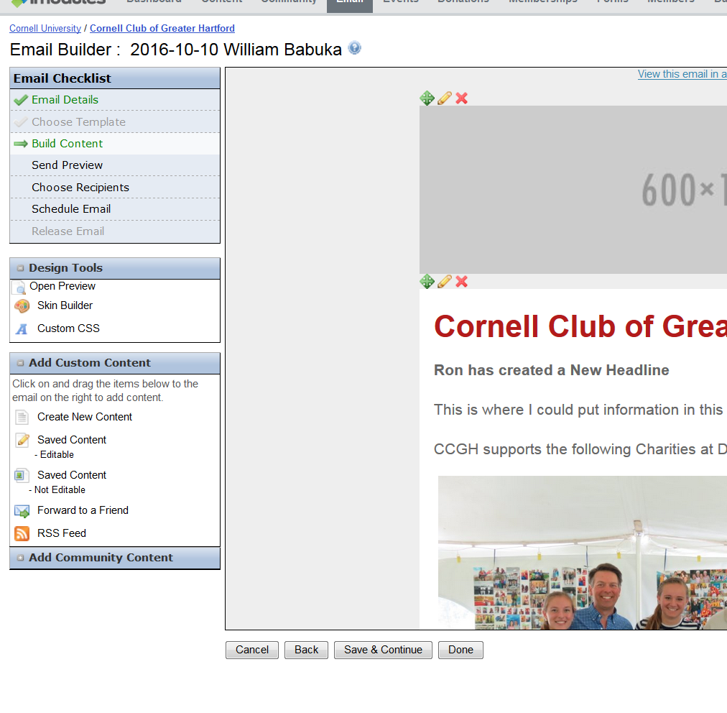

By selecting Save & Continue, the e-mail tool will advance to the Preview step.
E-mails must be previewed before they can be e-mailed.
Often if an images, hyperlink, or content has be improperly copied into an e-mail, the preview will fail.

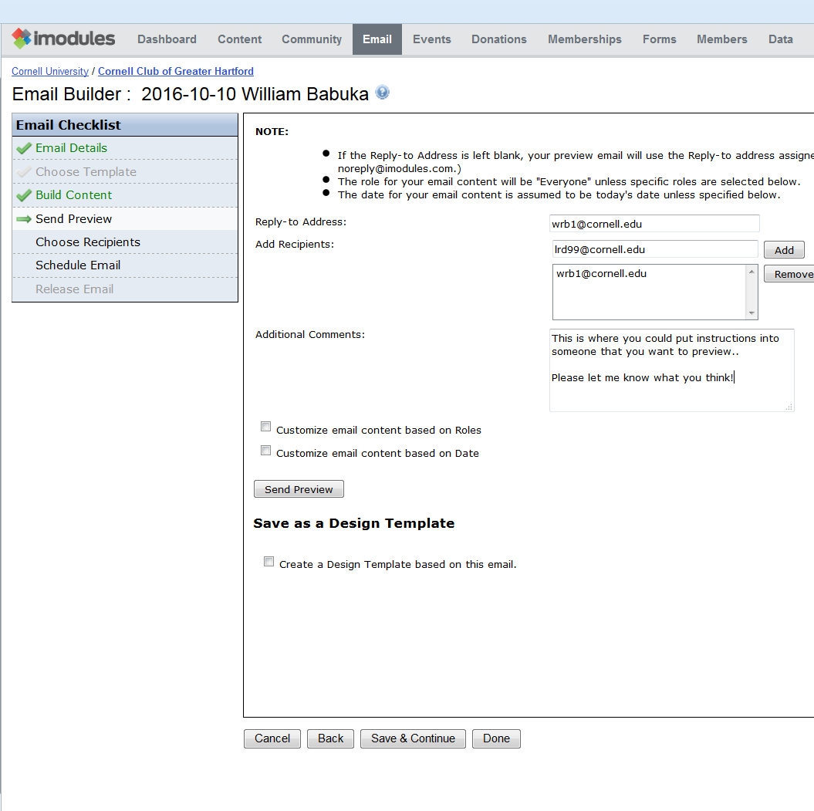

Reply-to Address: | By default, when replying to this preview email, you will reply to the address specified in the Email Details. You can change this here to enter a substitute email address that will only be in effect for the preview email.
Add Recipients: | By default, your email address is already entered as recipient of the preview email. You can add more recipients by typing in their email address into the box, then clicking Add .
Additional Comments: | If you choose to enter comments, they will appear directly before the body of the email you are sending, stripping out all formatting of the comments.
Create a Design Template: | It is not suggested to save an e-mail as a new template. Any new templates may not be able to be supported by iModules and the AA&D iModules support team.
If you realize that your email needs more work, you can click on the “Build Content” step in the Email Checklist. Every time you make a change, you should send a new preview before releasing the email.

Step – 4 Select Recipients
(note for this documentation I am using a different e-mail)
The primary suggested manner of selecting alumni’s for mailing is to use the process described below. This will utilize the power of iModules. We do NOT suggest using list of e-mail addresses unless there is a population of e-mail recipients who are not stored in iModules.

At the “Choose Recipients” stage of the process, select “Data Viewer”

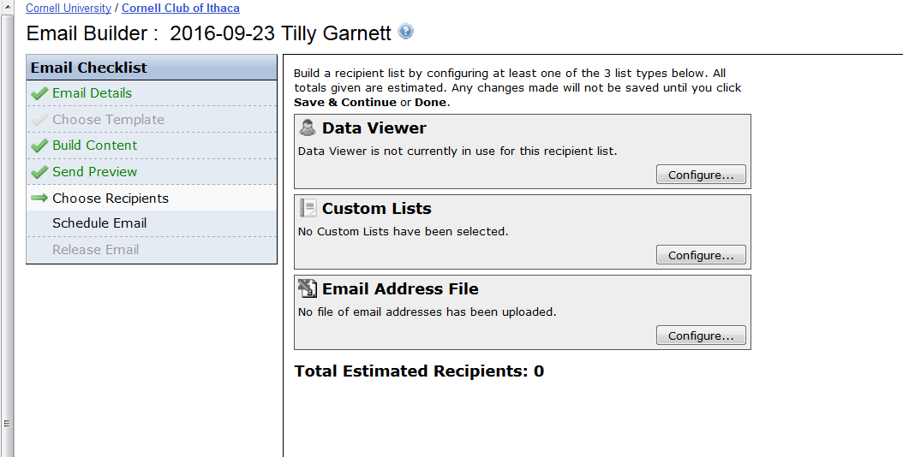

Using list of emplids from sources such as Brio:
Select Data Viewer Configure
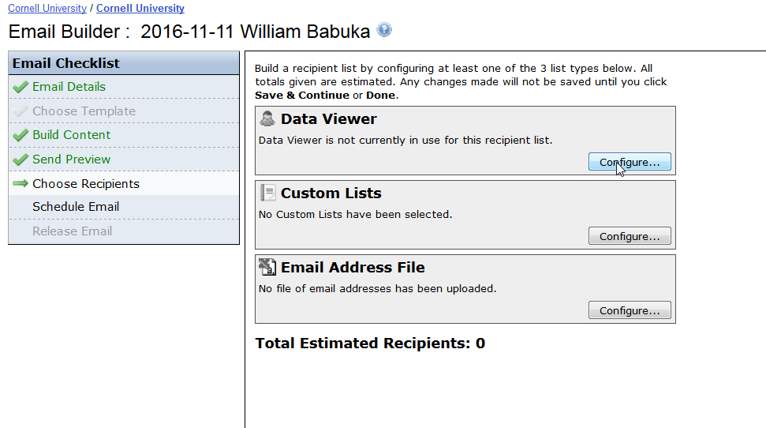

A .CSV file of emplids was generated and stored in a location that can be easily browsed.
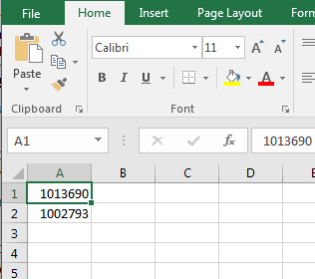

Select Upload button, then Browse button to find a CSV file of emplids/common-ids
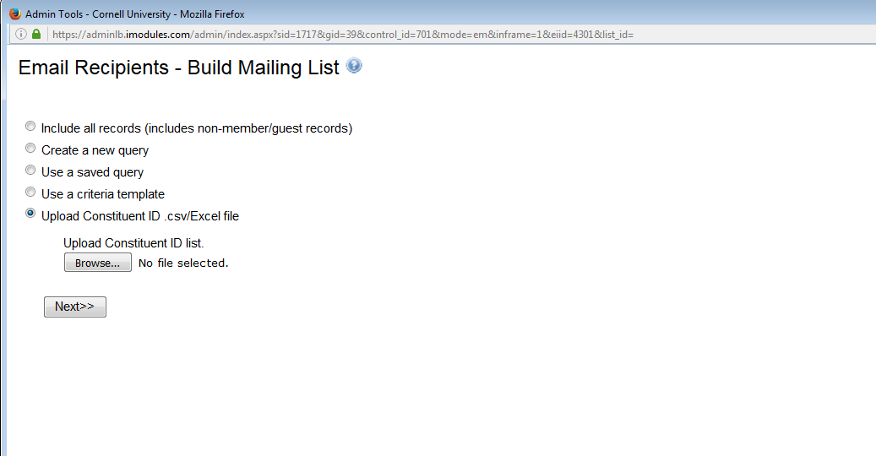
The count of emplids to be uploaded will be displayed.

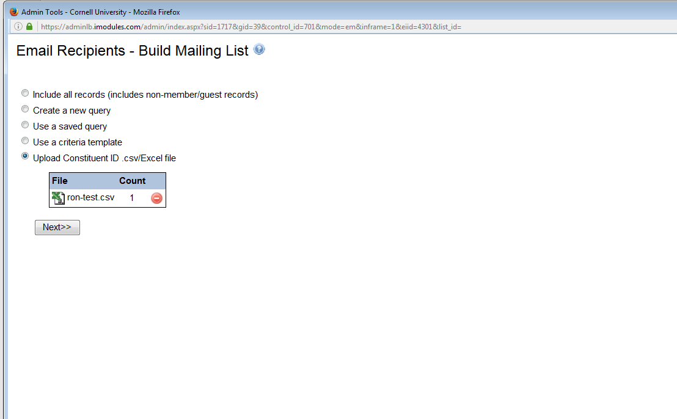

The count of ‘mailable’ recipients of the list will be displayed.
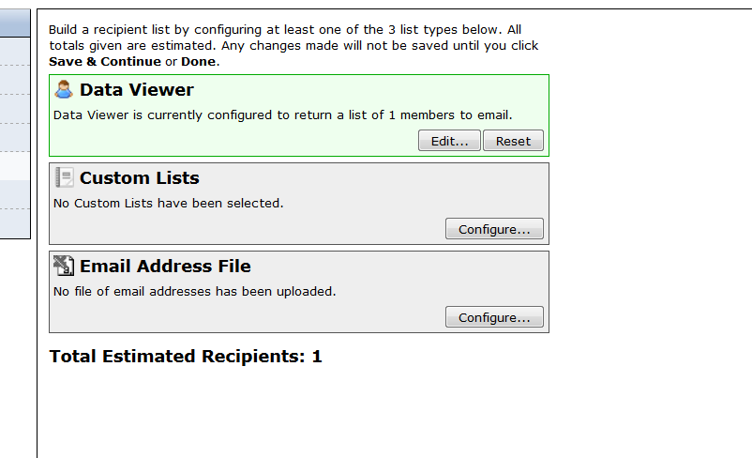

Using the Query Tool to select e-mail recipients from the iModules database:
This technique is most often used by Clubs and Classes. The example that follows is used to select alumni members of a club.
Select “Create a New Query” (one you have created and saved a query, you can select “Use a Saved Query” in the future.
Select Next

Select “Club Name” from the Quick Field List
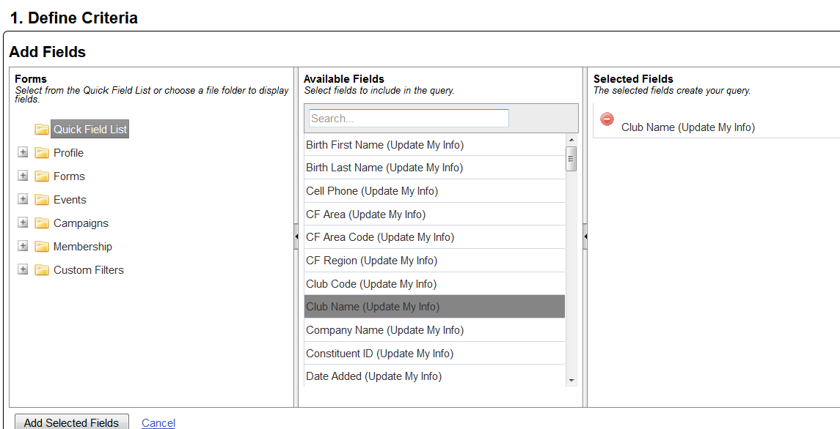

For Club emails, select the “Club Name” field. While it is not 100% necessary, it is suggested as a good practice.
For Class emails, select ‘Preferred Class Year” field instead of “Club Name”
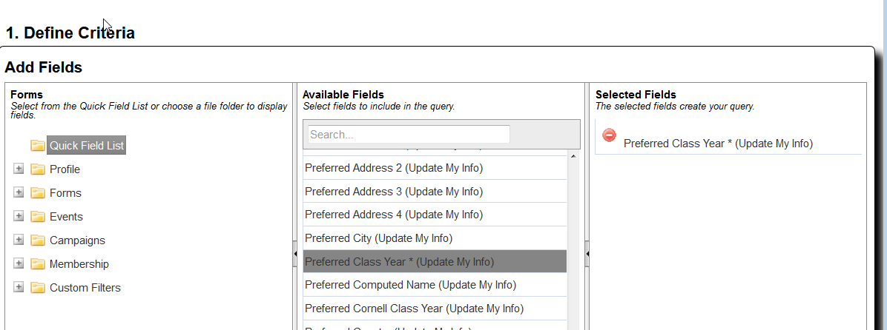

Both Class and Club should also select the “Primary Constituent Type.”
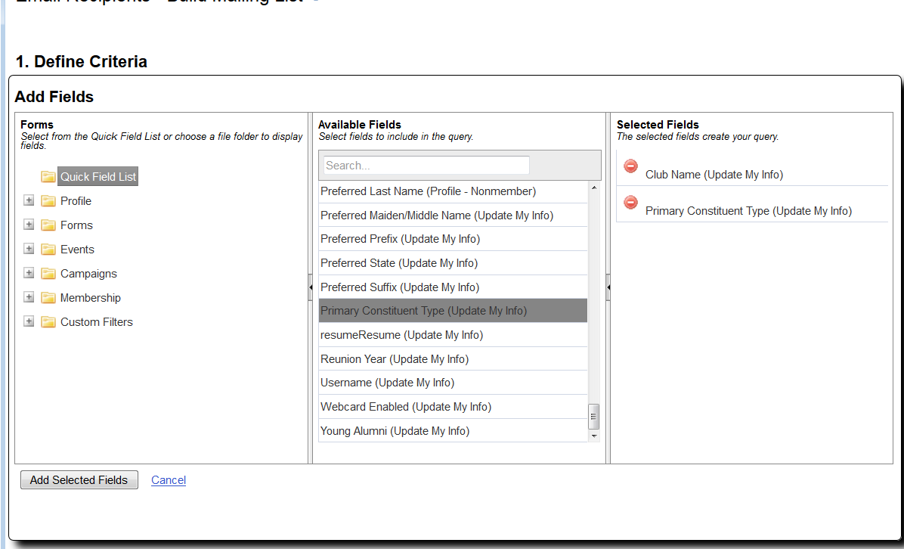

The Primary Constituent field is used to determine a persons relationship to Cornell University. A person can be an Alumni, a Friend, a Parent, a student and such. They can also have a status of Alumni Non-Degreed which indicates that they were accepted and matriculated to a college but did not receive a degree.

Only one Primary constituent value is assigned to each person who could have more than one type of relationship with the University. A person could be an “Alumni”, whom is also “Staff” and is a “Parent” As the system only allows one code to be assigned. The highest Primary Constituent Code that can be assigned is Alumni.

Select your club and the different types of constituent types to be selected from your club community.

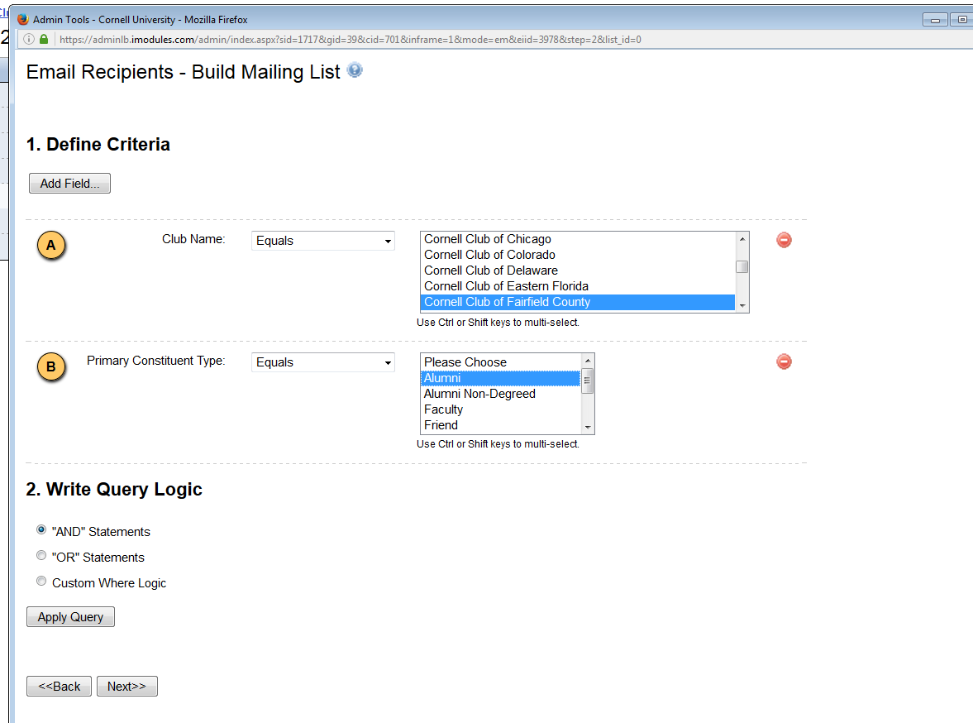

You can select more than one of each.
You may also add in additional “and/or” logic for your selection criteria. Selecting the Apply Query button will present a preview list of recipients returned from the query.

Select Next to continue.

Save your query with a name and select Next if you would like to reuse the query.

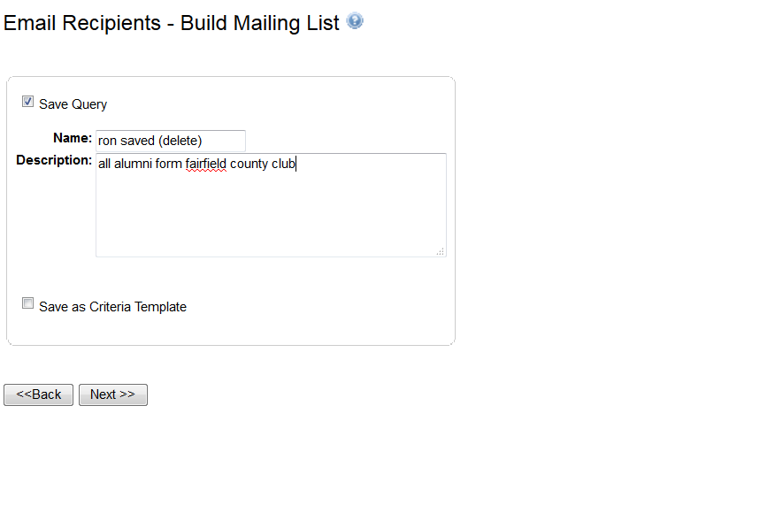

Deselect “Save Query” if there is no need to save the query for future use.

The screen displayed will show you the number of e-mails to be sent… (this example was for Ithaca Club)

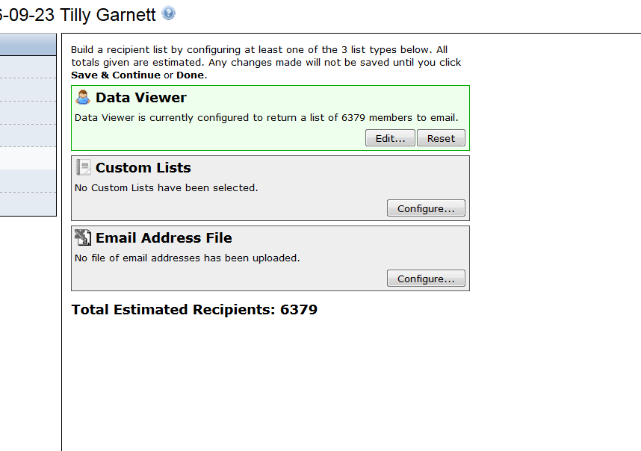

This indicates that there are 6379 emails that would be sent. If Alumni have ‘Do not e-mail’ flags set, have an invalid e-mail address, or have a recently bounced e-mails, they will NOT be included in the list generated. I

You can also add e-mail addresses of persons not included in iModules by selecting the Custom List button and in e-mails.
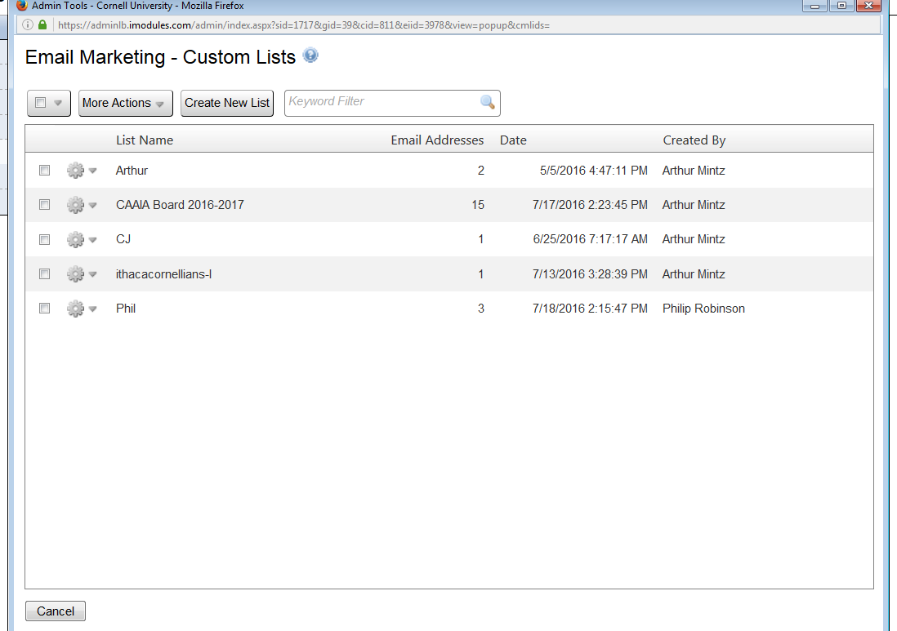

You can create a new list to be also processed in addition to the list of id’s in the previous step

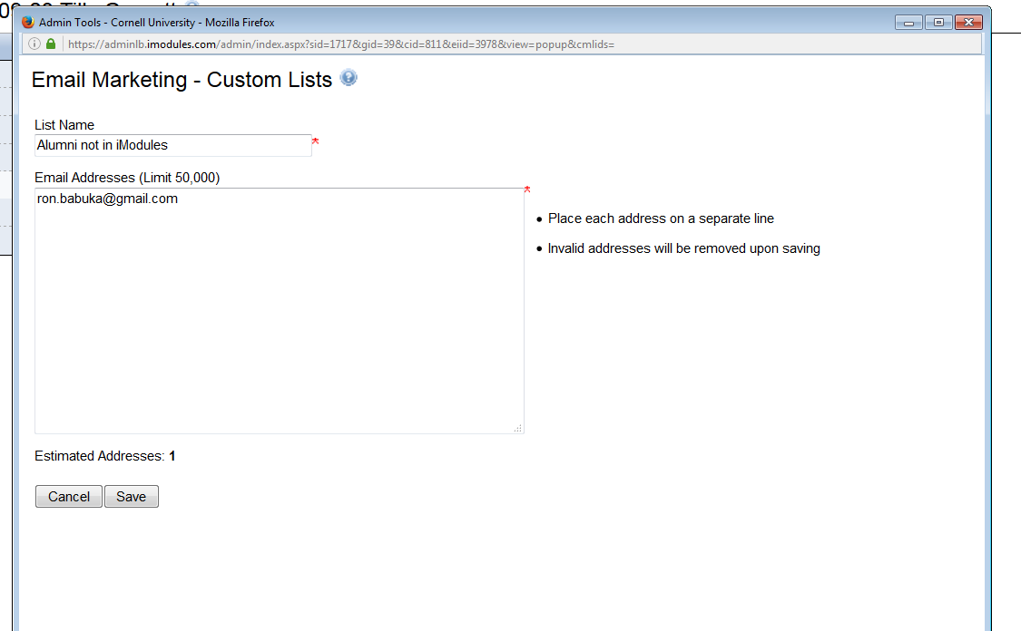
And save this as a list of for mailing.
This should only be used for person not stored in iModules.

Step 5 – Schedule e-mail for mailing

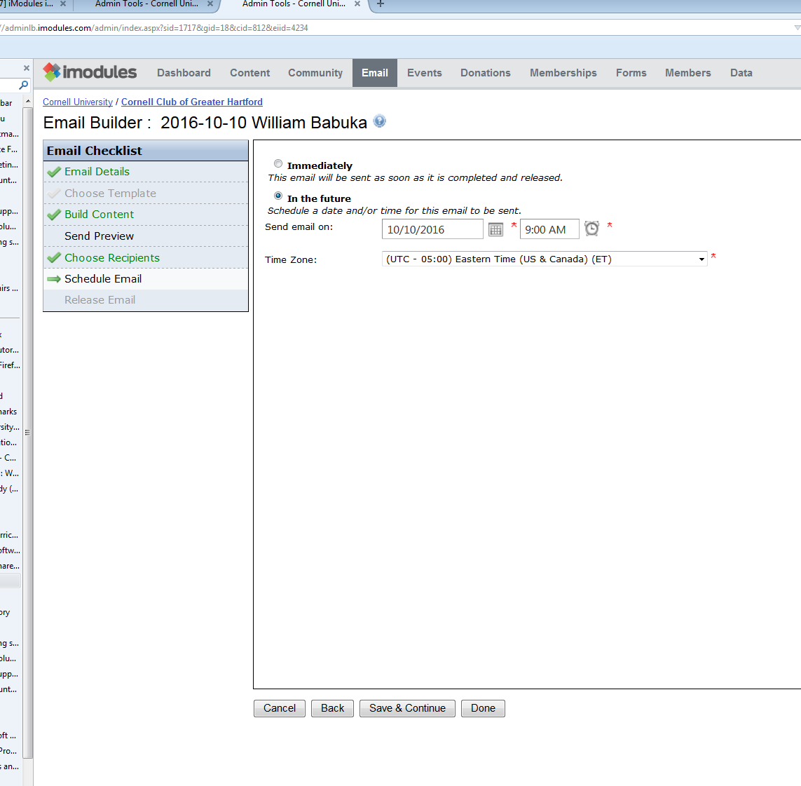
E-mails can be released immediately for mailing or scheduled for future release. If future release is necessary, select the date, time, and the time zone for the email to be released.

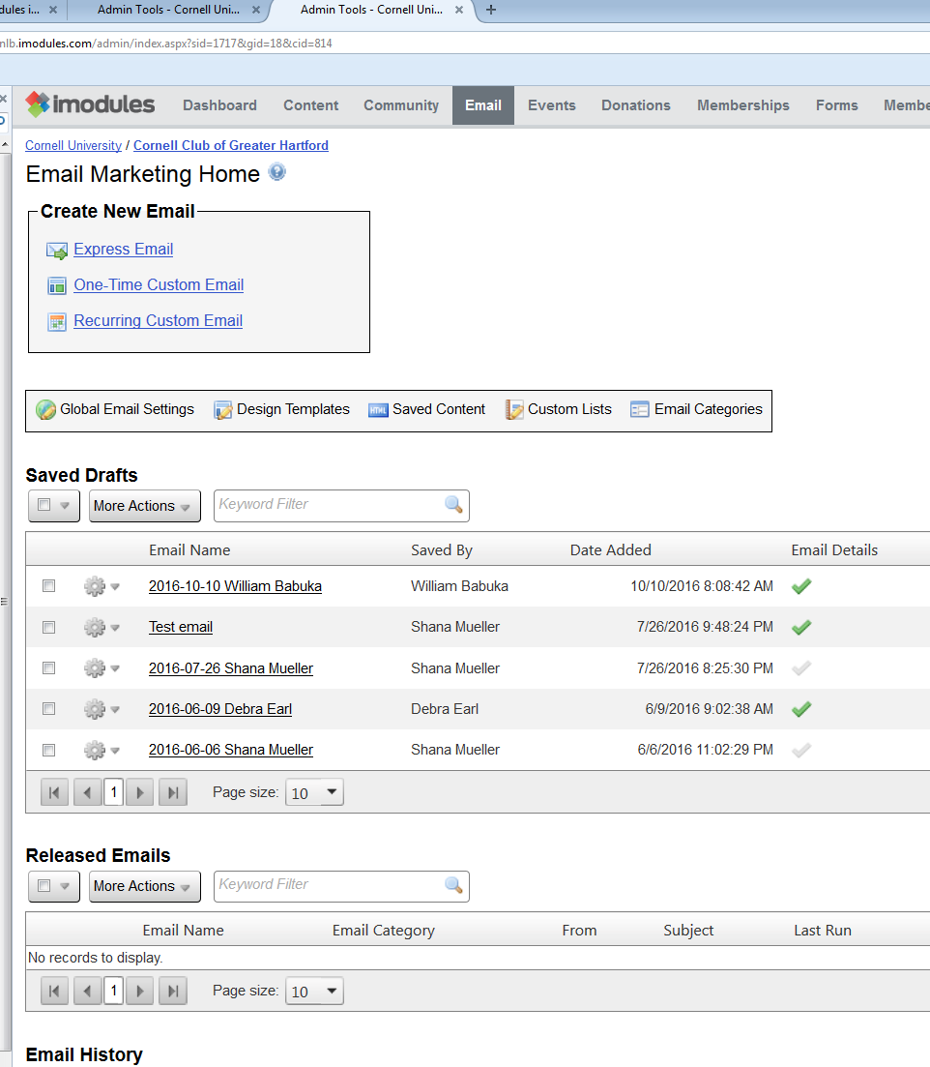

E-mails will move from the Saved Grouping to the Released Grouping when scheduled. For release.
The cog wheels can be used to move an e-mail back to the Saved List if you wish to make changes before release.
E-mails will then move History Grouping after being sent. E-mails in this grouping can be reused by the cog wheel.
One suggested approach for e-mails is to reuse an e-mail times if there would be only small changes necessary. Select the cog next to the e-mail in the History Grouping, select ‘reuse’, then begin the process documented in this document. The e-mails original content can be modified along with the mailing population.

