Using a role to manage page (step) display
This template was designed to use a registration field “Are You Attending” to control the display of subsequent pages. If an Alumni indicated they would not be attending, there is no reason to collect additional registration or guest information for the event.

The box highlights there are three pages (steps) to walk through for a registration.
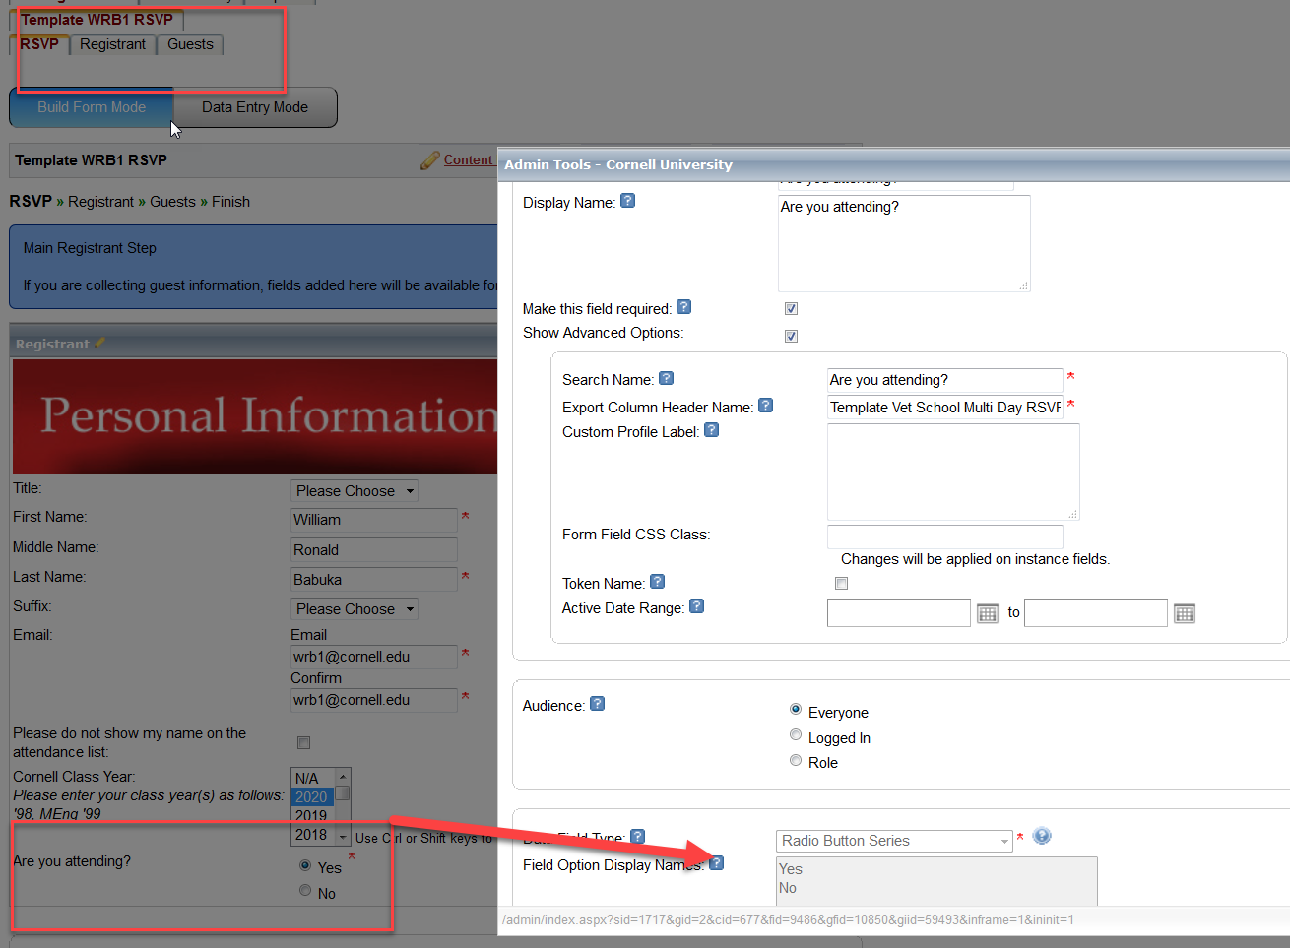

The registration field, that drives the registration process and e-mail notification, has been edited to have a Yes/No value

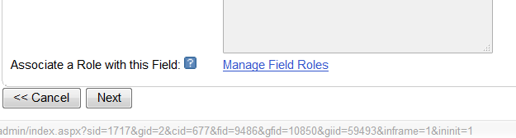

Select the “Manage Field Role” link

Select the “Choose Role” pull down and select “Add New Role”
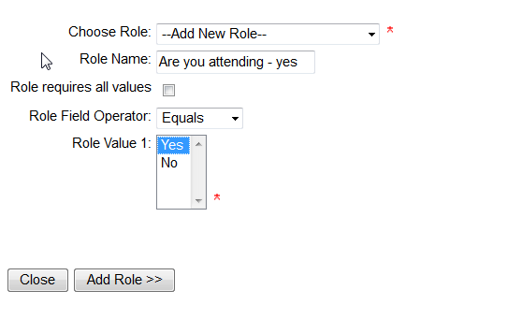

Create a Role Name, set the Role value to one of the options for the field. Repeat for all values.

Once completed, the roles page will look as follows:

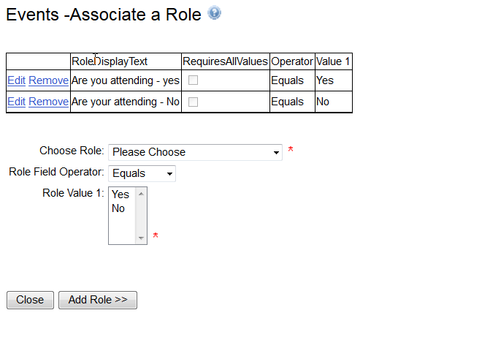

With the second page (step) selected, move the cursor to the Manage Forms pull down

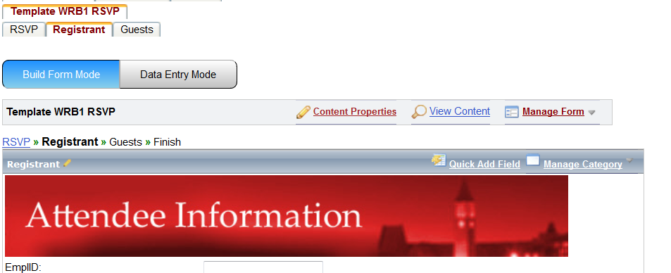
And select “Edit Step Setting”

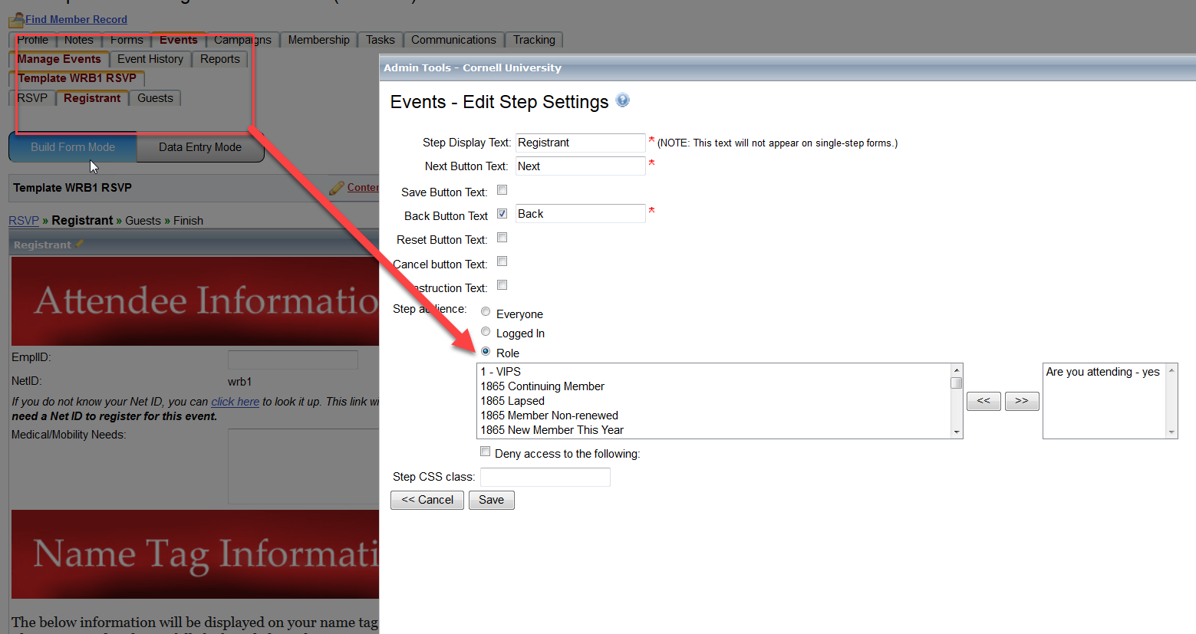

With this, If the registrant selects Yes, the next page will display. If the registrant selects No, the subsequent pages will be displayed.

Another example can be used to manage event fees, for example certain Alumni classes receiving a discounted rate but not displaying that rate to other registrants.

In this scenario, members of the Class of 2005 will see a reduced rate for an event.

Create a role, based on the Preferred Class Year

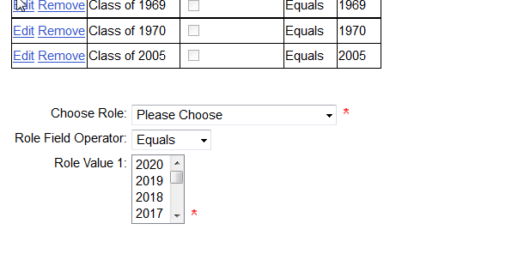

On the first page (step) of the event, place the Preferred Class Year field.

Edit the ticket commerce field that is placed on a following page (step), assign the role for the Young Alumni ticket

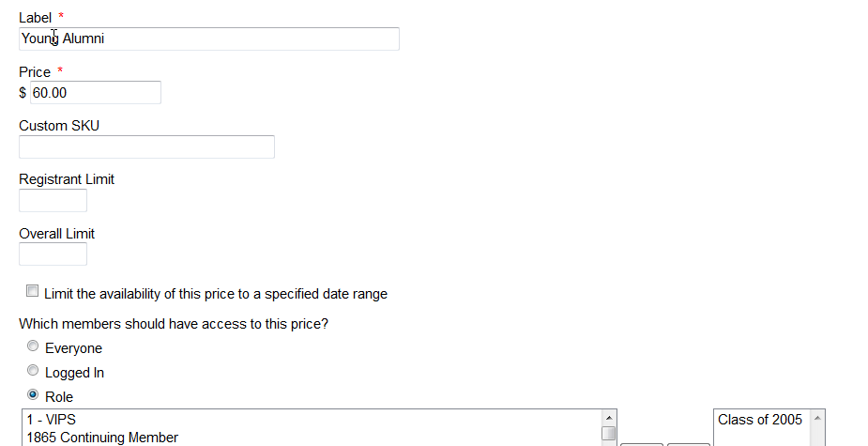

The user experience is:
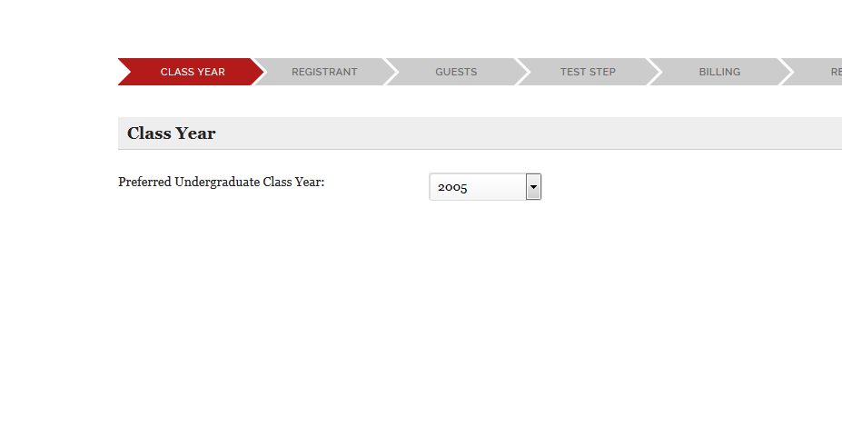
Class of 2005 year is selected
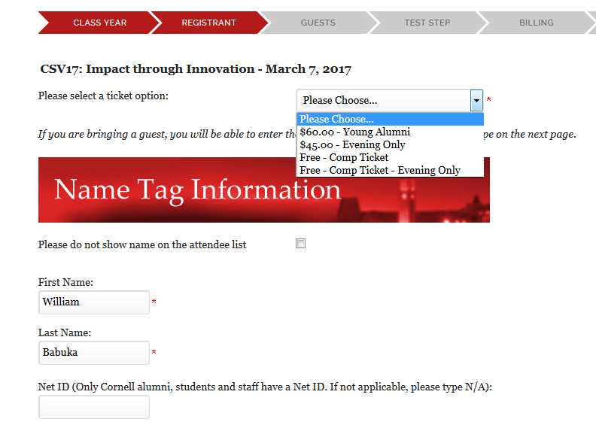

Notice the Young Alumni ticket option is available

If Class of 2004 had been entered, the option is no longer available.
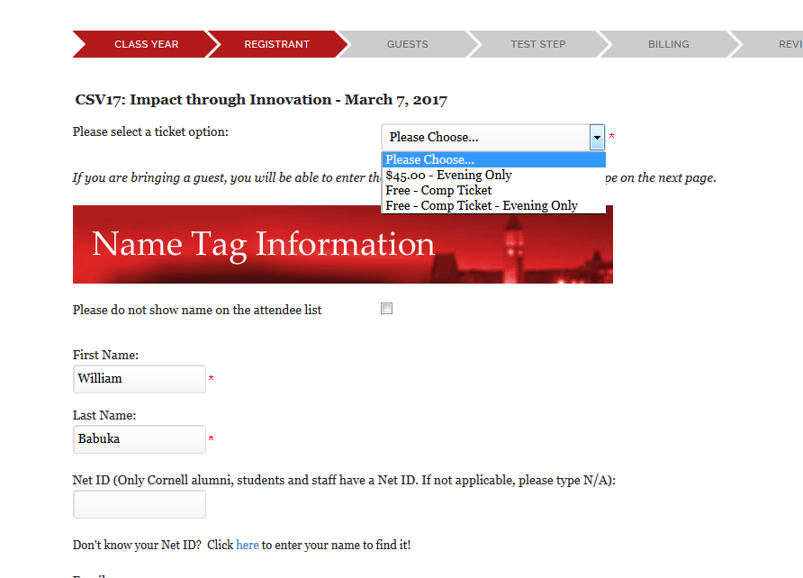

This also could be done with text field such as a Yes/No to a field added to the form that asked “Are you a member of the Class of 200 – Class of 2018”. There are numerous manners of deploying roles.

