Accessing the E-Mail Exception Report

Once the e-mail has been sent, an exception report can be accessed.
Select the cog wheel next to the e-mail.

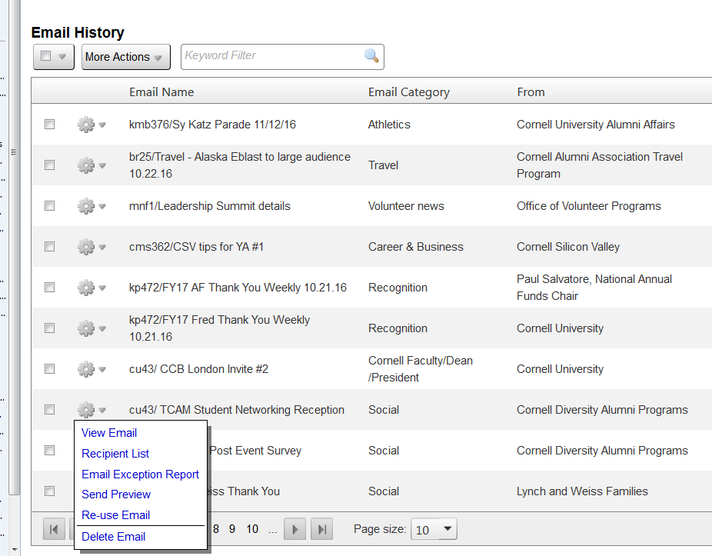

Select Email Exception Report

A window will pop-up presenting the:
Email name
Recipient sources (and list)
Total count of Emails in the list
Total count of Emails sent

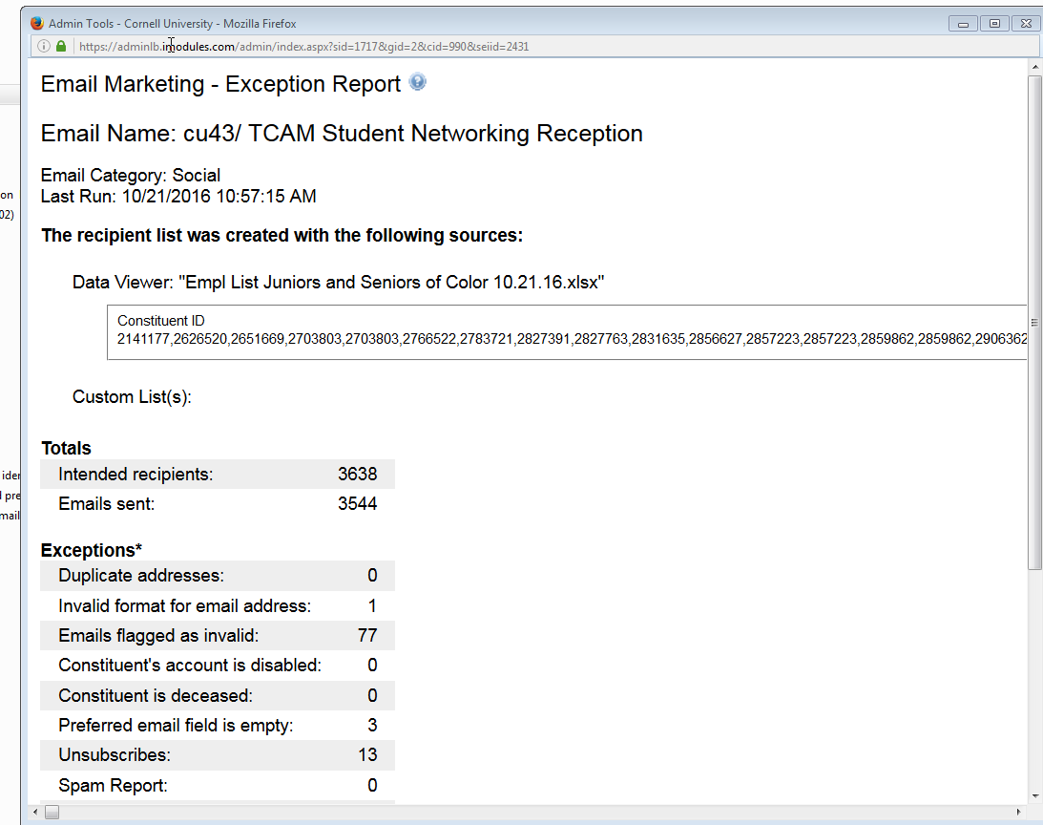

Emails not sent are broken down to the following reasons.
- Duplicate addresses - The recipient list had duplicate email addresses
- Invalid format for email address - The email address in the recipient list was in an invalid format. Example: There could be a space in the email address: test @imodules.com or the email address is missing the .com: test@imodules.
- Emails flagged as invalid - An email in the recipient list has been flagged in the database as invalid.
- Constituent's account is disabled - An email in the recipient list is tied to a member that is set to disabled.
- Constituent is deceased - An email in the recipient list is tied to a member that is set to deceased.
- Preferred email field is empty - A member in the recipient list does not have a value in the preferred email field.
- Unsubscribes - An email in the recipient list is tied to a member who has unsubscribed globally, unsubscribed from a community or unsubscribed from a category.
- Spam Report - The constituent has marked the email as spam.
- Unknown

Scrolling down, a .CSV file of the exception report can be downloaded along with a bounce report.

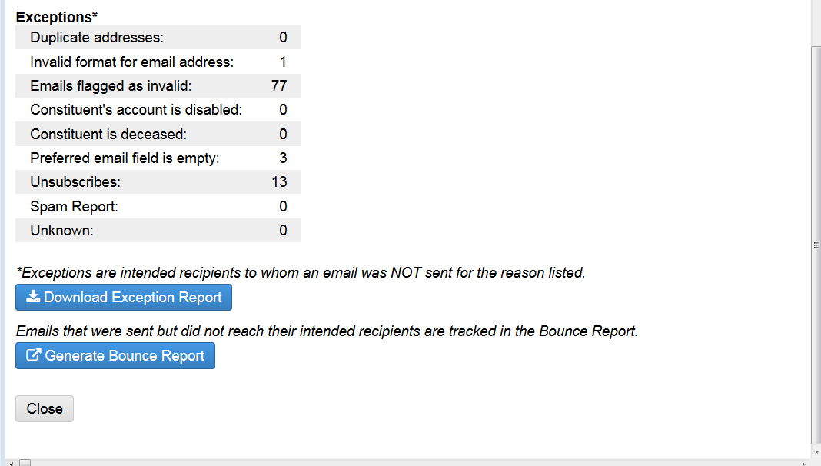

An example of a downloaded Exception Report.
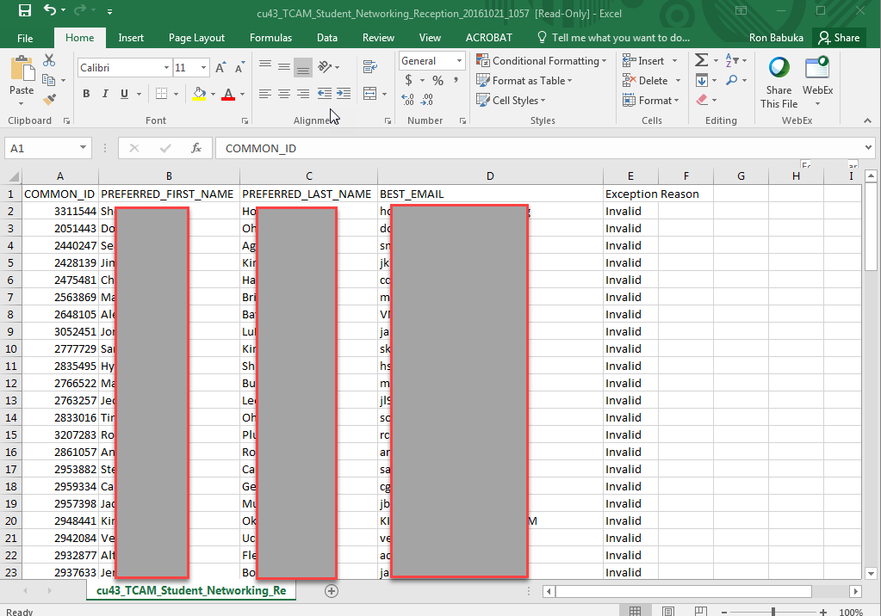

And an example of a Downloaded Bounce Report.
Once an individual has been flagged with a hard bounce, their status of having a valid e-mail will be removed and they will no longer be eligible to receive e-mail. A member of the iModules support team can reinstate their ‘OK to E-Mail’ flag.

