Using a template to create an e-mail:

Templates should be used as a pattern for future e-mails.

Chose a template
(Please use only one of the following as they have been vetted to be mobile ready and work across multiple platforms)
- Save the Date [DO NOT EDIT/MODIFY]
- Single CTA [DO NOT EDIT/MODIFY]
- Clubs and Classes Single CTA - 2 [DO NOT EDIT/MODIFY]
- Newsletter - 2 Column [DO NOT EDIT/MODIFY]
- Three Choices Newsletter [DO NOT EDIT/MODIFY]

Modify the necessary content, by selecting “Build Content”

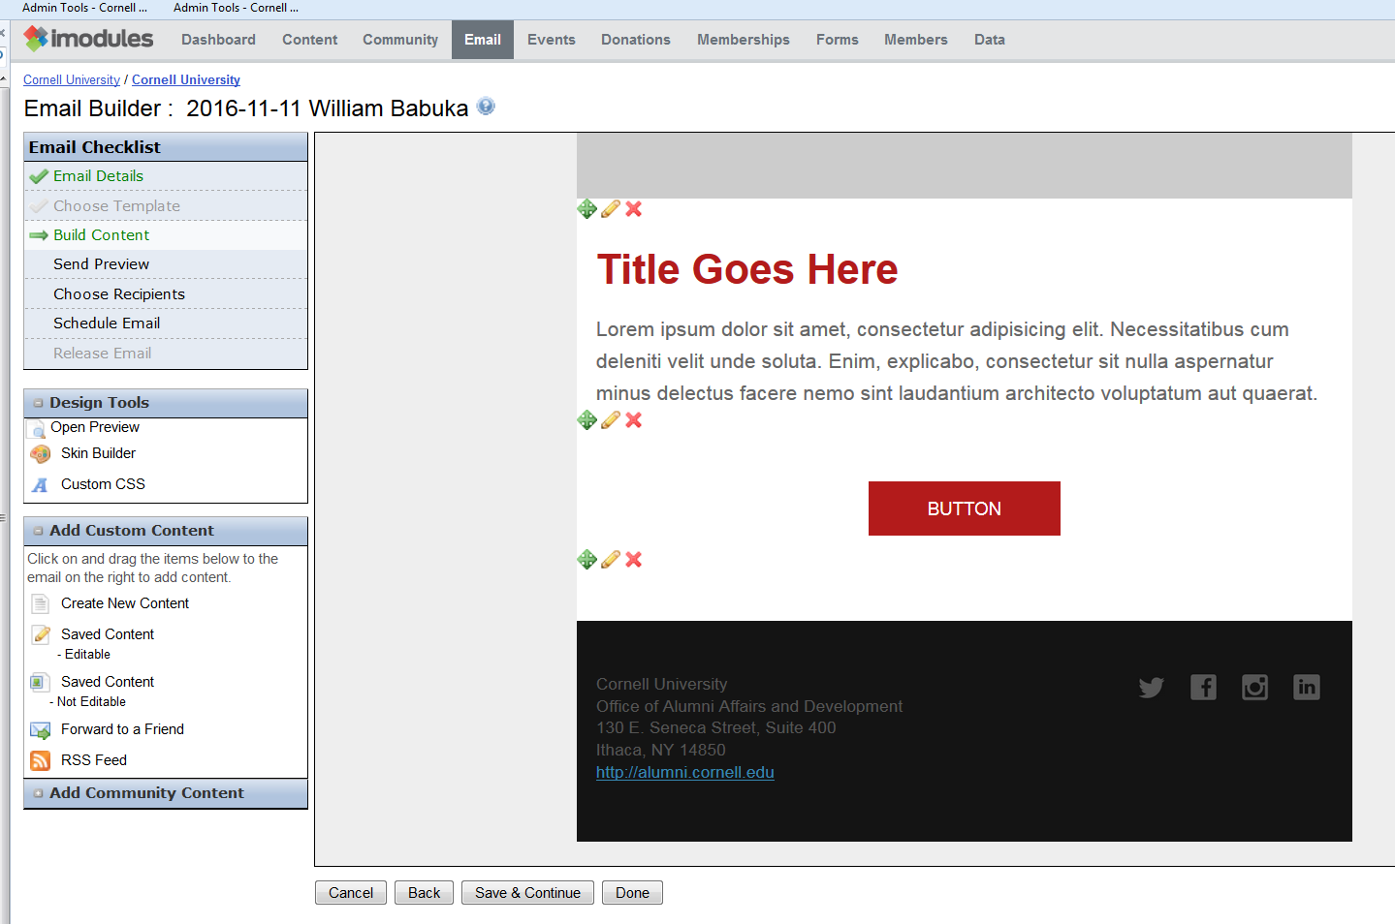

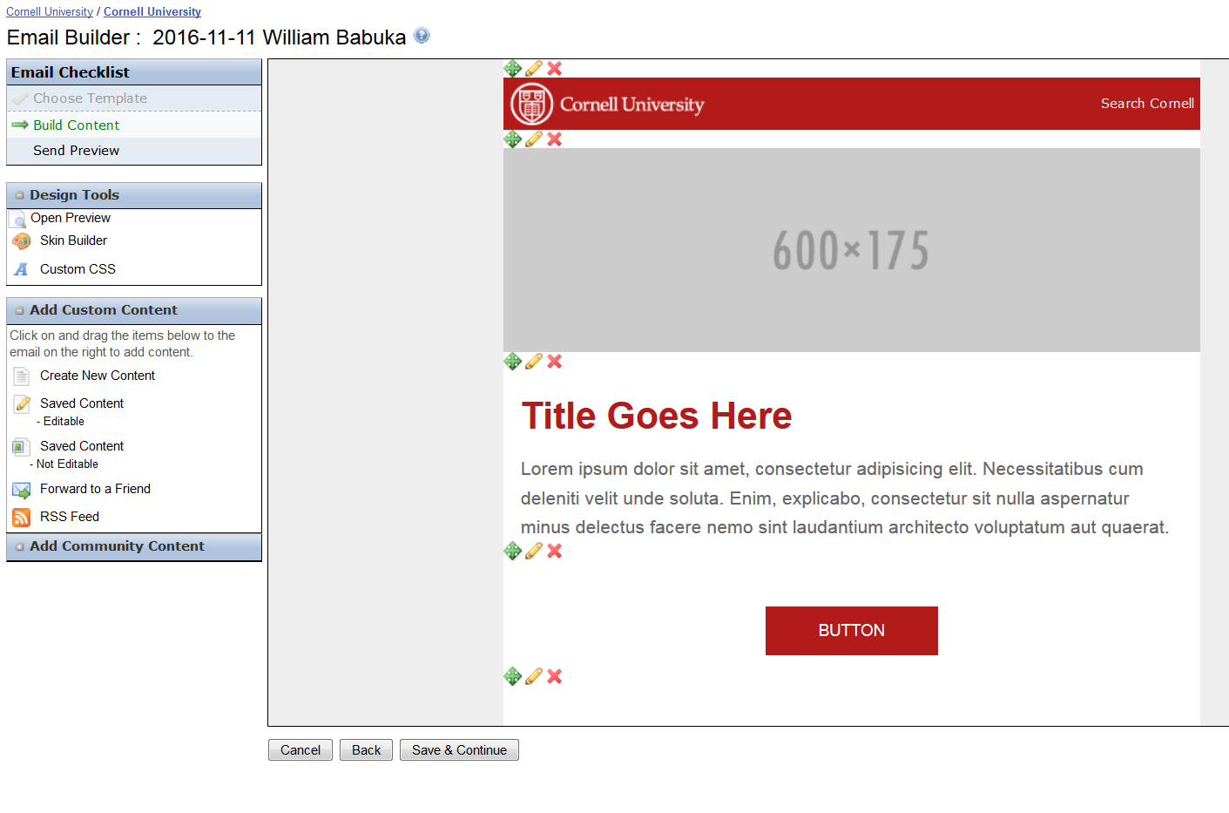

To modify content, select the pencil, to delete content select the “X” to move content use the green arrow.

iModules will display the standard content edit window, where content can be added.
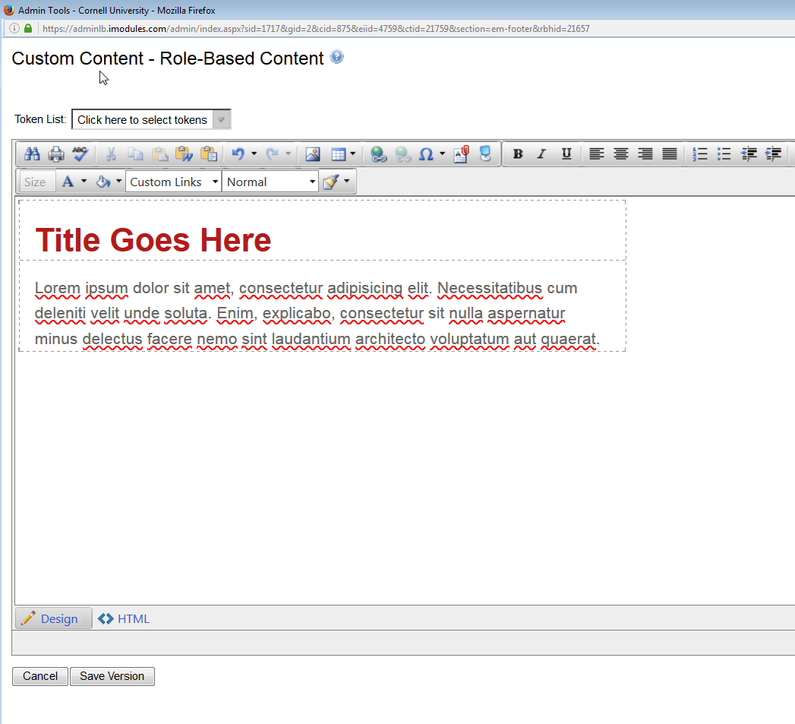

Make changes and save the version. At this point it is not suggested that college specific content be saved.

If more content is required to be inserted into an e-mail:
Place the cursor on the “Saved Content Editable” box and drag onto the form

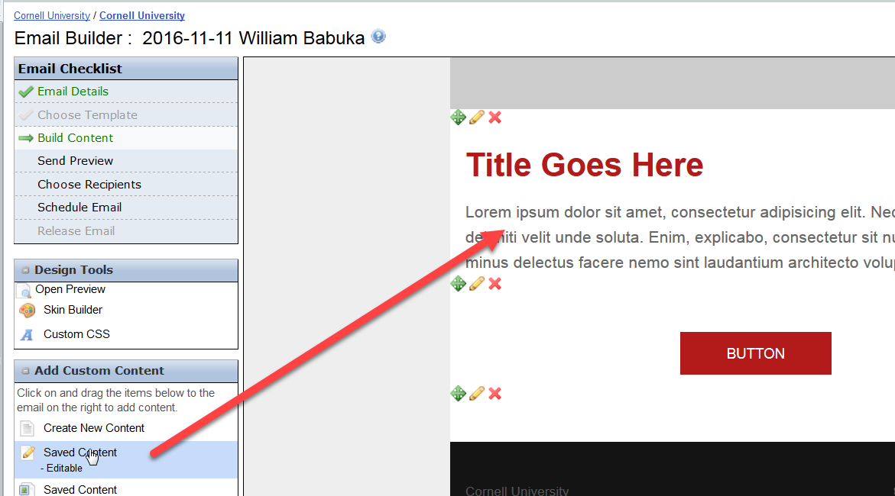

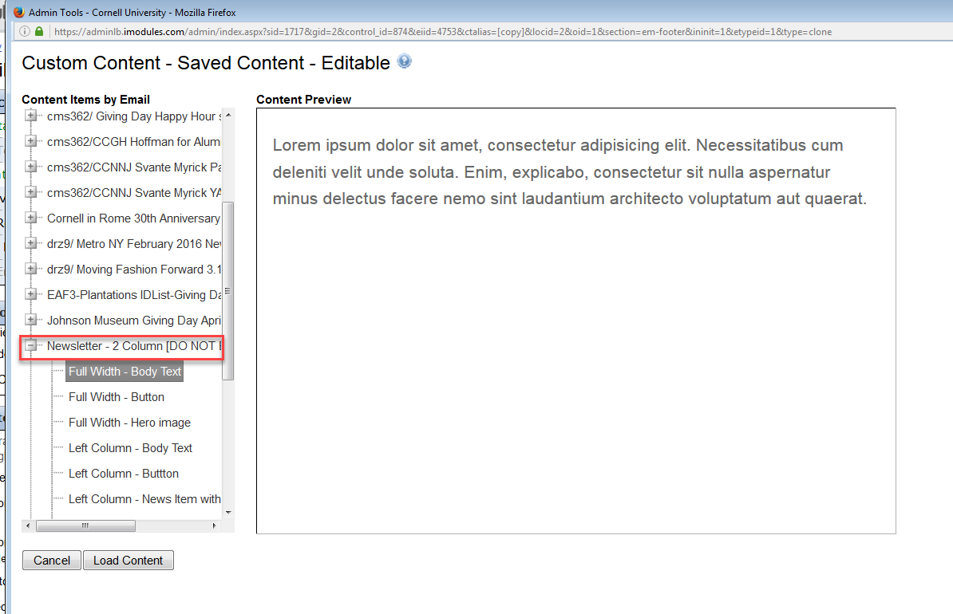
Select a content item ONLY from an approved template form. The item will be previewed.

Select “Load Content”
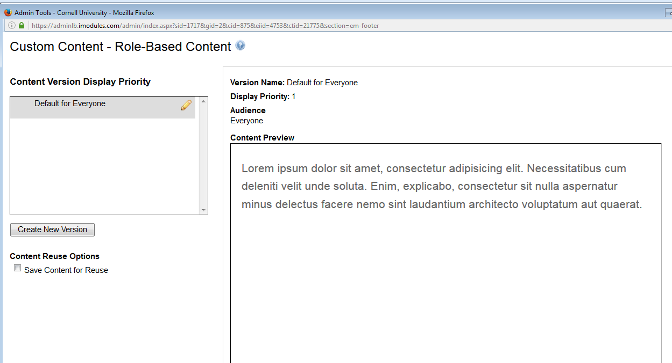
Select the pencil icon to edit.
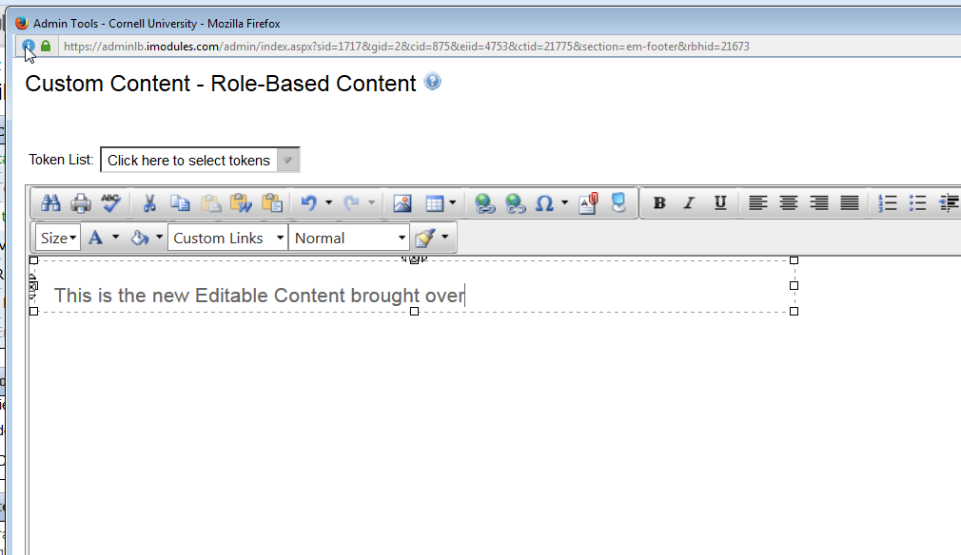

Modify the form and save content. The new content will be placed on the form.

