**Commerce Item**

When creating an event that involves registration or activity fees or any form of commerce items, three steps should be completed.

Add Payment Gateway information

Select the key icon on the right side of the iModules page.

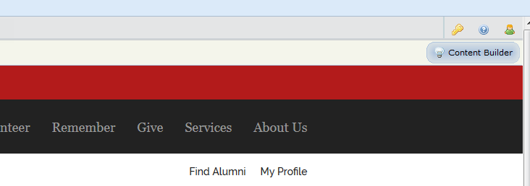

Then “Commerce” > “Payment Gateway”. (Note: Access to the Payment gateway is granted in addition to Events Administration. This request should go to the ITSG Support Team.)

Select the Events Tab

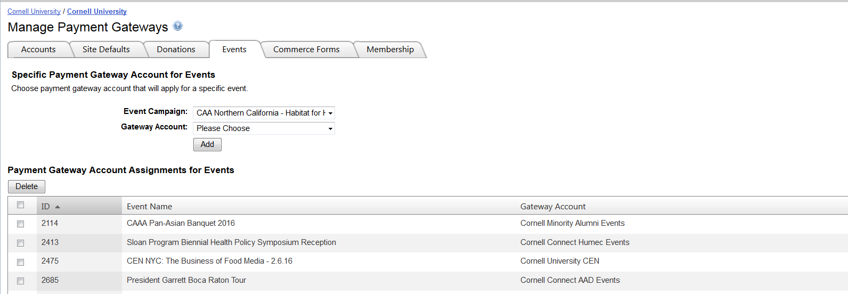

Select the event campaign (name) that was created in the first pull down. The list of events in iModules will be large as all events are listed regardless if they are active or inactive.

Select the gateway account to associate the event.

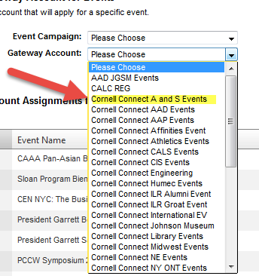

If there is confusion as to what gateway account to use, contact Kathleen Davis (KD17) or Casey Inman (CHI2).

Send to Casey Inman (CHI2) an e-mail with the 5 pieces of information.

1. Event ID, Event Name, Event Date
2. URL to the iModules event
3. Event fee
4. Gateway (see A)
5. Expense Account String (see B)

For Example

1. E_9425"Frozen Apple Hockey 2016" 11/26/16
2. <http://cornelluniversity.imodules.com/s/1717/alumni/event.aspx?sid=1717&gid=2&pgid=4338&content_id=5540>
3. $89  PP + $8 shipping cost
4. AADEVENTS
5. IT G654742 D0010 6385 EVT CCPHILLY
6. How to determine the Gateway?

Select the Accounts Tab

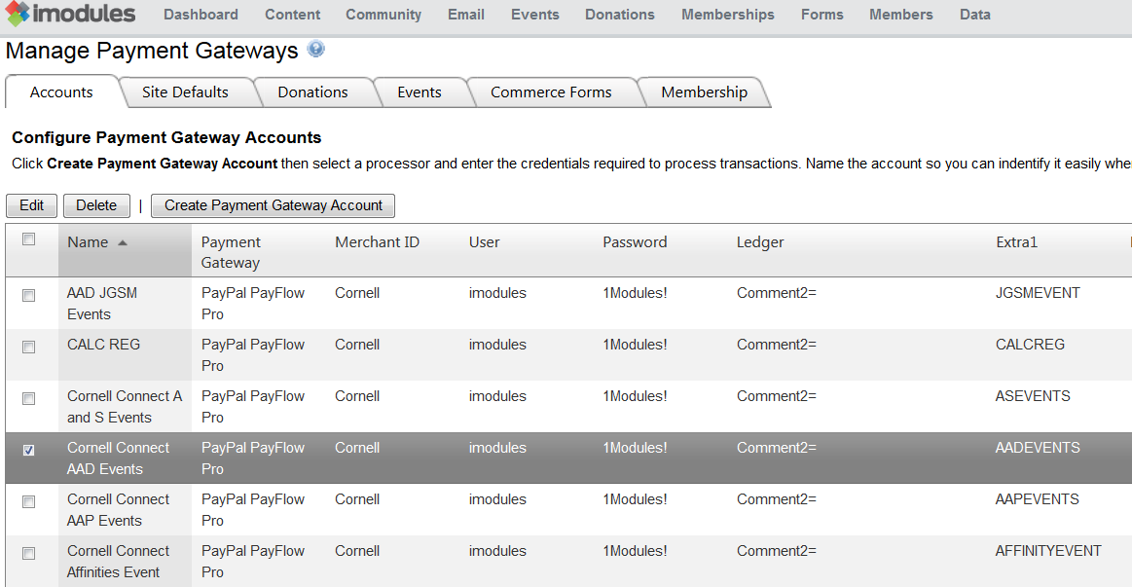

Select value under Extra1 for Gateway Account used.

1. How to determine the Expense Account String?

The first set of numbers represents their department’s account. In this case, G654742, is for Northeast Corridor Alumni Affairs.

The second set is the sub-account which some departments use and others don’t. In this case, D0010, stands for Mid-Atlantic since that’s the geographical location of this event. If it were taking place in NYC then D0009 (Metro NY) would be used. The sub-account isn’t always necessary but for accounts like this they use them to help keep regions separate for tracking purposes.

6385 EVT will always be used with all events. 6385 is the object code that represents hosted event expenses. EVT indicates that these expenses are for an event.

The last part is a “wild card” where you have 8 characters that allow you to give specific clubs or events their own name in the accounting string. CCPHILLY stands for Cornell Club of Philadelphia and most of them follow that format; CCFFIELD (Cornell Club of Fairfield), CCMIAMI (Cornell Club of Miami), etc. And if it’s for a specific event it will cater to the name of that event like International Zinck’s night, all of those events used ZINKS in that portion of the account string.

Update Commerce Identifier for Reporting

Open the iModules Event created, add in “Cornell Appeal Code= “<Gateway Account>”

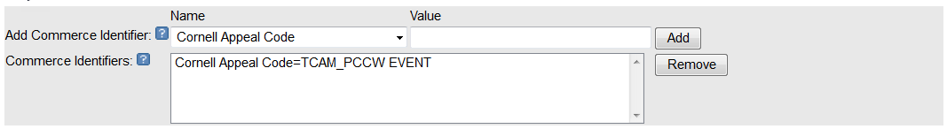

Commerce IDs allow you to assign commerce identifier fields to Events, Campaigns and Commerce Forms for reporting. These IDs  will automatically be pulled in the Event, Campaign and Commerce Form reporting, and also Reconciliation Reporting. They can include Revenue Codes, multiple General Ledger codes, etc.  For example, Commerce Identifier Name = Department and the Value = 1247 (or "Accounting", however you track it internally).

* Select a Commerce Identifier from the dropdown list.  Enter the Value for the Commerce Identifier field. Click Add.