Using the Directory

- Click “Find Alumni”
- A gray box will momentarily be presented, then the following page.

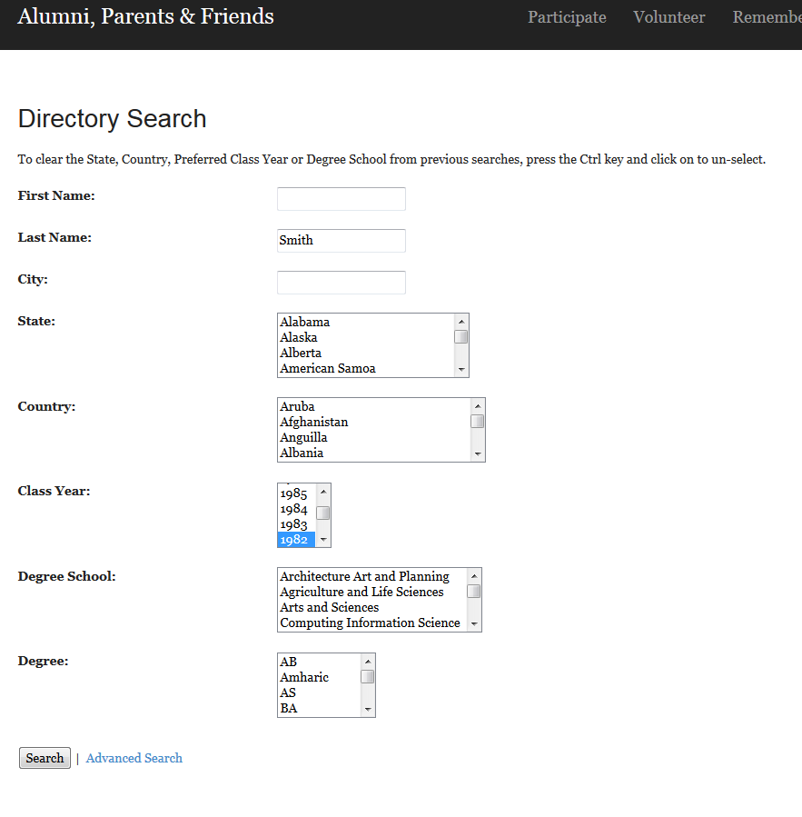

My strategy is to normally start large and get a lot of results, then start to shorten the list by adding in search criteria. In the example below, I started with Smith as a last name, and then I added Class of 1982 as their class year to make the list of returned Alumni more manageable to look through.

A gray screen will be shown momentarily, then the results: (next page)

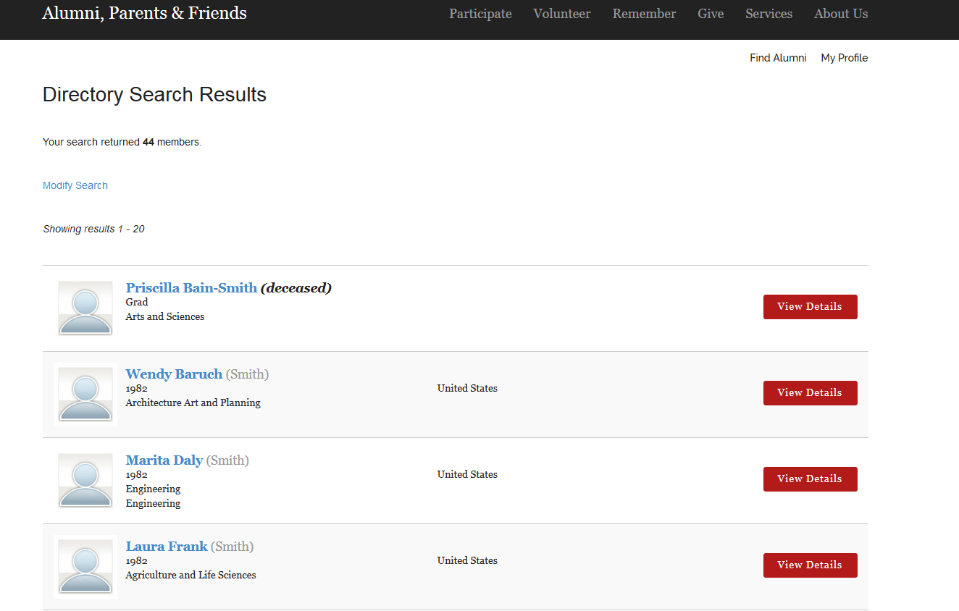

I can select the “modify results” link on the page to try to add a school, degree, or home state if the list is still to large.

In order to use a more powerful search, select the advanced search link on the bottom of the search page.

The advanced Search function is identical in functionality outside of the fact that it has extra search criteria. When you have selected a search criteria, the selection should remain blue as seen below.
So you can always tell what criteria you have selected.

