Adding Fields to an Event (which ones do we use?)
iModules Training: https://support.imodules.com/hc/en-us/articles/218261968-Fields-Event-Form
When creating a new form, several fields will default to the form.
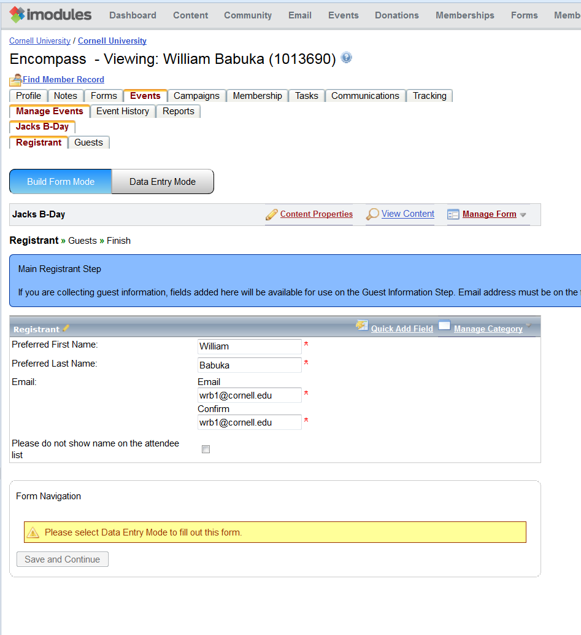

There are minimum fields that should be added that even if they don’t provide value to the event, the information collected will be updated into PeopleSoft through interfaces.
Requested fields – Place of form please make required:
Preferred First Name, Preferred Last Name, Preferred Email
Requested fields – Place of form but does not need to be required:
Preferred Maiden/Middle Name, Preferred Prefix, Preferred Suffix, Preferred Address 1, Preferred City, Preferred State, Postal/ZIP
Existing Fields
When inserting these fields onto the form, select “Manage Category” then “Add Existing Field”.
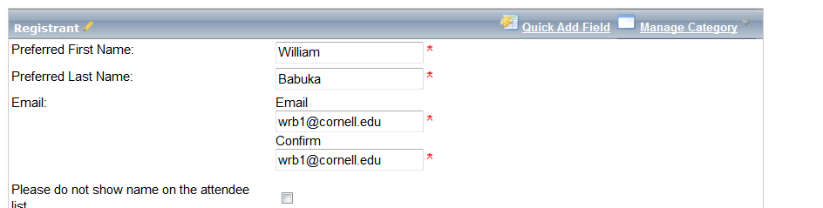

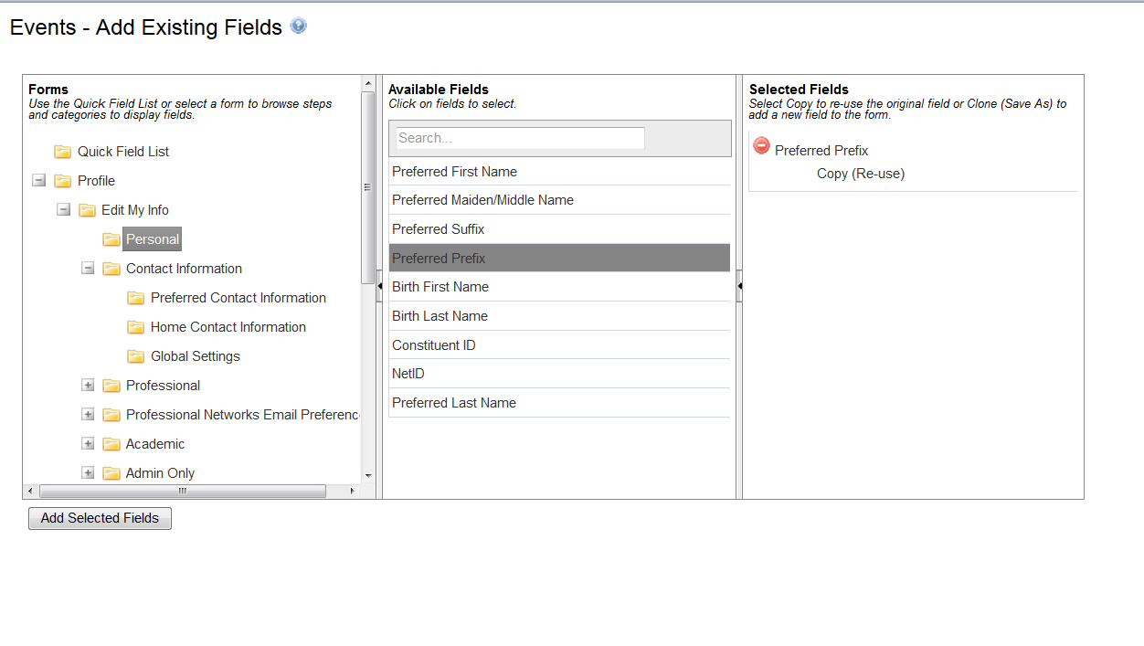
Navigate on the left pane to open folders. The profile folders include fields that if changed by the alumni, will be fed to PeopleSoft to also be updated.
Select the field in the middle column. All selected columns will appear in the right most column.
Selecting the red circle will remove them from the list. Select the “Add Selected Fields” button to insert the fields to the bottom of the form.

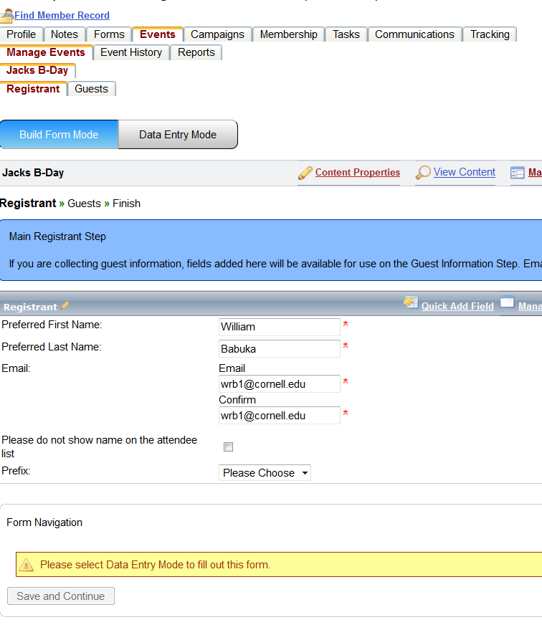

The Prefix field was added to the form and is able to be moved to the correct spot on the form.

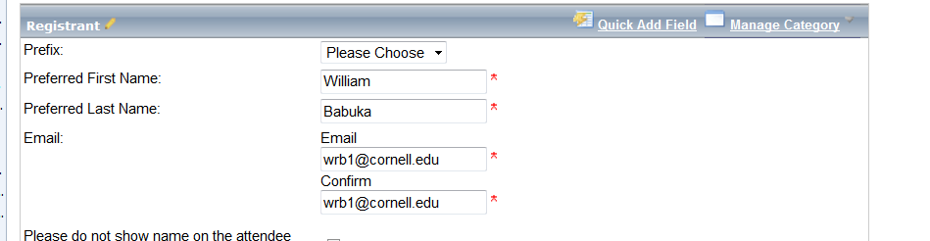
Prefix has been moved to the top of the list.
A spreadsheet of existing fields that ‘feed’ into Peoplesoft is located in the Training Portal.

New Fields
When inserting these fields onto the form, select “Manage Category” then “Add New Field”.

Complete the fields as needed (also select “Show Advanced Options” to access all fields)

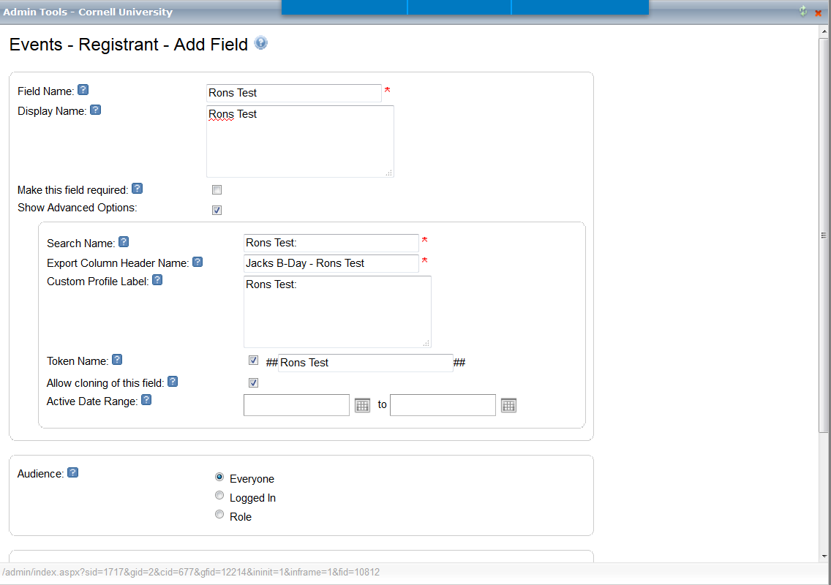
Field Name: This is the name visible to Admins when searching the database. It can be thought of as the more “technical” or shorthand name. It will default to being the Display Name as well if a different Display Name is not entered.
Display Name: The Display Name should be a more attractive/user friendly version of the Field Name. It can be thought of as the full question you want to ask or the piece of data you want to collect.
Check the Make this Field Required box to force users to fill in the information in the field.
Show Advanced Options:
Search Name box: The name entered here will be available to members via the Search area.
Export Column Header Name: The column name for the field that you will see in reports.
Custom Profile Label: Useful for putting in text that is more attractive to members when viewing the profile. This is often used for the Mentoring and Webcard area of the Profile
Token Name: The field can be set to be a Token, which is useful for personalizing communications.
Allow cloning of this field: The field can also be set to be “cloneable” in the future. (This may be an option based on the field type.)
Set the Active Date Range for the field.

Audience: Select the Audience for the field.
Everyone - Leave as delivered, Please access training on Roles before selecting any other value.

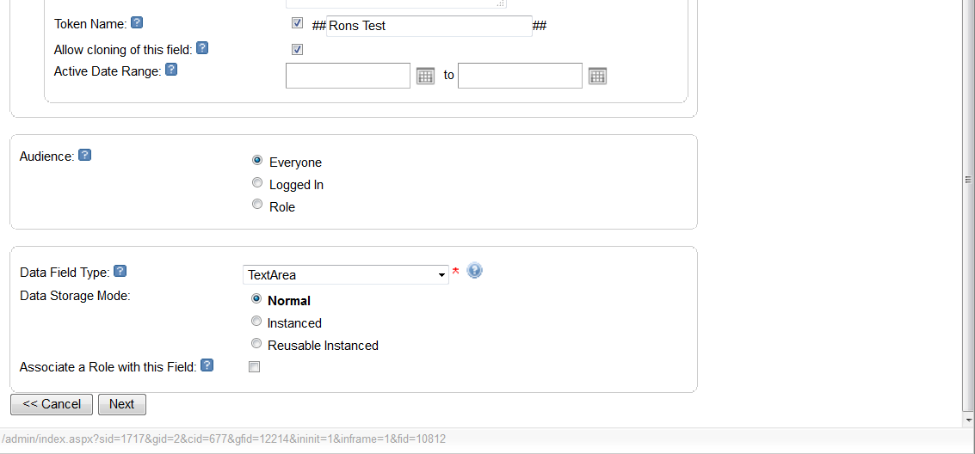
Data Field Type: Select the type of data field you want to use, such as dropdown list, checkbox, etc. Depending on the type of data field you pick, you may have additional information to enter.
Data Storage Mode options (the options shown depend on the data field type):
Normal – Standard field creation that allows new data to overwrite old data (default setting)
Instanced – An instance field will save each change a member makes to a field as an "instance" and will not overwrite the previous data.
Reusable Instanced - Allows this data field to be re-used within the same form type
Associate a Role with this Field to create a role based on this field. Based on the value they choose for the field, users will be placed in a role. More information on Creating Roles
Click Next.

