COVID-19 Guidance on Community Gardens
Text Adapted from NYC Parks Department GreenThumb Guidance, https://greenthumb.nycgovparks.org/

The World Health Organization has declared the COVID-19 disease, known as the coronavirus, a pandemic. At Cornell Garden-Based Learning, the health and safety of the public and our partners is always our top concern. In compliance with Governor Cuomo’s recent executive order we’re providing guidelines to private community gardens who choose to remain open for members only. For public community gardens, please consult local governments guidelines on accessibility to these spaces. Due to the relatively small spaces in most gardens and the difficulty in achieving safe social distancing of 6 feet or more, we recommend gardens stay closed to the general public that are not garden members. We realize that this will be disappointing to some, but it is necessary to help protect public health. Below are guidelines to help garden groups support their members safely:

- Garden Access: Access should be limited to garden members only, and only for garden maintenance and season preparation that is absolutely necessary. Gardens should remain closed to the public, and member gardeners should keep garden gates closed while working in gardens.
- Events and Gatherings: All public events in community gardens or on public parks property are prohibited. In addition, all in-person meetings, activities, and gatherings of garden groups are prohibited. Large projects that require many hands must be postponed, based on Governor Cuomo’s Executive Order.
- Social Distancing: Community Garden members working in gardens should always observe safe social distancing by keeping at 6 feet between all people
- Staggering Access: Garden groups should make best efforts to stagger access to gardens to minimize the number of members inside at the same time. Limit community garden member access to one at a time. Allocating plots by garden members and eliminating communal garden plots is a guideline to reduce contact.
- Disinfecting surfaces: Gardeners should regularly disinfect all communal tools and surfaces, and where possible gardeners should aim to use only their personal tools. Disinfection guidelines can be found on the CDC website. If possible provide gardeners with the materials to disinfect communal tools at the garden site. One guide to disinfecting tools can be found here: https://extension.unh.edu/blog/guide-csa-farmers-amid-covid-19
- Seeds, Plants & Produce: If a community garden provides seeds to the public, direct ship seeds to their members’ homes to reduce needing contact. When using or donating produce, follow Extension guidance on food safety found here: https://instituteforfoodsafety.cornell.edu/coronavirus-covid-19/food-industry-resources/
- Review Current COVID-19 Information: Gardeners should review current information and guidelines on COVID-19 on the CDC and NYSDOH webpage, especially with regard to populations at risk.

Cornell Garden-Based Learning shares your disappointment in reducing access to community gardens, especially during a crisis, but it is imperative that we all work together to help protect public health and keep our fellow New Yorkers safe.

Thank you in advance for your close attention to New York COVID-19 social distancing guidelines. We encourage you to continue to take all necessary steps to help keep yourself safe during this challenging time. You can learn more, including how to help stop the spread of the coronavirus, on the CDC webpage.

For additional resources on healthy gardening practices, educational videos, materials and gardening supplies as well as guidance on donating produce during COVID-19, please see:
- Safe Soil Guidance: http://blogs.cornell.edu/healthysoils/
- Beginning Gardening Guides: gardening.cals.cornell.edu
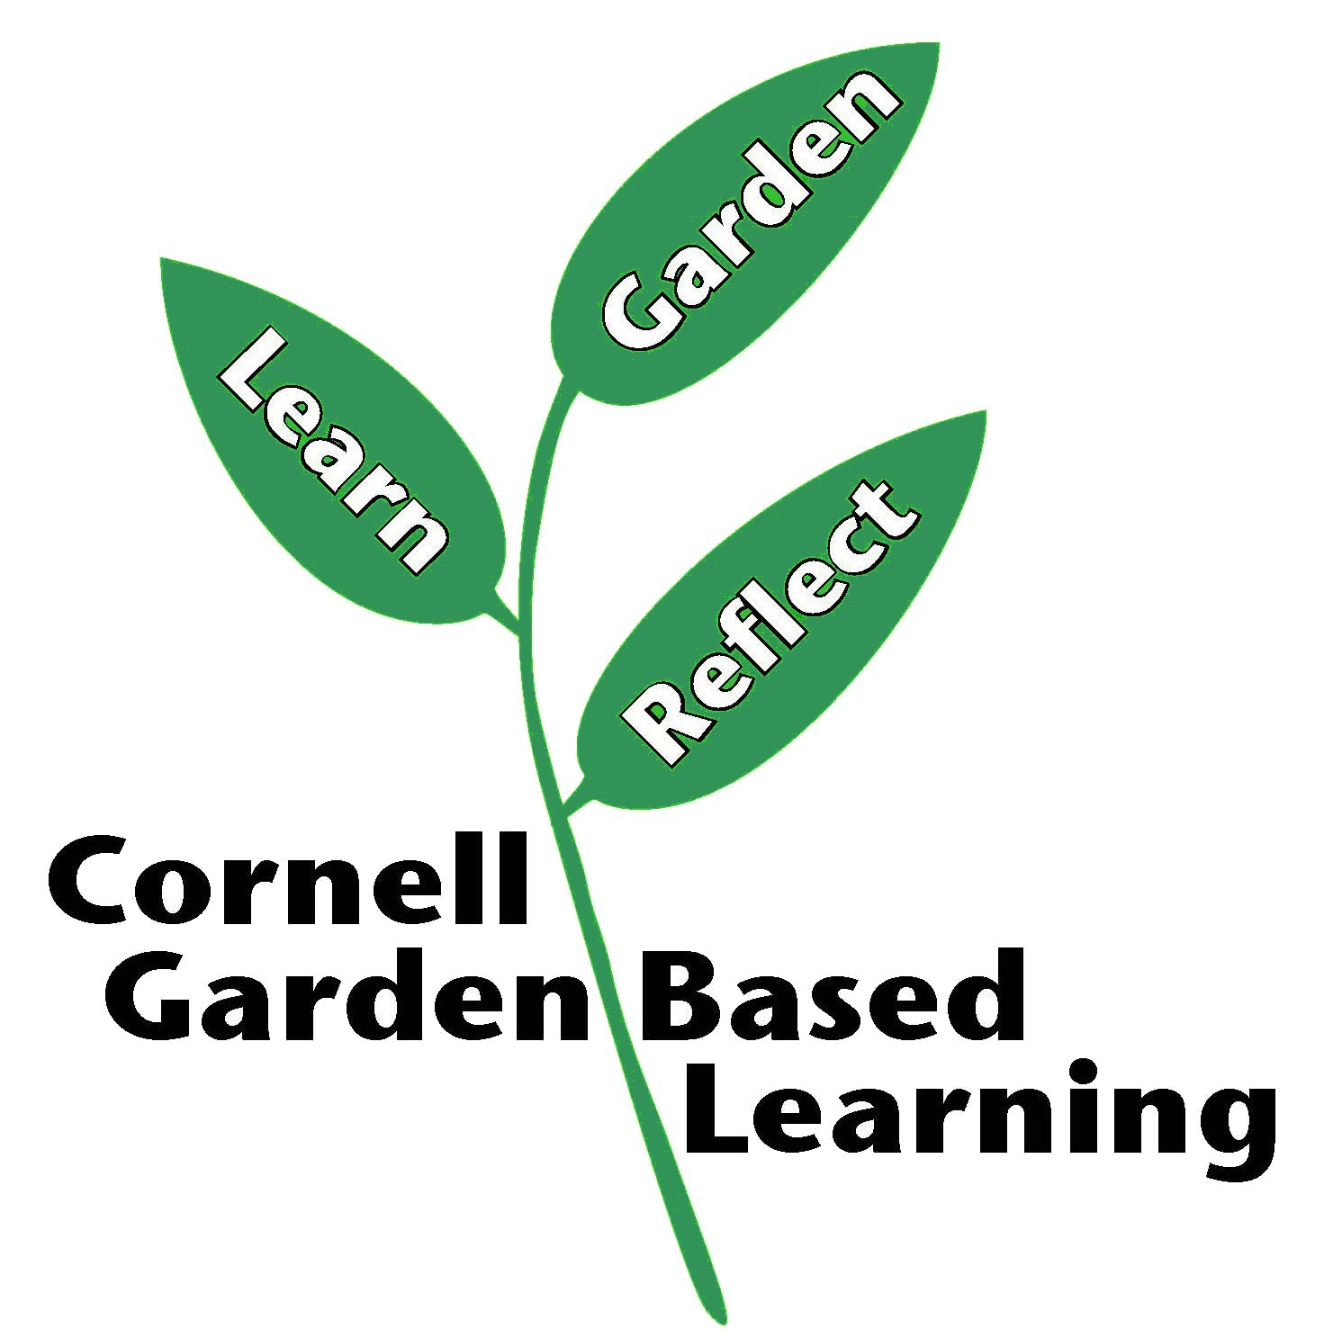
References:
Centers for Disease Control. (2020, April 1) https://www.cdc.gov/
Institute for Food Safety at Cornell University. (2020, April 1) Food Industry Resource. https://instituteforfoodsafety.cornell.edu/coronavirus-covid-19/food-industry-resources/
New York City Parks Green Thumb Program. (2020, March 21). GreenThumb’s News: Important Service Changes. https://greenthumb.nycgovparks.org/news.html?news_id=468
New York State Department of Health. (2020, April 1). https://www.health.ny.gov/
University of New Hampshire Cooperative Extension. (2020, March 20). Guide for CSA Farmers amid COVID 19. https://extension.unh.edu/blog/guide-csa-farmers-amid-covid-19

Published/Updated: 4/10/2020
Author: New York Parks Department Green Thumb Program, Adapted by Ashley Helmholdt
Reviewer: Sharon Bachman, Hannah Shayler, Jonathan Russell-Anelli

