Student Activity Sheet Name: ______________________

## j0397040

**Agarose Gel Electrophoresis Protocol**

**Hypothesis:**____________________________________________________________________________________________________________________________________________________________________________________________________________________________________________________

**MATERIALS (per 3 teams of two students)**

* PCR products from previous lab
* About 20 1.5 ml microtubes
* Latex gloves
* Waste containers for tips, etc.
* 3 sharpies
* 3 boxes of P20 pipet tips
* 3-6 P20 pipettors
* 3 tube racks
* 5X loading dye (Fisher TAK-9156)
* DNA standard (HindIII cut lambda DNA)
* 1 bottle 10X TBE Buffer (enough for 4 gels)
* 1 conical tube (10 g) agarose for entire class
* 1 gel box with tray and comb (for 3 teams of students)
* Power supply (can run 2 gels)
* GelStar® DNA stain
* Electronic balance for entire class
* Weighing dishes or paper
* 250 ml glass flask
* 2-liter glass flask
* 100 ml graduated cylinder
* Microwave or hot plate for class
* Oven mitt or tongs for class
* 1 liter distilled H2O (forTBE buffer)
* Microcentrifuge
* Thermometer
* Safety goggles (optional)
* Dark Reader for entire class

**INTRODUCTION**

In this activity, you will:

1. Determine the presence and size of Wolbachia 16S rDNAamplified by PCR.
2. Understand the basic principles of Agarose Gel Electrophoresis and use it as a molecular tool to generate data to accept or reject your Wolbachia hypothesis.



**PROCEDURE**

*Preparing the Agarose Gel*

1. Up to 3 teams of 2 students will work together on one gel as an investigatory group. One group will prepare the 0.5 X TBE buffer that is needed to make and run 2 gels (for two groups). The group of students that is to prepare the buffer will need to add 200 ml of distilled water to the bottle of TBE powder (USB #70454). **Mix thoroughly.** This is now a 10X concentration of the TBE buffer. Pour 100 ml of the 10x TBE into a 2-liter beaker or Erlenmeyer flask. Carefully add 1900 ml of distilled water and mix until fully dissolved. This is enough buffer for two gels. Share the extra buffer with another group of students. If only 1 liter of 0.5X TBE is needed for one gel, then it can be prepared by combining 50 ml of the 10X concentrate and 950 ml of distilled water.

2. Each investigatory group (1-3 teams of 2 students) will need to prepare a gel. Each pair of students in the Investigatory group will load their samples on to this gel.

1. Weigh out 1.0 gram of agarose and add it to 100 ml of 0.5X TBE buffer in a 250 ml Erlenmeyer flask.

b. Place a magnetic stir bar into the flask and heat the flask on a stirring hot plate until the agarose powder is completely dissolved. The solution will have to boil for several minutes for this to occur. If a magnetic hot plate isn’t available, heat the materials in a 250 ml or 500 ml beaker and **stir frequently**. The agarose solution will look clear when the agarose is completely dissolved. Alternatively, a microwave oven can be used for this purpose if it is available. If a microwave is used, microwave on high for 1 minute, then swirl the flasks. If the agarose is not completely dissolved, microwave for a few seconds longer until it is.

c. Once the agarose is fully dissolved remove the flask from the hotplate, insert a thermometer, and allow the solution to cool to about 75°C.

3. While the agarose is cooling, the next step is to prepare the casting tray. Place the casting tray in the gel running apparatus so that the open ends of the casting tray are facing the sides of the gel box. The gaskets should make a seal with the sides of the gel apparatus. To prevent leakage, make sure that the gaskets have not popped out of their grooves when you have pushed the casting tray in the gel box.

a. Add 2 µl of GelStar® to 100 ml of the cooled agarose before pouring the gel. **Wear gloves** when handling the GelStar® stain.

b. Pour the cooled agarose solution into the tray to a height of approximately 0.8 to 1 cm.

c. After the gel is poured, place the comb so that it fits in the slots that are closest to the end of the gel-casting tray. There are two sets of slots in the gel casting tray, one close to the end of the tray and one in the middle of the tray. **Do not** use the slots in the middle of the tray. You will notice that the green comb has teeth on both sides. One set of teeth is slightly thicker than the other. Position the comb so that the thicker teeth are facing down into the gel.

d. Leave the gel undisturbed for 20 minutes until the agarose becomes firm and opaque.

4. When the gel has cooled, carefully lift the gel casting tray and turn it 90˚. The gel should be positioned so that the comb/wells are near the negative (black) terminal of the gel box. There should be a piece of red tape marking the negative terminal on the bottom of the gel box.

a. Add 0.5X TBE buffer to the gel chamber until the level reaches the black fill line. The gel should be fully covered by about 2 - 3 mm of buffer.

b. Remove the comb by gently **pulling it straight upward**. If the gel moves during this process, gently push it back into place using the blunt end of a pipette tip. You will load your samples into the slots created by the comb.



*Loading the Gel*

1. Label a new 1.5 ml microtube for each of your reactions (5 tubes total for your group). Use a P20 micropipette to add 8 µl of each reaction product (from the small PCR tubes) to the appropriately labeled microtube. Add 2 µl of 5X Loading Dye to each tube. The loading dye is a mixture of an indicator dye and a dense molecule called glycerol. Place all five tubes into the microcentrifuge and spin for 5 seconds to make sure that all the liquid is combined in the bottom of the microtube.
2. Your teacher will give you a microtube with the DNA size standard. This size standard is actually the genome of a virus, bacteriophage  (lambda) that has been previously digested with HindIII into fragments of known lengths (see the figure below).



1. Record the order each sample will be loaded on the gel, including who prepared the sample, the DNA template – what organism the DNA came from, controls and ladder/size standard (organize your samples in your tube rack according to the order shown under step 4.) The notes section can be used to document unusual events such as cross-contamination between wells or the gel being punctured during loading.

|  |  |  |  |
| --- | --- | --- | --- |
| ***Lane #*** | ***Prepared by*** | ***DNA Template*** | ***notes*** |
|  |  |  |  |
|  |  |  |  |
|  |  |  |  |
|  |  |  |  |
|  |  |  |  |

1. Load your samples according to the following order: From left to right the first student group loads tube 1, 2, 3, 4, 5 (where 1 is insect 1, 2 is insect 2, 3 is neg. control wasp, 4 is pos. control wasp, and 5 is pos. control Wolbachia DNA). Then skip one lane (or place a DNA standard in that well). Then the next student team loads their samples in the same pattern. Again skip a lane or add a DNA standard before the 3rd team of students loads their samples (see also picture below).
2. Carefully pipette 8 µl of each sample/Loading Dye mixture into separate wells in the gel.
3. Pipette **3** µl of the DNA size standard into at least one well of the gel.

**

*Running the Gel*

1. Place the lid on the gel box, connecting the electrodes appropriately – positive (red) and negative (black).
2. Turn on the power supply to about 180 volts. Maximum allowed voltage will vary depending on the size of the electrophoresis chamber – it should not exceed 5 volts/cm between electrodes!
3. Check to make sure the current is running through the buffer by looking for bubbles forming on each electrode.
4. Check to make sure that the current is running in the correct direction by observing the movement of the blue loading dye – this will take a couple of minutes.
5. Let the power run until the blue dye approaches the middle of the gel, then turn off the power, disconnect the electrodes, remove the lid and the gel using gloves.



*Gel Viewing*

1. Wearing gloves, gently transfer the gel onto the blue surface of the Dark Reader for viewing. Place the orange filter screen over the gel and turn on the Dark Reader. The DNA bands will now be visible. A darkened room works best for viewing the gel with a Dark Reader.

2. Scientific results need to be documented in permanent form. We recommend using a digital camera to take a photograph of the gel. We have found that digital cameras work best in a dark room with the camera flash turned off. We also recommend using a tripod or a ring stand and a clamp to steady the camera.

3. Once the pictures are taken, you can add labels to each of the lanes using programs such as Photoshop™ or PowerPoint™, or by hand on the paper print out.

**Example of a gel photo:**

From left to right (tubes 1-5): Student Team 1: insect #1, insect #2, neg. control wasp (3-), pos. control wasp (4+), Wolbachia DNA (W5), Standard/Ladder (STD);

Student Team 2: insect #1, insect #2, neg. control wasp (3-), pos. control wasp (4+), Wolbachia DNA (W5).

The long arrow marks the positive result for insect #2 that looks similar to the pos. control wasp (4+) and the Wolbachia DNA (W5). The short arrow points to the bands that are the primers (W-spec forward and reverse, 20bp) added prior to the PCR reaction.

Notice the location of the 7 standard bands: 4 towards the top, a couple a bit further down, and the 7th is very faint (0.6kb).

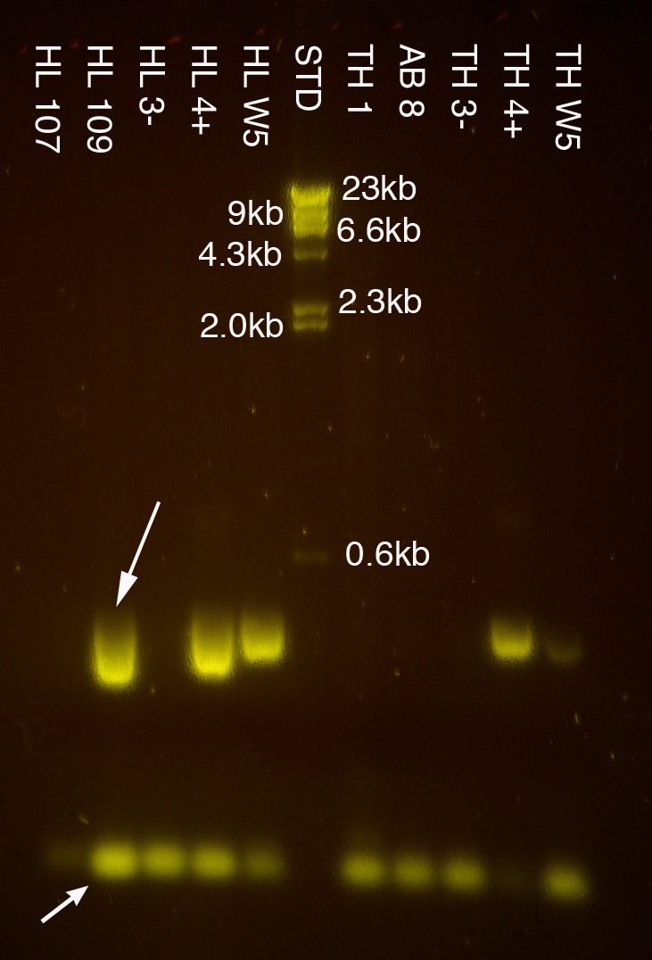

**CLASS SUMMARY**

Date ________

|  |  |  |  |  |
| --- | --- | --- | --- | --- |
| ***Lane #*** | ***Prepared by*** | ***DNA Template*** | ***notes*** | ***Results (+ or -)*** |
| 1 |  |  |  |  |
| 2 |  |  |  |  |
| 3 |  |  |  |  |
| 4 |  |  |  |  |
| 5 |  |  |  |  |
| 6 |  |  |  |  |
| 7 |  |  |  |  |
| 8 |  |  |  |  |
| 9 |  |  |  |  |
| 10 |  |  |  |  |
| 11 |  |  |  |  |
| 12 |  |  |  |  |
| 13 |  |  |  |  |
| 14 |  |  |  |  |
| 15 |  |  |  |  |
| 16 |  |  |  |  |
| 17 |  |  |  |  |
| 18 |  |  |  |  |
| 19 |  |  |  |  |
| 20 |  |  |  |  |
| 21 |  |  |  |  |
| 22 |  |  |  |  |
| 23 |  |  |  |  |
| 24 |  |  |  |  |
| 25 |  |  |  |  |
| 26 |  |  |  |  |
| 27 |  |  |  |  |
| 28 |  |  |  |  |
| 29 |  |  |  |  |
| 30 |  |  |  |  |
| 31 |  |  |  |  |
| 32 |  |  |  |  |
| 33 |  |  |  |  |
| 34 |  |  |  |  |