Questions from the Watson and Crick article from Nature, April 25 1953, “A Structure for Deoxyribose Nucleic Acid”
- Watson and Crick first mention another model proposed by Pauling and Corey. What were the three main features of this previously proposed model?

- The Watson and Crick model was different in all three of these main features. Contrast the features of the Watson/Crick model to the three features of the Pauling/Corey model.

- Answering as specifically as you can and in your own words, tell how the two chains are held together as explained in the paper. [do not just copy the paragraph from the paper into your answer ]

- According to Watson and Crick, only specific pairs of bases can bond together. You know this, right? ________________bonds to _______________, and ___________________bonds to ________________.

- The pairing is specific; however, what do they say is NOT restricted in any way?

- Why doesn’t the model work if ribose is used in place of deoxyribose?

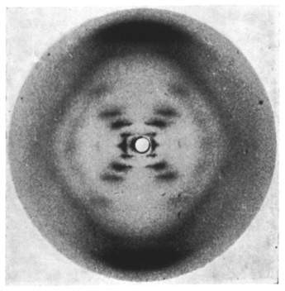
BONUS! In discussing the “previously published X-ray data”, Watson and Crick state they were “not aware of the details” when they devised their structure. In some opinions, this represents an inexcusable failure to give credit to another scientist.
Here is a picture of the X-ray data. Do you know who took this picture, and what specific evidence it supplied in regards to the structure of DNA?

- The last line of the article is a very famous line that is perhaps the understatement of the century because this knowledge started a scientific revolution: “It has not escaped our notice that the specific pairing we have postulated …..”
What do they say the specific pairing suggests?
- This paper is short because it was intended only to announce Watson and Crick’s discovery, since they believed they were in a race. They later published a paper with more details. Do you think this discovery was worthy of a Nobel Prize? Why or why not.
Speaking of Nobel Prizes and DNA, try playing this game (it uses FLASH and won’t work on your iPad…need to use a lap top) http://www.nobelprize.org/educational/medicine/dna_double_helix/

