|  |  |
| --- | --- |
| Getting to Know Your Cricket | Macintosh HD:Users:seh235:Desktop:Student Lab Exercise Logo.jpg |

**Background Information**

Crickets are most active at night. In nature they are found in tall grass, leaf piles, weeds, rock piles, and rotting logs. Meadows, pastures, and roadsides are all common places to find crickets. Some crickets might spend their entire lives inside buildings and basements, in warm places where there is enough moisture and food, under objects and in cracks or crevices.

Crickets are *omnivores* (they eat both plants and animals). They scavenge for dead insects and eat decaying material, fungi and young plants. Their predators include [birds](http://www.enchantedlearning.com/subjects/birds/printouts/" \t "_top), [rodents](http://www.enchantedlearning.com/subjects/mammals/rodent/Printouts.shtml" \t "_top), reptiles, other [insects](http://www.enchantedlearning.com/subjects/insects/printouts.shtml) (including beetles and wasps), and [spiders](http://www.enchantedlearning.com/subjects/arachnids/spider/Spiderprintout.shtml" \t "_top).

Crickets have both positive and negative effects on their environments. They help break down plant material, which increases soil quality, and they are an important food source for many other animals. However, large numbers of crickets can be destructive. They injure tree seedlings, and the males’ songs are very loud.

Crickets are *ectotherms*, or as some scientists like to say, variable-temperature animals. This means that a cricket’s body temperature changes according to the surrounding temperature. Crickets undergo incomplete metamorphosis. They hatch from eggs that the female deposits in soil using her ovipositor. Immature crickets (called nymphs) look like small adults, but the wings and ovipositors are not fully developed. They molt many times as they develop into adults.

Adult males of most cricket species begin to chirp when they are six to eight weeks old. They chirp by rubbing their forewings together. This process is called *stridulation*. The adult male stridulating organ consists of a smooth scraper on one forewing that is drawn across a serrated file on the other forewing to produce a song. Because crickets spend most of their time hidden in the grass or under leaves and almost never see each other, sound is one of their most important communication tools.

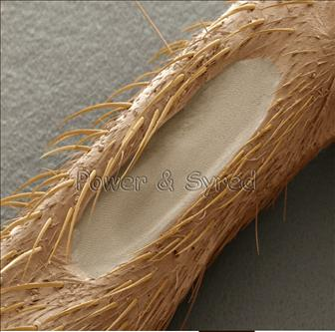Male field crickets (the ones you may find in your backyard) have at least three songs: one that attracts females, one that woos the female after he gets her attention, and one that warns other males to back off. Some males use the chirping sounds to mark their territory. Crickets can also disguise their “voices” when in danger. By lowering his “voice,” a cricket can make himself sound far away. Chirping patterns are specific to each species and females respond only to the song of their own species.

Females hear the males through a small pit or depression on the front side of the leg, that has a thin membrane stretched over it (Figure 1). This “ear” picks up the vibrations of the chirps and helps the females find the males.

*Figure 1: Female cricket’s “ear”*

**Based on what you now know about crickets’ food, temperature, and light preferences, design an appropriate habitat for your crickets. Use a separate sheet of paper to either describe it or draw and label it.**

**A Cricket’s Body Parts**

Read the following descriptions of a cricket’s body parts, then **label the diagram**:

Antennae- Help the cricket sense and smell objects in its environment.

Cerci- A pair of sensory organs at the end of the abdomen, which help the cricket feel in its environment.

Eyes- Simple eyes, which allow the cricket to distinguish between light and dark, AND compound eyes, which have hexagonal lenses so the cricket can see in many directions.

Wings- Help propel the cricket through the air.

Jumping Legs- Long, powerful jumping legs enable the cricket to jump high and far.

Palpi- These are the mouthparts that enable the cricket to pick up food. You’ll see them move when the cricket is eating.

Spiracles- A series of holes used for breathing.

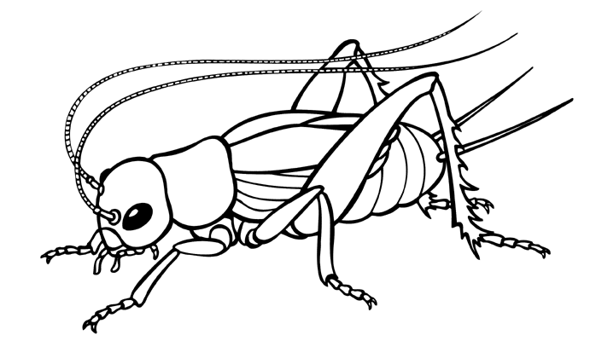

Now spend a few moments observing your cricket as it eats, using a magnifying glass. Write a description of how it eats:

\_\_\_\_\_\_\_\_\_\_\_\_\_\_\_\_\_\_\_\_\_\_\_\_\_\_\_\_\_\_\_\_\_\_\_\_\_\_\_\_\_\_\_\_\_\_\_\_\_\_\_\_\_\_\_\_\_\_\_\_\_\_\_\_\_\_\_\_\_\_\_\_\_\_\_\_\_\_\_\_\_\_\_\_\_\_\_\_\_\_\_\_\_\_\_\_\_\_\_\_\_\_\_\_\_\_\_\_\_\_\_\_\_\_\_\_\_\_\_\_\_\_\_\_\_\_\_\_\_\_\_\_\_\_\_\_\_\_\_\_\_\_\_\_\_\_\_\_\_\_\_\_\_\_\_\_\_\_\_\_\_\_\_\_\_\_\_\_\_\_\_\_\_\_\_\_\_\_\_\_\_\_\_\_\_\_\_\_\_\_\_\_\_\_\_\_\_\_\_\_\_\_\_\_\_\_\_\_\_\_\_\_\_\_\_\_\_\_\_\_\_\_\_\_\_\_\_\_\_\_\_\_\_\_\_\_\_\_\_\_\_\_\_\_\_\_\_\_\_\_\_\_\_\_\_\_\_\_\_\_\_\_\_\_\_\_\_\_\_\_\_\_\_\_\_\_\_\_\_\_\_\_\_\_\_\_\_\_\_\_\_\_\_\_\_\_\_\_\_\_\_\_\_\_\_\_\_\_\_\_\_\_

**Is My Cricket Male or Female?**

|  |  |
| --- | --- |
| **Female** | **Male** |

Though both males and females have two cerci, only females have an ovipositor. It may look like a third cerci, or appear to be a different length. Female crickets use this organ to lay eggs into the dirt. Only male crickets chirp—they do this to attract a female mate.

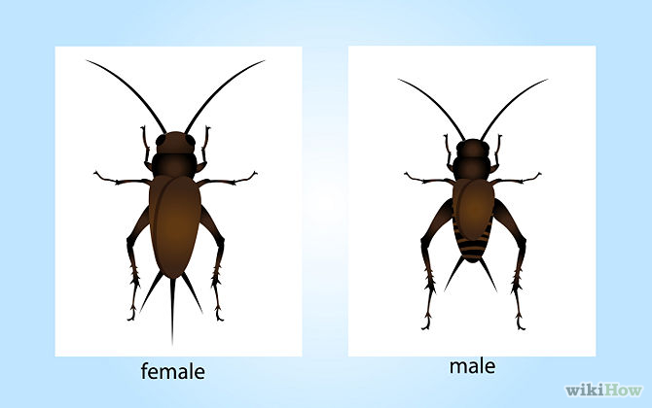

Ovipositor

# Extension Activities

* 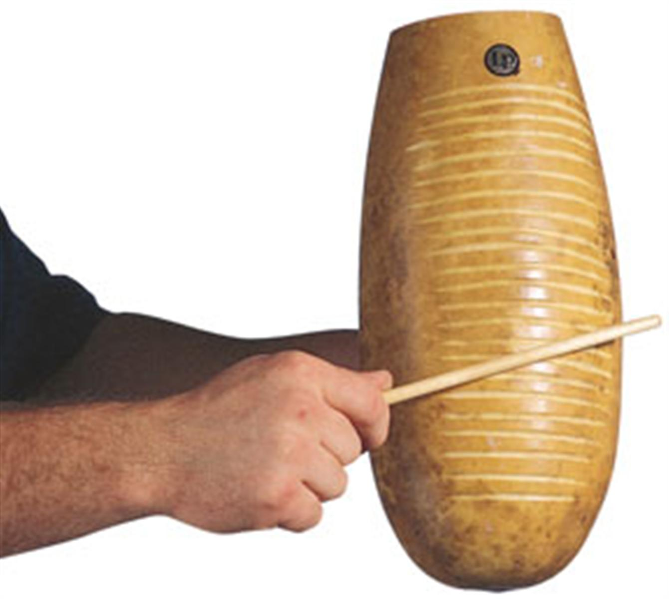Have you ever played the *Güiro*? It’s a Latin American percussion instrument made from a hollow gourd with parallel notches on the side. You play it by rubbing a stick along the notches to produce a clicking sound—the same way male crickets chirp! Crickets have a smooth scraper on one forewing (like the stick) that is drawn across a serrated file on the other forewing (like the notched body of the *güiro*) to produce a sound. If your school’s music department has a *güiro* you can play, see if you can make up at least three different songs to send different messages, like a cricket.

*Photo from: interstatemusic.com*

* 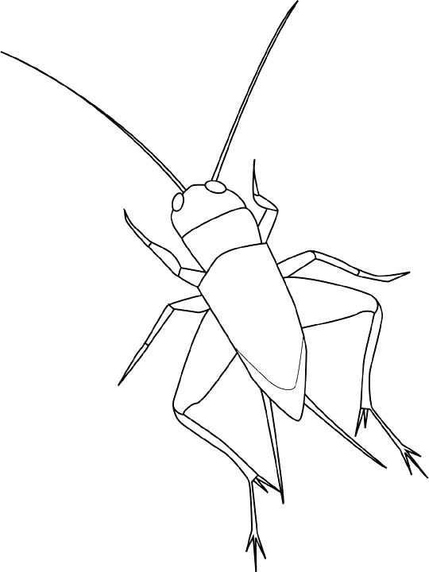You can use a simple drawing of a cricket to color in or draw your own cricket. Or, write instructions for someone else to draw a cricket. For example: 1. First draw a small semi-circle for the head; 2. Add two small circles on the top sides for the eyes. 3. Add a small square behind underneath the head; 4. Add an inverted triangle for the abdomen...etc.

*Photo from: http://www.animalstown.com/*

You could do this activity using the computer (on the Microsoft Word Drawing Toolbar), or draw it by hand.

* Make a Paper Cricket

Try making your own cricket out of paper! There are white and green templates to choose from on the next pages.

|  |  |
| --- | --- |
| 1. If you decide to print the white background, make sure you color it in before cutting. Fold the piece in half, as shown here. |  |
| 2. Cut along the thick lines, as shown here, in order to make the cricket's antennae, then fold them upwards, as shown in the illustration. |  |
| 3. Fold along the dotted lines to make the cricket's body, apply glue to the border and stick the two ends together, as shown here. |  |
| 4. Cut out four strips of paper, twist them and glue them together to make the legs, as shown here. |  |
| Your cricket will look like this when it’s done: |  |

*From the ‘Paper Zoo’:* [*http://www.elbalero.gov.mx/kids/bio/html/zoo\_papel/iniciozoo.html*](http://www.elbalero.gob.mx/kids/bio/html/zoo_papel/iniciozoo.html)

# 

# Henry David Thoreau was a famous American naturalist and poet of the 1800s. Here is what he wrote about crickets in his journal on August 21, 1851:

# *“I hear a cricket in the Depot field, walk a rod or two, and find the note proceeds from near a rock. Partly under a rock, between it and the roots of the grass, he lies concealed,—for I pull away the withered grass with my hands,—uttering his night-like creak, with a vibratory motion of his wings, and flattering himself that it is night, because he has shut out the day. He was a black fellow nearly an inch long, with two long, slender feelers. They plainly avoid the light and hide their heads in the grass. At any rate they regard this as the evening of the year. They are remarkably secret and unobserved, considering how much noise they make. Every milkman has heard them all his life; it is the sound that fills his ears as he drives along. But what one has ever got off his cart to go in search of one? I see smaller ones moving stealthily about, whose note I do not know. Whoever distinguished their various notes, which fill the crevices in each other’s song? It would be a curious ear indeed, that distinguished the species of the crickets which it heard, and traced even the earth-song home, each part to its particular performer. I am afraid to be so knowing. They are shy as birds, these little bodies. Those nearest me continually cease their song as I walk, so that the singers are always a rod distant, and I cannot easily detect one. It is difficult, moreover, to judge correctly whence the sound proceeds. Perhaps this wariness is necessary to save them from insectivorous birds, which would otherwise speedily find out so loud a singer. They are somewhat protected by the universalness of the sound, each one’s song being merged and lost in the general concert, as if it were the creaking of earth’s axle.”*

# Research about crickets in different parts of the world. Did you know they are kept as pets in some places? People enjoy listening to their songs. Try reading stories about crickets from other cultures. Check out The Golden Cricket: A Story of Luck and Prosperity by Marilee Joy Mayfield, or The Cricket’s Cage: A Chinese Folktale by Stefan Czernecki.

# Go online and check out <http://www.hup.harvard.edu/features/cricket-radio/> to make your own Cricket Radio!

**Sources**

<http://insected.arizona.edu/cricketinfo.htm>

<http://www.mrnussbaum.com/insects-play/crickets/>

http://www.enchantedlearning.com/subjects/insects/orthoptera/Cricket.shtml