The Float Leaf Disk Assay for Investigating Photosynthesis

- Prepare a 0.2% solution. This is not very much- it is only about 1/8 of a teaspoon of baking soda in 300 ml of water.
- Add 1 drop of dilute liquid soap to this solution. The soap wets the hydrophobic surface of the leaf, allowing the solution to be drawn into the leaf. It’s difficult to quantify this since liquid soaps vary in concentration. Avoid suds. If your solution generates suds, then dilute it with more bicarbonate solution.
- Cut 10 or more uniform leaf disks for each trial (single hole punches work well for this but stout plastic straws will work as well).
Infiltrate the leaf disks with sodium bicarbonate solution.
- Remove the piston or plunger and place the leaf disks into the syringe barrel. Replace the plunger being careful not to crush the leaf disks. Push on the plunger until only a small volume of air and leaf disk remain in the barrel (< 10%).
- Pull a small volume of sodium bicarbonate solution into the syringe. Tap the syringe to suspend the leaf disks in the solution. They will all float.
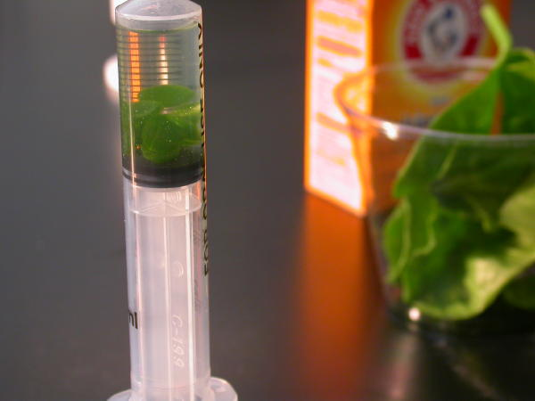
- Holding a finger over the syringe-opening, draw back on the plunger to create a vacuum. Hold this vacuum for about 10 seconds. While holding the vacuum, swirl the leaf disks to suspend them in the solution. Let off the vacuum. The bicarbonate solution will infiltrate the air spaces in the leaf causing the disks to sink. You will probably have to repeat this procedure 2-3 times in order to get the disks to sink. If you have difficulty getting your disks to sink after about 3 evacuations, it is usually because there is not enough soap in the solution. Add a few more drops of soap.
- Pour the disks and solution into a clear plastic cup. Add bicarbonate solution to a depth of about 3 centimeters. Use the same depth for each trial. Shallower depths work just as well.
- For a control, infiltrate leaf disks with a solution of only water with a drop of soap- no bicarbonate.
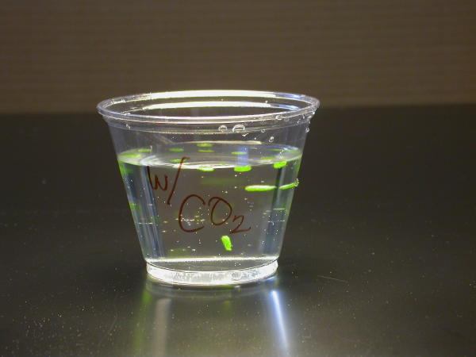
- Place under the light source and start the timer. At the end of each minute, record the number of floating disks. Then swirl the disks to dislodge any that are stuck against the sides of the cups. Continue until all of the disks are floating.

