Evolving Trees | 
This exercise introduces the basic methods of phylogenetic analysis. You will make an hypothesis about evolutionary relationships of groups of organisms and become familiar with the methods using the basic principles of taxonomy and classification for building evolutionary trees.
Part I
Using the cladogram below, (Figure 1, Modified from Gergus and Schuett, 1997), complete the attached chart by determining which taxa (groups) have the characters listed in the left column. With this exercise, you will be working backwards utilizing the steps for building a cladogram.
Figure 1. Cladogram.
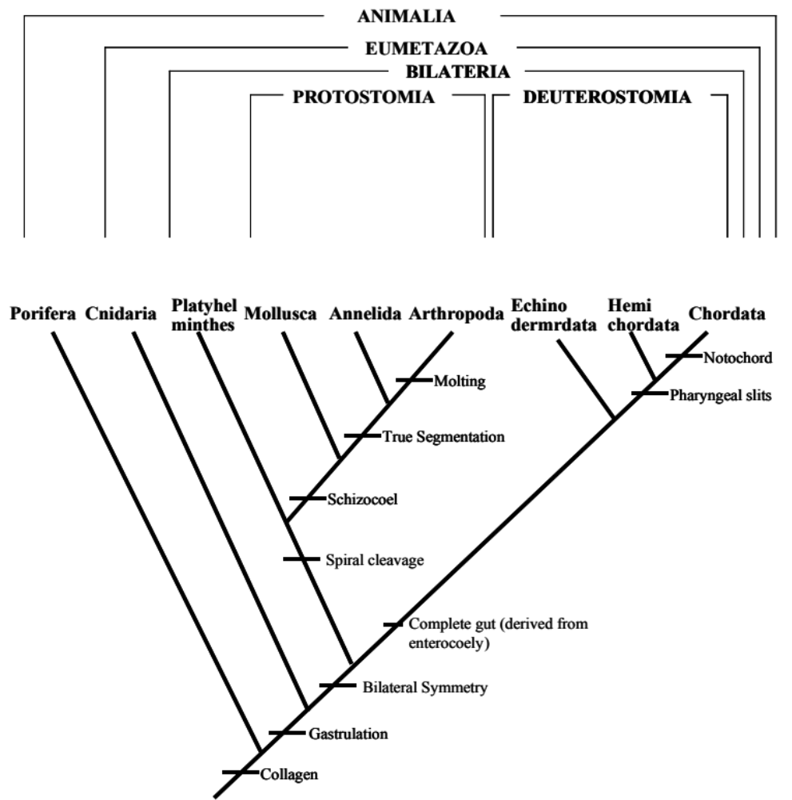

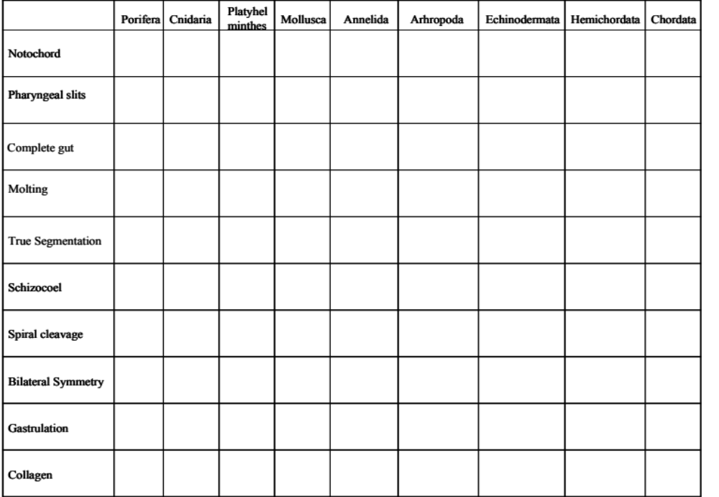
Questions
Describe how the pattern in the chart reflects the pattern of the cladogram.

Part II
Illustrated on the last page is a group of hypothetical fly species.
- Form an hypothesis that states the evolutionary relationships among the flies. Sketch your predicted cladogram below.

- Test your hypothesis by following the steps below to build a cladogram.
  - Carefully compare the flies’ features (characteristics) and identify the characteristics that are present or absent for each animal.
  - Fill out the chart below to arrange the data (+ = feature is present).
 | Species A | Species B | Species C | Species D | Species E
Large Wings
Stinger
Wing Veins
Bug Eyes (Bg)
Leg Bulbs
- Build a series of cladograms beginning with Large Wings and adding each characteristic as you go. Keep it simple. Sketch the new cladograms below. (Hint: the absence of a trait can also be a characteristic.)

- Compare the final cladogram to your hypothesis. Does the data support or reject your hypothesis? Are there other acceptable cladograms? Explain.

- Practice your taxonomy skills. Using the Figure 1 as an example, use your final cladogram and create a hierarchical system to name the groups of flies.


