|  |  |
| --- | --- |
| The Mystery of the Skulls:  What Old Bones Can Tell Us About Hominins | logo black |

**Name:________________________________________**

In this laboratory activity, you and your investigative team will examine 9 skulls to expose the secrets of how these species lived. In a CSI-type analysis, your team will collect and compare data that will enable you to unlock the mystery of the relatedness of these species.

**Introduction**

When scientists discover an organism, whether it is a fossil or a living species, they set out to determine whether this organism is a new species or one that has already been described. With living, or recently dead specimens, this task is reasonably easy because usually an entire body is found, or because DNA analysis can be used to compare the specimen to other known species. With fossils, the task is much more difficult because most of the time only a skull, a fragment of a skull, or some other part of the body is found. Scientists must then determine how similar or different it is to species that are already described. In some cases, the differences are so significant that they cannot be explained as individual differences or differences between the sexes. In these cases, scientists decide that they have found a new species. From here, again they make comparisons to other described species to decide how to classify their new discovery. Organisms that are similar to those already described would be placed in the same genus, while those that are very different would be classified in a different genus, or even a different family within the accepted classification system.

The study of human origins is known as paleoanthropology. Paleoanthropologists have found about 20 extinct species that are closer to humans than to other primates such as chimpanzees, gorillas, baboons, and macaques. These species are known as hominins (the older synonym hominid is still used in some textbooks). Among hominins, skulls of different species have specialized features that are used to classify them. These features include, among others, the presence or absence of a brow ridge, cranial capacity (the volume of the braincase), and the placement of the foramen magnum (the hole in the underside of the skull through which the spinal cord attaches to the brain). You will examine the same features that scientists do in the skulls that you will be working with. These features will help you to determine how closely related the skulls are to each other.

One of the most exciting aspects of examining old bones, however, is that they can reveal information about how the organism lived. Just from information gathered from the bones, scientists can determine whether the species walked on 2 legs (bipedal) or 4 legs (quadrupedal).

**Pre-Lab Questions**

1. What is the difference between bipedal and quadrupedal?

2. Where is the foramen magnum located?

3. What is the function of the foramen magnum?

4. How many species of extinct hominins have been described by paleoanthropologists?

5. Why is the task of classifying fossil organisms more difficult than the task of classifying living organisms?

**Procedure Part I: *Collecting Your Data***

Your classroom will be set up with 4 workstations through which you and your team will rotate. Three of these stations include 3 skulls, and you will make observations and measurements that you will record and use later to determine the identity and relatedness of these specimens. At the fourth station, you will be asked to graphically represent the time during which each of the hominins lived. You will have approximately 10 minutes at each station during which to make your observations and measurements OR to make your graph.

Look for the letter codes written on the underside of each skull. Your investigative team’s mission is to identify each skull with its proper scientific name and figure out how it is related to the other skulls.

Skulls found at 3 workstations:

**Station 1 Station 2 Station 3**

**S** **G** **B**

**N** **H** **K**

**E** **A** **L**

At **Station 4** you will create a geological time scale. First you should label the Geological Time Scale graph so that 0 years (= present time) is set far to the right on the x-axis, and each tick mark represents one million years ago (mya). Remember that we are going BACKWARDS in time, so it might help to think of the years as “negative” years from the present, i.e., 2 mya = - 2 million years from the present, hence further to the left on the

x-axis.

You should mark/shade the following time periods on each bar of the graph starting with the top one:

1. 160,000 years ago to present
2. 200,000 to 30,000 years ago
3. 1.8 to 0.2 mya
4. 1.9 to 1.5 mya
5. 2.4 to 1.6 mya
6. 3.0 to 2.4 mya
7. 2.2 to 1.0 mya
8. 3.5 to 3.3 mya
9. 4.0 to 2.7 mya

|  |  |  |  |  |  |
| --- | --- | --- | --- | --- | --- |
|  |  |  |  |  | **I** |
|  |  |  |  |  | **II** |
|  |  |  |  |  | **III** |
|  |  |  |  |  | **IV** |
|  |  |  |  |  | **V** |
|  |  |  |  |  | **VI** |
|  |  |  |  |  | **VII** |
|  |  |  |  |  | **VIII** |
|  |  |  |  |  | **IX** |
|  |  |  |  |  |  |

**Geological Time Scale (mya)**

Each Roman numeral represents the time period for one of the 9 skulls. Think of each time period as a fossil layer in which a skull was discovered. From a collaborating lab that performs radiometric dating of fossils, you received the age of each of the fossil layers (I through IX), and will later pair these ages up with the identity of the skulls found in these layers (your teacher will provide you with the corresponding letter codes at a later time). As an investigator, you will want to establish the relationship between these layers and the corresponding skulls – see the column labeled “Age” in Table 1. Once you have filled in the graph above, you will later be able to determine the time intervals during which each species lived, and possibly coexisted with others. Remember, not all fossils were found in the same location, or even the same continent. You will eventually place this information in a phylogenetic tree that shows the relatedness of these and other hominin species.

At **Stations 1 – 3**, you will be presented with 3 skulls at a time and should fill out the table below by looking at 1 feature at a time. When you are examining the skulls, you should collect the data to complete the following: FL, SC, BR, P/S, CL, FB, SL, CC. If you have time left before you have to rotate to the next workstation, you may calculate the FMI (Foramen Magnum Index, see directions below), otherwise leave this calculation for a later time. The gray shaded columns (Class AVG FB, Class AVG SL, and CLASS FMI) and the last three columns (CCC, ESV, ACC, and Age) should be left blank for now – you will return to them later. **Make sure that you record your data in the row (Skull Letter Code in the leftmost column) that corresponds to the particular skull that you are examining.**

**FL** - Forehead Length: Look at the front of the skull and determine if the forehead is Long (L) or Short (S). The forehead is roughly the area from the top of the eye socket to the part of the skull that begins to flatten. Visualize your own forehead and imagine the part between your eyebrows to where your hairline begins. This is the forehead. If this length is at least the length of the average thumb, we consider it to be Long (L).

**SC** - Sagittal Crest: Look at the top of the skull and determine if a sagittal crest is present (+) or absent (-). A sagittal crest is a ridge of bone that protrudes from the skull and runs on top of the skull from front to back.

**BR** - Brow Ridge: Look at the front of the skull and determine if a brow ridge is present (+) or absent (-). A brow ridge is a bone that runs the entire width of the skull just above the eyes.

**P/S** - Prognathism/Snout: Look at the front of the skull and determine if it exhibits prognathism (+) or not (-). Prognathism refers to the protrusion of the mouth from the front of the skull. Animals with prognathism are thought of as having a ‘snout’. To determine if a skull exhibits prognathism, press your fingers along the base of the nose opening (Anterior Nasal Spine) and rest it on the top of the maxilla (where the top teeth attach). If this area is greater than 1 index finger in width, then we consider the skull to exhibit prognathism.

**CL** - Canines Long (and sharp): Look at the teeth in the top of skull and determine if the canines are long and sharp (+) or (-). The canines are sometimes referred to as ‘fangs’. They are the third pair of teeth from the front – in your mouth, your 2 front teeth and the next one in each direction are called ‘incisors’. The next tooth on either side is slightly pointy and called ‘canine’, but in many animals, like dogs and cats, these canines are very long and sharp. If the canines are not present in the skull, the cell in the table has been blackened out. If you notice that the canines are ‘fang-like’, we consider them to be long and sharp (+).

**FB** - Foramen Magnum Distance to Back (mm): Look at the underside of the skull and determine the distance between the foramen magnum and the back of the skull, measured in mm). The foramen magnum is the hole in the skull through which the spinal cord attaches to the brain. To determine this distance, place a ruler on the base of the skull, starting at the back most edge of the foramen magnum and measure the distance to the end of the skull (see diagram below). Be sure to follow the directions that were demonstrated by your teacher.

|  |
| --- |
|  |

**SL** - Skull Length (mm): Look at the underside of the skull and determine the length of the skull (measured in mm). Place a ruler on the base of the skull (see diagram above) and measure the distance from the back of the skull to the end of the palate (roof of the mouth). Be sure to follow the directions that were demonstrated by your teacher.

**FMI** - Foramen Magnum Index: Calculate the ratio using the Foramen Magnum Distance to Back (FB) and the Skull Length (SL). To do this for each skull, divide the value that you recorded for FB by the value that you recorded for SL, and fill in the corresponding box to the 3rd digit after the decimal point.

**CC** - Cranial Capacity: Look at the skull from the top and sides and estimate the number of average fists that would fit inside the cranium (the area of the skull where the brain is located). For these skulls, limit your estimate to 2, 3 or 4.



Next you will take additional measurements of the skulls and eventually compare these measurements to the ones that you made previously using your fists to estimate cranial capacity.

You and your team will rotate through the sets of skulls again, this time taking measurements to estimate the volume of the skulls. Once again, you will be presented with

3 skulls at a time. You should collect the data to complete the columns L, W, and H of **Table 2**. **DO NOT calculate ASV (Approximate Skull Volume) at this time** because you will be using the class data to make these calculations. The gray shaded columns Class AVG L, Class AVG W, Class AVG H, and ESV (Estimated Skull Volume) should be left blank for now – you will return to them later.

**L** – Length of the braincase: Position three rulers as shown on the left side of the photograph below. Ruler 1 should stand perpendicular to the table, and rest at the back of the skull. Ruler 2 should also stand perpendicular to the table, but rest on top of the skull, just behind the brow ridge. If a brow ridge is not present, align the ruler against the forehead in the same perpendicular orientation (imagine it flat against your forehead). Ruler 3 should rest on the highest point of the cranium, making sure that it is parallel with the table. Once all 3 rulers are in place, read the distance on ruler 3 between the 2 upright rulers in mm (see the right side of the photograph below). Record your data in the first column labeled “L”.

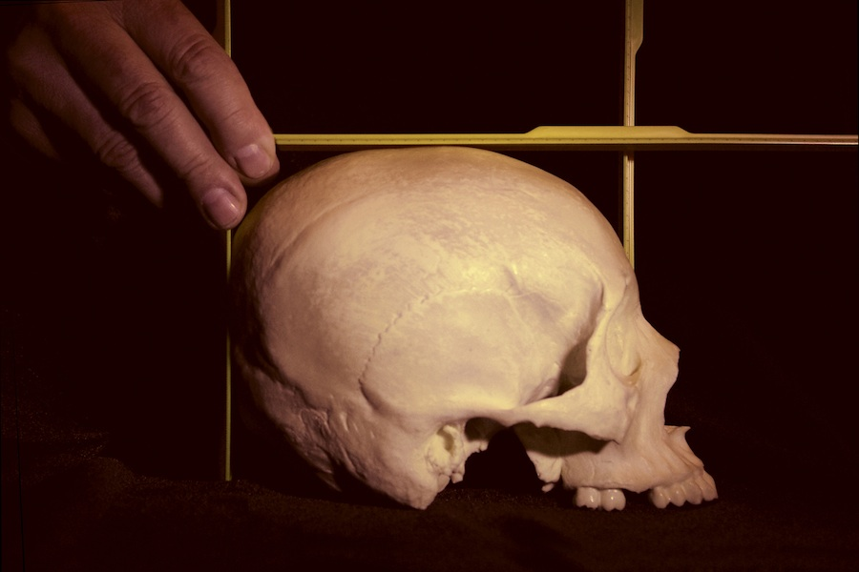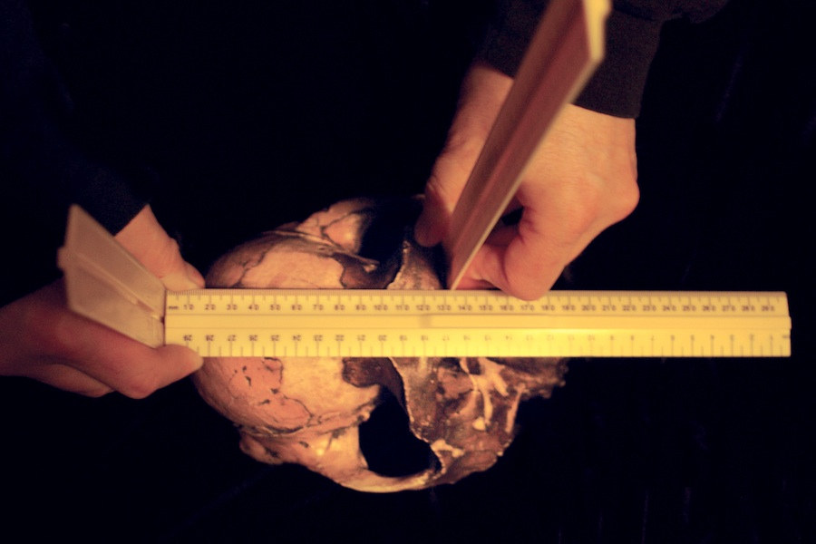

*Skull length measurements for two different species: View from the side (left), view from the top (right).*

**H** – Height of the braincase: Without moving the 3 rulers from your measurement of Length, read the height of the skull off ruler 1 (at the back of the skull) in mm (also see photographs below). Record your data in the first column labeled “H”.

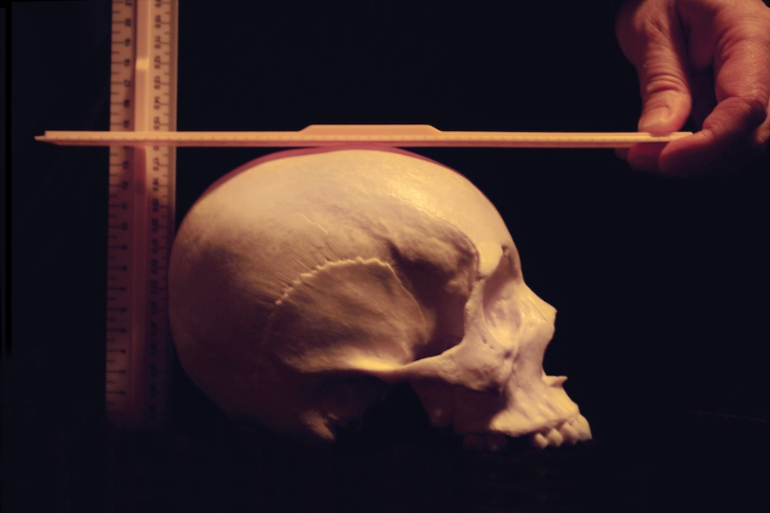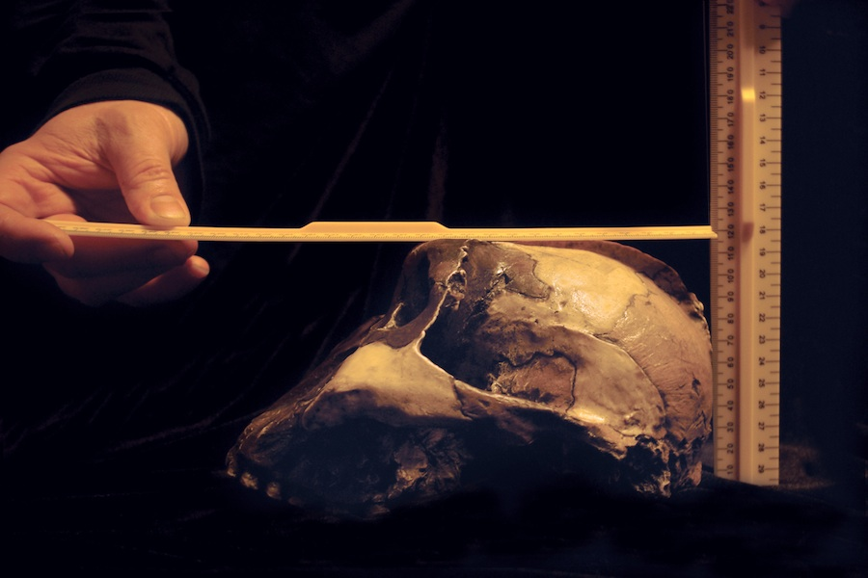

*Skull height measurement: view from the side for two different species. Note: upright ruler in the front of skull is removed.*

**W** – Width of the braincase: Position 3 rulers as shown in the photographs below. Rulers 1 and 2 should stand perpendicular to the table and flat against the skull (imagine 2 rulers flat against where the ears would be positioned). Position ruler 3 resting on the top of the skull, making sure that it is parallel with the table. Read the distance between rulers 1 and 2 in mm. Record your data in the first column labeled “W”.

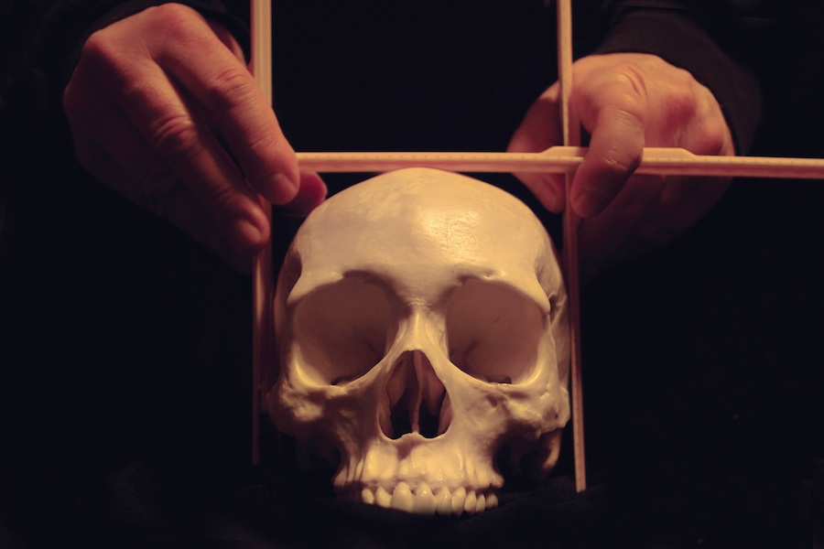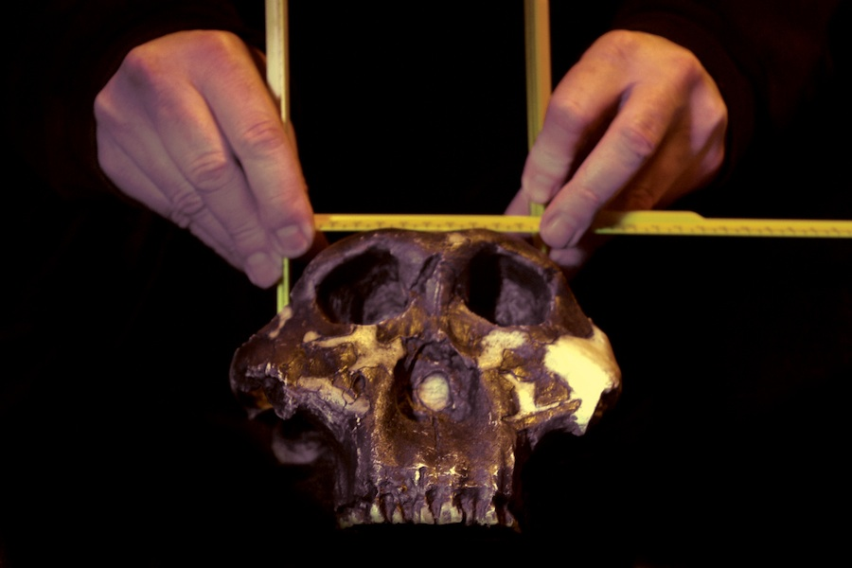

*Skull width measurement for two different species with the three rulers perpendicular to each other. Note the placement of the upright rulers on the sides: for the species on the right photograph, the rulers are not at the widest point of the skull (the ‘zygomatic arch’ or cheek bone), but at the widest point of the braincase further back.*

Next you will assess the approximate shape of each cranium:

**Cranium Shape** – Look at each skull from the top. Specifically, look at the shape of the cranium (the part of the skull where the brain is located). If the shape is boxy, we consider it to be Cuboid (C). In other words, it more closely resembles that of a box than that of a ball. If the shape is rounded, then we consider it to be Spheroid (S). In other words, it more closely resembles that of a ball than that of a box.

***Table 2***

|  |  |  |  |  |  |  |  |  |  |
| --- | --- | --- | --- | --- | --- | --- | --- | --- | --- |
| Skull  Letter  Code | L (mm) | Class  AVG L | W (mm) | Class  AVG W | H (mm) | Class  AVG H | ASV  (LxWxH/1000)  (cm3) | ESV  (cm3) | Cranium  Shape  (C/S) |
| S |  |  |  |  |  |  |  |  |  |
| N |  |  |  |  |  |  |  |  |  |
| E |  |  |  |  |  |  |  |  |  |
| G |  |  |  |  |  |  |  |  |  |
| H |  |  |  |  |  |  |  |  |  |
| A |  |  |  |  |  |  |  |  |  |
| B |  |  |  |  |  |  |  |  |  |
| K |  |  |  |  |  |  |  |  |  |
| L |  |  |  |  |  |  |  |  |  |

*All of the measurements in this table should be taken with the top of the skull facing upwards (natural resting position) with the lower jaw removed.*

**Procedure Part II: *Organizing Your Data***

Once you have collected all the data for Tables 1 and 2 in Part I of the lab, you can begin organizing your data (if you have not already calculated FMI, you should do so now). You also will begin calculations for comparative analysis so that you can draw conclusions about relatedness of these 9 hominins. To do so, fill in the Table 3 below following your teacher’s guidance. Once you and your team have gathered all of the data for Table 1, you will need to compile the data from all other teams for FB and SL into Table 3. When you have compiled the class data, you can then calculate the class average for FB (Class AVG FB) and SL (Class AVG SL); and from these data you can calculate the Class FMI (AVG FB/AVG SL). These calculated averages can then be transferred into the corresponding gray shaded columns in Table 1.

***Table 3***

|  |  |  |  |  |  |  |  |  |  |  |  |
| --- | --- | --- | --- | --- | --- | --- | --- | --- | --- | --- | --- |
| Skull Letter Code | FB (mm) | FB (mm) | FB (mm) | FB (mm) | Class AVG FB | SL (mm) | SL (mm) | SL (mm) | SL (mm) | Class AVG SL | Class FMI  AVG FB/ AVG SL |
| S |  |  |  |  |  |  |  |  |  |  |  |
| N |  |  |  |  |  |  |  |  |  |  |  |
| E |  |  |  |  |  |  |  |  |  |  |  |
| G |  |  |  |  |  |  |  |  |  |  |  |
| H |  |  |  |  |  |  |  |  |  |  |  |
| A |  |  |  |  |  |  |  |  |  |  |  |
| B |  |  |  |  |  |  |  |  |  |  |  |
| K |  |  |  |  |  |  |  |  |  |  |  |
| L |  |  |  |  |  |  |  |  |  |  |  |

To complete Table 4, copy your L, W and H data from Table 2 into the first columns with the corresponding labels in Table 4. Collect the data from the other teams in your class and complete Table 4 by calculating the average for L, W and H (Class AVG L, Class AVG W, Class AVG H) **and record these averages in the corresponding gray shaded columns of Table 4, and then Table 2 as well.** Now you can complete your calculations for ASV and ESV in Table 2, which are defined as follows:

**ASV** - Approximate Skull Volume: calculate the product of AVG L, AVG H, and AVG W, and divide your answer by 1000.

**ESV** - Estimated Skull Volume: the measurements that you took of the skull will overestimate the cranial capacity because skulls are not cubes. To correct this, you should divide the number that you calculated in the previous column (ASV) by 2 for species S, N, E, G and H, and by 3 for all other species (A, B, K and L). You use a different correction factor for each group of skulls because the skull shapes vary between the two groups.

***Table 4***



Next, convert your fist estimates for Cranial Capacity (CC) into an approximate measurement (CCC) by using the formula CC x 300 cm3 - the estimated volume of an average human fist is 300 cm3. These calculations can be added to Table 1.

**At this point in time, your teacher will provide you with the Actual Cranial Capacity (ACC) for each skull based on scientists’ measurements.** Use these data to complete the appropriate column in Table 1.

Compare your data for FMI to the class FMI, which is based on average class data.

1. Why is the class FMI usually a better indicator of the location of the foramen magnum than your individual calculation?

Compare the data that you calculated for cranial capacity (CCC) to the Actual Cranial Capacity (ACC), which has been determined by scientists in Table 1.

2. Which of your calculations have overestimated the cranial capacity?

3. Which of your calculations have underestimated the cranial capacity?

4. Which of your calculations are within the range of the Actual Cranial Capacity?

5. What could you do to get your Calculated Cranial Capacity value closer to the actual value?

6.a Imagine using ping pong balls instead of fists as your unit of measure for cranial capacity, do you think that your calculated value would be closer to or further from the actual value?

b. Why?

7.a What about using an even smaller unit of measure, such as grains of rice or sand? Do you think that your calculated value would be closer to or further from the actual value?

b. Why?

c. What new problems might you encounter when using such small units of measure?

d. How could you overcome those problems? What tools could you use?

8.a After measuring the skull volume using rulers, you applied a correction factor to arrive at your ESV. Why was a correction factor necessary?

b. Why was a different correction factor used for different groups of species?

c. What was the shape of the cranium of the skulls for which you applied a correction factor 2?

d. What was the shape of the cranium of the skulls for which you applied a correction factor 3?

**Your teacher will now also provide you with the Skull Letter Codes that correspond to each time period in your Geological Time Scale graph.** Once your teacher has identified the time period that corresponds to each skull, write the single letter code for each skull in the area that you shaded within the Geological Time Scale graph. Once you have added the single letter codes into this graph, you can then transfer these identified ages into the appropriate places in the last column (Age) of Table 1.

9. Which time interval has the greatest number of hominin species coexisting?

10. What is the time period during which species S has been the only surviving hominin?

As scientific investigators, your team will now begin to compare the data that you have collected from different skulls. Specifically, you will put some of your Class FMI data onto a graph in order to compare them to each other.

The location of the foramen magnum in the skulls will reveal some interesting information about the way that the hominins lived. The FMI is an indicator of the location of the foramen magnum on the underside of the skull. The closer to 0.3 the FMI of a species is, the better adapted this hominin is to upright/bipedal walking. In order to visualize any trends in the location of the foramen magnum among the hominin skulls, you will enter the Class FMI for the 4 skulls (L, H, G, N) on the Foramen Magnum Index graph (see below). Determine the FMI for dog (a quadruped) and human (a biped) using the scales provided. Focus on the bottom end of the foramen magnum, which is labeled for these two species and write this number on the line above the diagrams of these 2 skulls. Next in Table 1, locate the Class FMI values for the 4 other hominin species (L, H, G, N). Write these values on the lines above each corresponding scale. Now you can plot your numbers on the provided scales with round dots approximately the same size of the illustrated foramen magnum of the dog.

|  |
| --- |
|  |

***Foramen Magnum Index graph***

11. Examine the Foramen Magnum Index graph. Do you notice any trend in the FMI as you look from left (dog) to right (human) among the hominin skulls? And if so, describe it.

12. Determine which of the skulls in this graph is the oldest by looking at the Geological Time Scale graph. Now, compare the FMI of this oldest species to that of the dog and human. Do you think that this species was bipedal or quadrupedal? Why?

13. Which of the 4 species (L, H, G, N) is best adapted to upright walking? Why?

14. Do any of the Class FMI in Table 1 closely match the one provided for the human in your graph? If so, which one(s)?

**Procedure Part III: *Analyzing Your Data***

In order to determine whether a relationship exists between the Foramen Magnum Index and Cranial Capacity, you will plot these two parameters for each species in the provided FMI-Cranial Capacity graph below. For this you need to first complete Table 5 using your Class FMI from Table 1. The provided Average Cranial Capacity is based on the Actual Cranial Capacity (ACC), also from Table 1. You will notice that there is a new Skull Letter Code “M” in Table 5. This “M” is also the only data point already filled in on the FMI-Cranial Capacity graph and represents the macaque, an old-world monkey species that is quadrupedal. From this data point “M” you can determine the macaque’s Average Cranial Capacity and FMI and add them to Table 5. With Table 5 now completed, plot the values in the graph and write the Skull Letter Code next to each data point. **Do not connect the dots with lines.** Instead, once you have plotted the points for all of the skulls, you should draw a “best-fit curve”. While there is a way to mathematically determine the location of such a curve, you can estimate it by visualizing the sum of the distances from each point above and below the curve. These 2 sums should be approximately the same. If you are having trouble finding the best-fit curve, your teacher will assist you.

***Table 5***

|  |  |  |
| --- | --- | --- |
| *Skull Letter Code* | *Average Cranial Capacity (ccm)* | *Class FMI (from Table 1)* |
| S | 1350 |  |
| N | 1450 |  |
| E | 1025 |  |
| G | 900 |  |
| H | 550 |  |
| A | 450 |  |
| B | 450 |  |
| K | 400 |  |
| L | 463 |  |
| M |  |  |

***FMI-Cranial Capacity graph***

15.a Excluding the macaque M, group the 9 species into 3 clusters of two or more points that are near each other. Draw a circle around each cluster and list the letters for each of these clusters.

b. Comparing cluster 1 (with 5 data points) to M (macaque), which variable accounts for the major difference between them, FMI or Cranial Capacity?

c. Comparing cluster 2 (with 2 data points to the right of cluster 1) to cluster 1, which variable accounts for the major difference between them, FMI or Cranial Capacity?

d. Comparing cluster 3 to cluster 2, which variable accounts for the major difference between them, FMI or Cranial Capacity?

e. Using the Geological Time Scale graph as a reference, list the three clusters in order of their relative age:

cluster #___ is older than cluster #___ is older than cluster #___

f. As you go from oldest to most recent cluster of hominin species, which factor (FMI or Cranial Capacity) changed more?

**Part IV: *Putting It All Together***

In this final part of the investigation you will combine your results with data that other scientists have already collected. Specifically your goal is to complete a phylogenetic tree that shows how all these hominins are related to each other and how paleanthropologists concluded that they have evolved. This phylogenetic tree contains many more species than the 9 that you have been studying. In this phylogenetic tree all the hominins are already correctly placed regarding their ages, and they are labeled with their scientific names. Your task is to fill in the Skull Letter Codes from your 9 skulls into the correct gray squares that are drawn next to some of the hominins - use the information that you gathered in Table 1 and the Geological Time Scale graph. Tip: the biggest help for this undertaking is most likely the age of the fossil species (see time axis on each side of the tree). Both the solid and stippled parts of the bars next to the skull sketches indicate the time period during which the species lived.

Other characteristics, especially skull shape, should also be taken into account when making your final determination. Once you have completed filling in the gray squares, you should write the names of the 9 skulls in Table 1. Use the space in the Skull Letter Code column.

Check with your teacher to see if you have correctly named the skulls! If so, congratulations – you solved the mystery!

**Post-Lab Questions**

1.a Concluding from the Phylogenetic Tree, what is the greatest number of hominins that coexisted?

b. List the names of these species (your answer may include species that were not represented by skull specimens in this investigation).

c. What is the approximate time period during which these multiple species coexisted?

2.a Based on your answers for question 15, what was the driving force in early hominin evolution?

b. What was the driving force in later hominin evolution?

3.a What trend do you notice in the shape of the cranium as hominin evolution progress?

b. Why do you think this trend occurred?

4.a Looking at the oldest fossil in the tree, *Sahelanthropus tchadensis*, and based on the evidence you collected during this investigation, to which of your 9 investigated species is that old hominin most similar with regard to cranial capacity?

b. And with regard to FMI?

c. Does the Phylogenetic Tree support your hypotheses for 4.a and b?

d. Go back to the FMI-Average Cranial Capacity graph that you completed earlier. Place a mark (use a big X) on the best-fit curve for *Sahelanthropus tchadensis*. Explain your reasoning for the placement of your X in the graph.

Macintosh HD:private:var:folders:AX:AXB44qXxE7O8KTVXPh3Qw++++TI:-Tmp-:TemporaryItems: HomPhylRE14bar.pdf

**Phylogenetic Tree**