How Many Teeth Do I Have?
In your mouth, you have at least three different types of teeth, all with different purposes. Other animals have these types of teeth too!
- Incisors specialize in cutting or snipping off pieces of food. They are broad and flat, with a narrow edge, and are located at the front of the mouth.
- Canines rip and tear tough foods; they also pierce and hold. Canines are located behind the incisors on both sides of the mouth.
- Molars are large teeth with broad surfaces designed for crushing, grinding and chewing food. They can be found at the back of the mouth.
The diagrams below show each of these tooth types from the side (the darker part is the root) and the top (the chewing surface).
Procedure
- Getting to Know Your Teeth
Feel your teeth with your tongue. Using the diagram above to review the information on the different types of teeth that you have in your mouth.
- Do all your teeth feel the same?
- What kinds of surfaces do you feel?
- How many different types of teeth can you feel?
- How many different tooth sizes can you feel?
- Where are the largest teeth located?
- Do some teeth feel flatter or duller than others?
- Do some teeth feel sharper than others?
- If so, where are they located?
- Why do you think you have different types of teeth?
Now, predict how many of each tooth type you have (don’t count yet!). Write your predictions in the first column Table 1 below.
- Next, read the book How Many Teeth by Paul Showers. Record the number of each type of tooth that the book says you have in the same table.
Table 1.  Numbers of Teeth | Predicted Number | Number from  How Many Teeth? Book | Counted Number
Incisors
Canines
Molars
Lower Jaw
Upper Jaw
TOTAL

- Now wash your hands with antibacterial soap. Use a mirror and work with a partner to count your teeth for the next section. You may want to use a coffee stirrer or Q-Tip (provided by your teacher) to help you count. Record your data in Table 1.

Class Data
Your teacher will now ask you how many teeth you counted and tell you how many teeth your classmates counted. Listen carefully in class so you can write down these answers:
How many students have 20 teeth? _____________
How many students have 19 teeth? _____________
How many students have 18 teeth? _____________
How many students have 17 teeth? _____________
How many students have 16 teeth? _____________
How many students have 15 teeth? _____________
How many students have less than 15 teeth? ____________
Use the next page to make a graph of this information.

Title of Graph: ________________________________________________

12
11
10
9
8
7
Number of Students
6
5
4
3
2
1
 | 20 | 19 | 18  Number of Teeth | 17 | 16 | 15 | Less than 15
Optional Worksheet 1: Younger Students
How old are you in months? You can find out by using a calculator to multiply your age by 12, and then adding the number of months over your age that you are.
Fill out Table 2 below by asking your group members these questions:
Table 2: Age in Months vs. Number of Teeth | Example | You
How old are you in months? | 88
How many teeth do you have? | 19
Now you will put a dot above the students’ age and next to their number of teeth on the graph below. The example from Table 2 is shown.
Number of Teeth
20
19
18
17
16
15
Less than 15
Title of Graph: ________________________________________________
Students’ Age (Months)
85 87 89 91 93 95 97 101

Can you find any trends in the number of teeth versus students’ age? If so, why do you think these may be? __________________________________________________________________
____________________________________________________________________________________________________________________________________________________________
Optional Worksheet 2: Older Students (PAGE 1)
Fill out Table 2 below by asking your group members the following questions:
Table 2. Age in Months vs. Number of Teeth
How old are you in months?
How many teeth do you have?
Now transfer your data to Table 3. You will need to find the AVERAGE number of teeth for each age range before filling it out. Use a separate sheet of paper for calculations.

Table 3. Age in Months vs. Average Number of Teeth
Age (months) | Average Number of Teeth
120-122
123-125
126-128
129-131
132-134
135-137
138-140
141-143
Make a bar graph using the data from Table 3 on the next page.

Optional Worksheet 2: Older Students (PAGE 2)
Title of Graph: ________________________________________________

20
19
18
17
Average Number of Teeth
16
15
Less than 15
 | 120-122 | 123-125  Age Range (Months) | 126-128 | 129-131 | 132-134

Do you see any trends in the average number of teeth versus age range? If so, why do you think these might be? ________________________________________________________________
__________________________________________________________________________________________________________________________________________________________________________________________________________________________________________
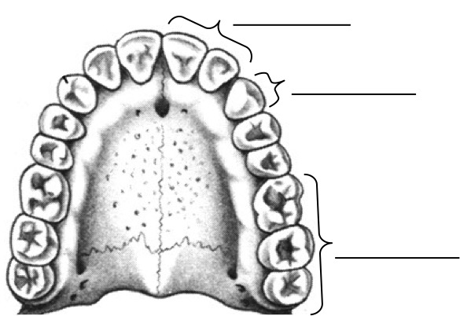
Label the following diagram of a mouth with canines, molars, and incisors:

FOR OLDER STUDENTS

Label the following diagram of a mouth with pre-molars, canines, incisors, and molars:
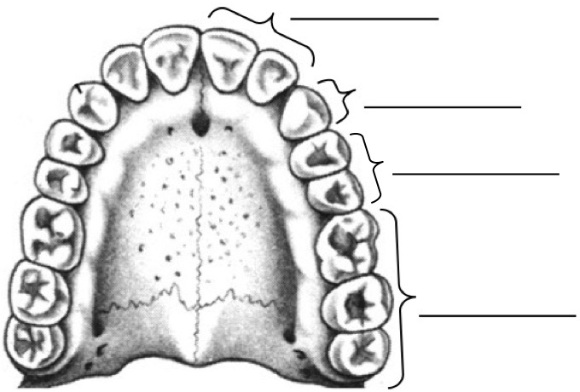
Which Teeth Do You Use?
What are the three kinds of teeth that you have?
_________________________, _______________________, and ________________________.
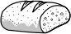
Predictions
Which teeth would you use to eat bread? __________________
Why?_______________________________________________________________________________________________________________________________________________________
Which teeth would you use to eat carrots? __________________
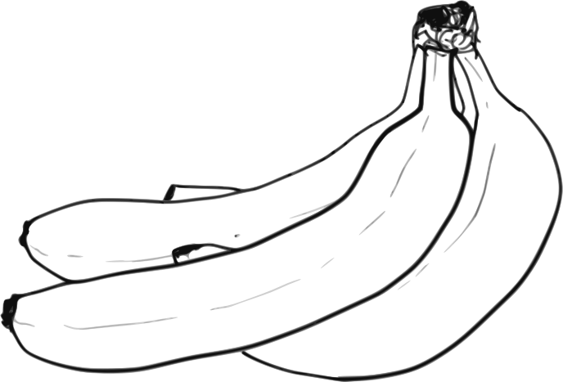
Why?_______________________________________________________________________________________________________________________________________________________
Which teeth would you use to eat bananas? __________________
Why?_______________________________________________________________________________________________________________________________________________________
Results
Now try eating the bread. Which teeth are used? _____________________
Are other teeth used as you continue or finish eating?_____________________________
Now try eating the carrots. Which teeth are used? _____________________
Are other teeth used as you continue or finish eating?_____________________________
Now try eating the banana. Which teeth are used? ______________________
Are other teeth used as you continue or finish eating?_____________________________
Notice that different types of teeth take different actions (for example: tearing, stabbing, cutting, crushing, grinding) when you’re using them to eat. This is because each type of tooth has a specific purpose.
What are incisors used for? ________________________________
What are canines used for?________________________________
What are molars used for?________________________________

What Did It Eat for Dinner?
Herbivores
What does an herbivore eat? ___________________
What kinds of teeth would an herbivore use the most? _________________________
Name two animals that are herbivores: ______________________, ______________________
Carnivores
What does a carnivore eat? ____________________
What kinds of teeth would a carnivore use the most? _________________________
Name two animals that are carnivores: ______________________, ______________________
Omnivores
What does an omnivore eat? ________________________________________________
What kinds of teeth would an omnivore use? _________________________________________
Name two animals that are omnivores: ______________________, ______________________
Your teacher will demonstrate how to answer the questions in Table 4 below using a cow jaw. Follow along and fill in the information in the first column. When your group receives two jaws from two different species labeled “R” and “C,” answer the questions in Table 4 to determine whether each animal was an herbivore, carnivore, or omnivore.
Table 4. Jaw Characteristics
 | Cow | R | C
Tallest type of tooth?
Widest type of tooth?
How many incisors?
How many canines?
How many molars?
Herbivore, carnivore, or omnivore?

Explain your choice.

Oh, What Big Teeth You Have!
Each tooth your teacher gave you has a code letter on the bottom, which you will enter in the first column to identify it. Fill out Table 5 below, using a metric ruler to measure the teeth in centimeters (cm). “Length” means from root tip to the top; “Width” means from left to right. Measure each tooth at its tallest or widest point, and round answers to the nearest tenth. Once you have gathered all the information, fill in the last column using the dichotomous key on the next page.
Table 5. Types of Teeth
See Page 12
Tooth Code | Drawing  Label top and root(s) | # of Roots | Length (cm) | Width (cm) | Tooth Index #  (Length ÷ Width) | Chewing Surface:  Flat, Pointed, or Sharp & Wedge-Like? | Incisor, canine, or molar?
Tooth Types Dichotomous Key

- The tooth has an index number below 2.7…………………………………………….Go to #2
The tooth has an index number of 2.7 or above……………………………………….Go to #3

- The chewing surface of the tooth is flat…………………………………………………Molar
The chewing surface of the tooth is not flat…………………………………………...Go to #3

- The tooth has one root…………………………………………………………………Go to #4
The tooth has two or more roots…………………………………………………………Molar

- The chewing surface of the tooth is pointed……………………………………………Canine
The chewing surface of the tooth is sharp & wedge-like……………………………….Incisor

Whose Tooth Was It?
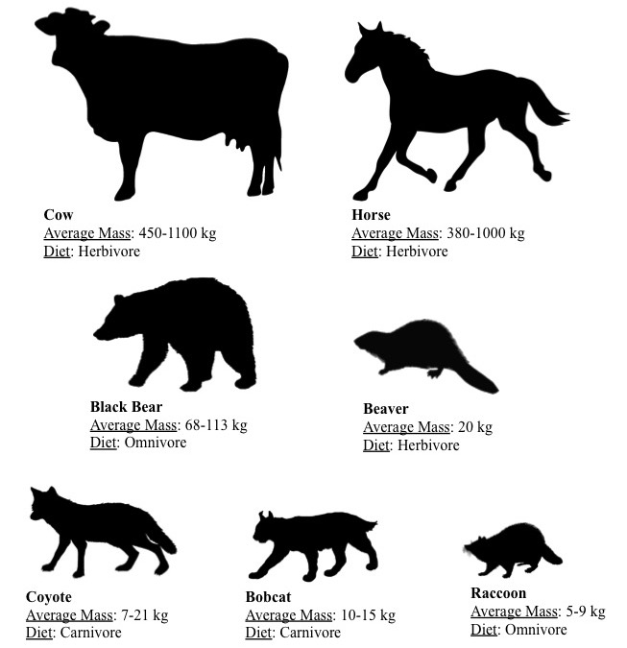
Now that we know what kind of tooth each one is, we must figure out who it came from! There are seven different animals that these teeth could be from. Use the guide below to help you decide which animal each tooth came from. Write your answers on Table 6, on the next page.
Use the graphic on page 12 along with your knowledge of teeth in carnivores, herbivores, and omnivores to fill out Table 6 to the best of your abilities. (HINT: remember Activity 3!)
Table 6: Tooth Type and Animal It Came From
Tooth Code | Animal | Tooth Type  (from Table 5)

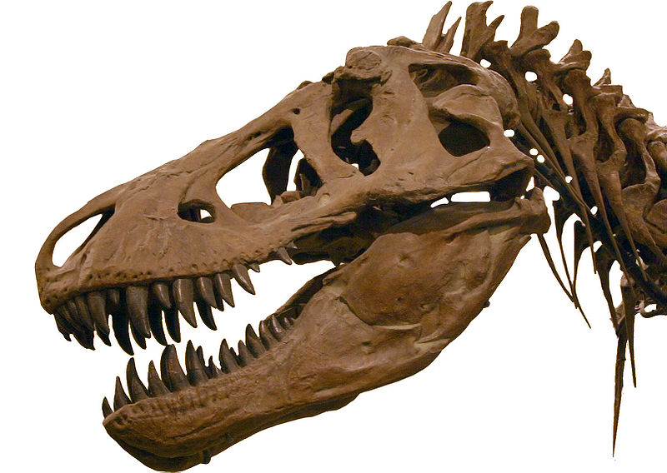
Tyrannosaurus rex
J. M. Lijit
Teeth Fact Sheet
- The Tyrannosaurus rex, a carnivorous dinosaur that lived 68-66 million years ago, crushed its prey—bones and all—with over 60 strong teeth and powerful, four-foot wide jaws.
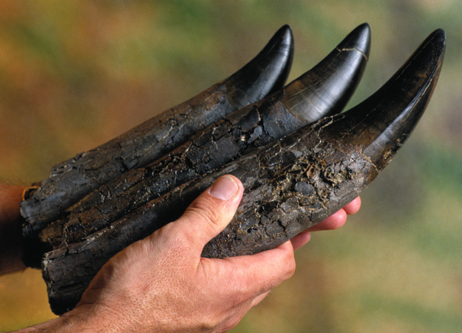
- Its teeth were about the size and shape of bananas (Figure 1), although some teeth grew up to four feet long. It had great variation in the sizes and shapes of its teeth.
discovery.com
Figure 1. T. rex teeth compared to a human hand.
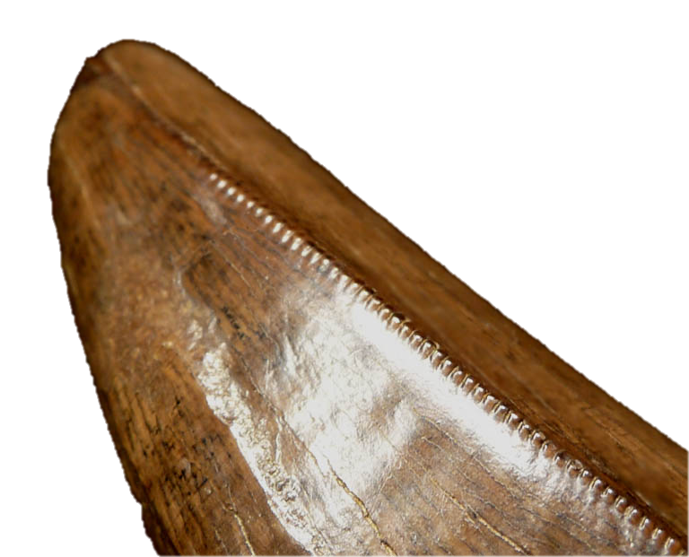
- The teeth had serrated edges, used to tear flesh (Figure 2). They were periodically shed and re-grown.
paleodirect.com
- The T. rex could bite with three times the force of a Great White Shark, 15 times the force of an African lion, and 77 times the force of an adult human!
Figure 2. Serrated edges on T. rex’s tooth.
- T. rex never flossed its teeth, so pieces of rotten, bacteria-infested meat would get stuck between them. If its prey escaped, it would almost certainly die of infection from the bite.
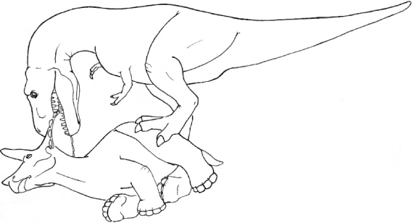
- T. rex's front teeth gripped and pulled, while the teeth along the side of the jaw punctured and tore flesh (Figure 3). The teeth at the back of the mouth sliced and diced chunks of prey, and also forced food to the back of the throat.
nature.com
Figure 3. T. rex using its strong front teeth to grip and pull apart its prey (a Triceratops).

