M&M™s Statistics: Pre-Lab Activity

Pre-Lab Activity
The following activity will introduce the basic concept used to determine how survivorship within a population is determined over time. A LARGE bag of M&M™s will represent a local graveyard and each M&M™ will represent one gravestone within that graveyard. Each team has a container of M&M™s to represent one section within that graveyard which you will use to collect your data. DO NOT EAT ANY M&M™S UNTIL YOU HAVE COLLECTED THE DATA!

Procedure
- Work in pairs.
- One member of the pair will obtain a container of M&M™s.
- Organize the M&M™s by color. Count the number of each color and organize them on your paper towels in the following order: Brown, Red, Yellow, Green, Orange, and Blue.
- Record the number of M&M™s above each group and add to the class data on the board.
- When class data is totaled, record those class totals in the data table on the next page.
- Follow the instructions above each column in the table to calculate each variable. Your goal is to complete this life table to determine the Survivorship of this population of M&M™s.
- Each column represents a specific variable:
- Age Interval: represented by a specific color of M&M™
  - Read each value, no data to input.
- Total number of individuals (dx) who died in this age range
- Proportion of total deaths in the time interval: divide each color count of M&M™s by the total number of M&M™s.
- Number of deaths in a normalized dataset of 1000: Multiply Column C x 1000 by moving the decimal three places (dx).
- Survivorship (lx) = Beginning with a total population of 1000, subtract the number of individuals who die (column D) in each time interval.

A. Age Interval (years old) | B. Total number of individuals who died in this age range (dx) | C. Proportion of total deaths in the time interval | D. Number of deaths in a normalized dataset of 1000 | E. Survivorship (lx)
Represented by a specific color of M&M™. |  | Divide each color count of M&M™s by total number of M&M™s. | Multiply Column C x 1000. | Beginning with a total population of 1000, subtract the number of individuals who die (Column D) in each time interval.
0-9.9  Brown |  |  |  | 1000
10-19.9
Red
20-29.9
Yellow
30-39.9
Green
40-49.9
Orange
50-59.9
Blue
TOTAL:

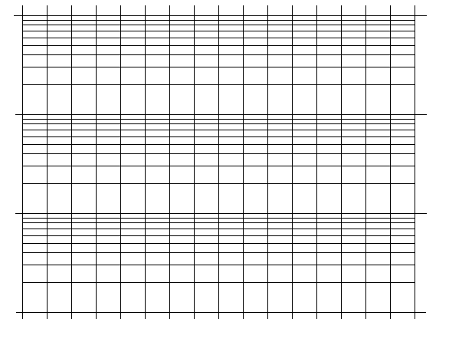
On the graph provided, label the Y-axis with the survivorship data from 0-1000. Note that this is semi-log graph paper. Ask for help if you do not know how to label the axis.
The X-axis represents time intervals. The M&M™ data only has six intervals, so you can spread out the data.

Now Try This
Plot this squirrel data (in table below) on the same graph grid as the M&M™ data.

Life Table for Belding’s ground squirrels in the Sierra Nevada Mountains of California.
x | L_{x} | d_{x}
Age interval  (in years) | Number of individuals alive at beginning of age interval (based on 1000) | Number of individuals who die during the age interval (based on 1000 total individuals)
0-1 | 1000 | 426
1-2 | 574 | 311
2-3 | 263 | 146
3-4 | 117 | 63
4-5 | 54 | 29
5-6 | 25 | 13
6-7 | 12 | 6
7-8 | 6 | 3
8-9 | 3 | 2
9-10 | 1 | 1
Source: Data from P.W. Sherman and M.L. Morton “Demography of Belding’s Ground Squirrel” Ecology 65 (1984).

