DNA Molecule Model Activity:  Post-Lab Questions | 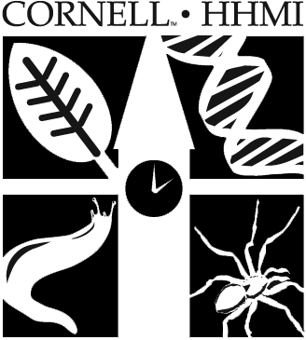
Name: ________________________________ Date: _________
Math Applications
- If a DNA molecule were composed of 10% guanine, what percents of the molecule would be made up of cytosine, adenine, and thymine? Show your work.

- If a DNA molecule contained a total of 600 bases and 20% of the bases were cytosine, how many bases would be adenine?

- DNA is an information molecule. How does it store this information? (Which part of the DNA structure stores the information?)

- How does DNA’s structure relate to its functions? List three specific jobs that DNA does, and match them to a specific aspect of its structure that allows it to perform the function. For example: The fact that the bases always match with their complementary pair – allows DNA to accurately copy itself.

Coloring Review of DNA Structure
In the molecule of DNA below, use colored pencils and follow these instructions:
- Circle the phosphate groups with GREEN
- Color the deoxyribose molecules in RED
- Trace over the hydrogen bonds with BLUE
- Color the purines in YELLOW
- Color the pyrimidines in PINK
- Circle a nucleotide with PURPLE

