DNA Molecule Model Activity | 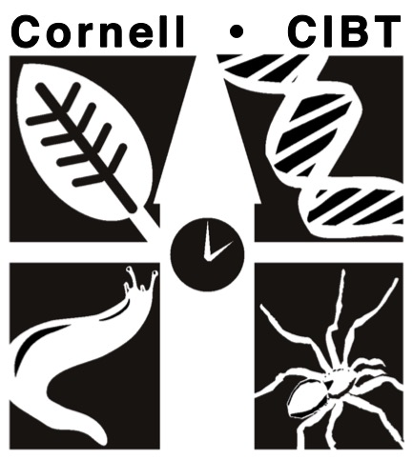
Name: ________________________________ Date: _________
Pre-Lab Questions
Answer the following questions for homework and be prepared to discuss your answers with your group before starting the activity.

- What is DNA?

- What are the building blocks of DNA called? Name the three main components of these building blocks.

- Where in the cells of animals, plants, and fungi is DNA found?

- List and describe as many functions of DNA in living things that you can think of (at least three!)

Model Procedure
Work with your group to construct the DNA molecule model. Be sure to answer the following questions as you proceed.

- Examine the nucleotides. Draw a nucleotide and label the three parts (Nitrogen Base, Sugar, and Phosphate Group). Use your textbook or Google images if you need help.

- What do all four types of nucleotides have in common?

- How do they differ?

- Write the names of all four nitrogen bases:

_______________________
_______________________
_______________________
_______________________

Start building the model by pairing the nitrogen bases. Pair all bases before proceeding.
_____________ pairs with _____________
_____________ pairs with _____________

- Start building your molecule upwards by locking four nucleotides together. In your model, the sugar of the lower nucleotide bonds with the ___________________ of the upper nucleotide.

Once you finish assembling the base pairs, continue to form the helical structure by connecting the sugar-phosphate sides of the ladder.

- Add another pair of nucleotides. Your molecule is now three nucleotides long, and all nucleotides are paired up (so your molecule has a total of six nucleotides).

- In your model, the phosphate group of a nucleotide always bonds with the _______________ of the ?contiguous? nucleotide.

- Visit another group. Compare your DNA model to the DNA model made by the other group and answer the following questions:

- Are there any differences in the types of nitrogen bases?

- Are there any differences in the sequence of bases? If yes, explain.

- Are there any differences in the arrangement of the sugars and phosphate groups? Explain.

- Are the nitrogen bases paired the same way? Explain.

- Your DNA model represents a part of a gene. Remember, genes are made up of a sequence of nitrogen bases. Write the complementary sequence to the gene given below:
DNA Strand | A | T | C | G | G | C | T | A | G | G | T | C
Complementary
DNA Strand

- In looking at your model, can you see clearly what part of the model makes up the double helix? Discuss this with your group and write your group’s thoughts below. The next step (on Page 4) might help…

Mini Toober Model
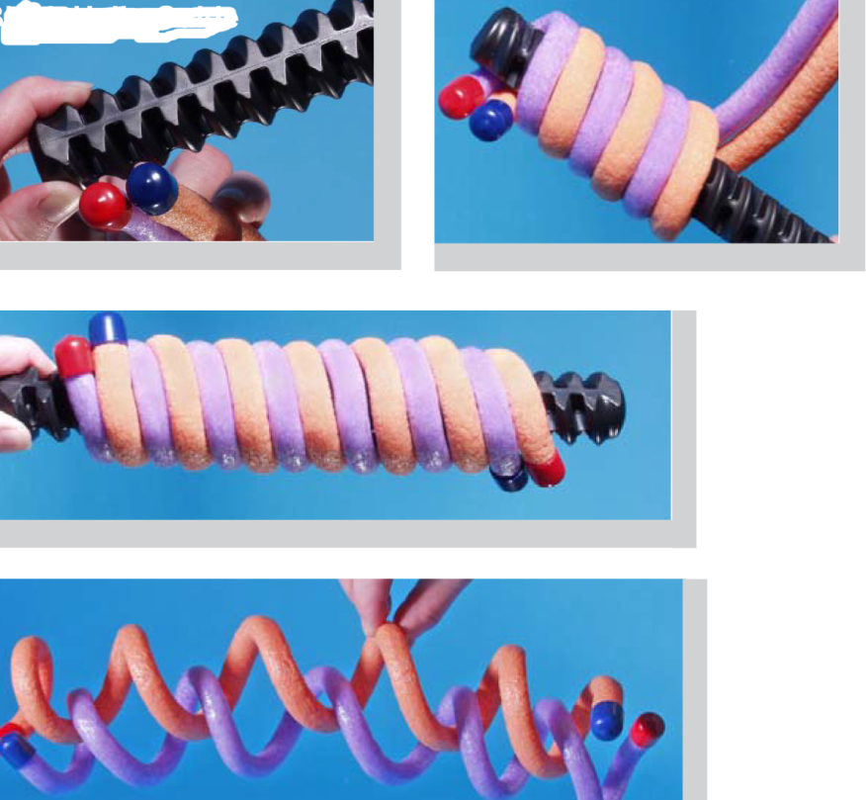
Follow the directions given in the figure at left to construct a DNA double helix using the mini toobers.

Now, using both your completed DNA model and the Toober model, determine the parts that make up the sides of the double helix. Were your group’s initial thoughts correct? Why or why not?

Post-Lab Questions
- Hereditary information is contained in genes. Genes are composed of DNA that makes up the chromosomes of cells. Put the following words in order from largest to smallest:
Genes, Chromosomes, DNA, Cell
_______________________
_______________________
_______________________
_______________________

Math Applications:
- If a DNA molecule were composed of 10% guanine, what percent of the molecule would be made up of cytosine?

- If a DNA molecule were composed of 30% adenine, what percents of the molecule would be thymine, cytosine, and guanine?

- If a DNA molecule contains a total of 600 bases and 20% of the bases are cytosine, how many bases will be adenine?

