DNA Molecule Model Activity | 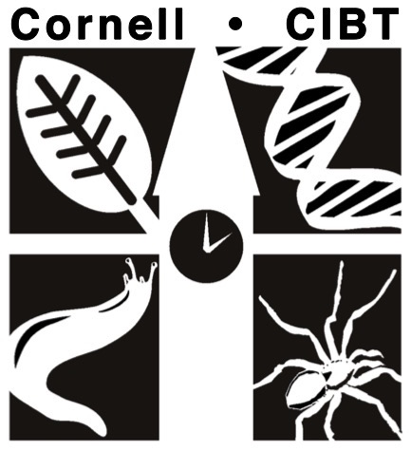
Name: ________________________________ Date: _________
Pre-Lab Questions
Answer the following questions for homework and be prepared to discuss your answers with your group before starting the activity.

- What is DNA?

- What are the building blocks of DNA called? Name the three main components of these building blocks.

- Where in a eukaryotic cell is DNA found?

- List and describe as many functions of DNA in living things that you can think of (at least three!)

Model Procedure
Work with your group to construct the DNA molecule model. Be sure to answer the following questions as you proceed.

- Examine the nucleotides. Draw a nucleotide and label the three parts. Use your textbook or Google images if you need help.

- What do all the four types of nucleotides have in common?

- How do they differ?

- Start building the model by pairing the nitrogen bases. Pair all bases before proceeding.

___________ pairs with __________

___________ pairs with __________

- What type of bonds form between the nitrogen base pairs? (Look it up if nobody in the group knows.)

Once you finish assembling the base pairs, continue to form the helical structure by connecting the sugar-phosphate sides of the ladder.

- What type of bonds form between the sugar-phosphate groups?

- Is there a difference in the relative strengths of the bonds between the sugar-phosphates and the bonds between the nitrogen base pairs. What bond is stronger? How do you know?

- Visit another group. Compare your DNA model to the DNA models made by the other groups and answer the following questions.

- Are there any differences in the types of nitrogen bases? If yes, what?

- Are there any differences in the sequence of bases? If yes, explain.

- Are there any differences in the arrangement of the sugars and phosphate groups? Explain.

- Are the nitrogen bases paired the same way? Explain

- Write a brief summary of your findings in question 8 based on your comparative study.

- Your DNA model represents a part of a gene. Remember, genes are made up of a sequence of nitrogen bases. Select one strand of nucleotides in your DNA molecule. Write the sequence of nitrogen bases in the chart below. Next, use your DNA strand to construct a part of a messenger RNA molecule. Finally, use the chart in the text or provided by your teacher to determine the sequence of amino acids in your polypeptide chain.

DNA Strand
mRNA
Amino Acids
(one AA per three bases)
- Compare your amino acid sequence to the other groups’ amino acid sequence. Even though each group used the exact same model components, almost every amino acid sequence will be different. Why?

- In looking at your model, can you see clearly what part of the model makes up the double helix? Discuss this with your group and write your group’s thoughts below. The next step (below) might help…

Mini Toober Model
Follow the directions given in the figure below to construct a DNA double helix using the mini toobers.

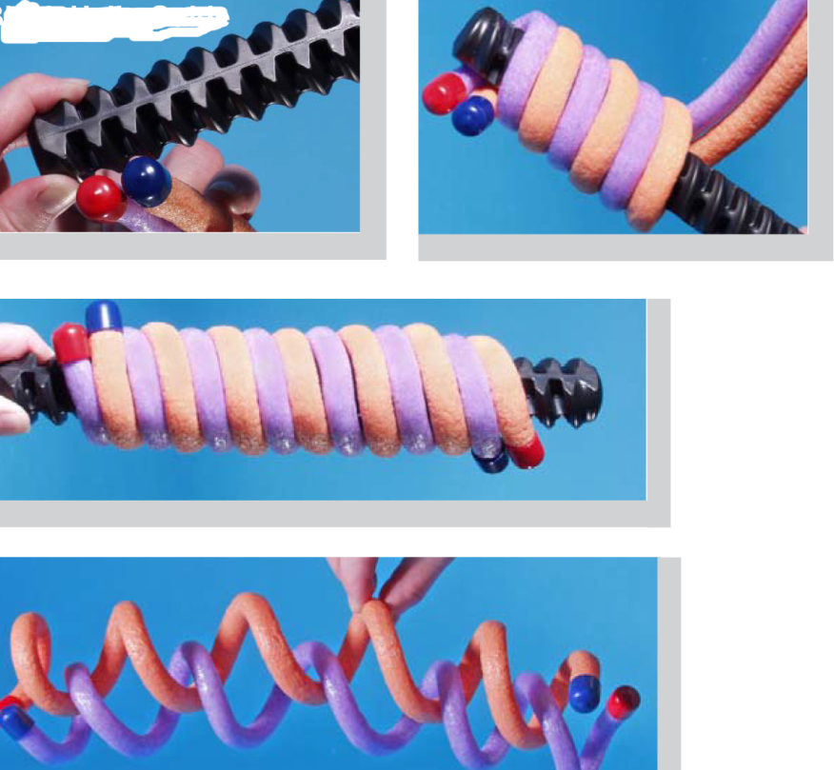
Now, Using both your completed DNA model and the Toober model, determine the parts that make up the sides of the double helix.
Were your group’s initial thoughts correct? Why or why not?

Post-Lab Questions
Math Applications:
- If a DNA molecule were composed of 10% guanine, what percents of the molecule would be made up of cytosine, adenine, and thymine? Show your work.

- If a DNA molecule contains a total of 600 bases and 20% of the bases are cytosine, how many bases will be Adenine?

- DNA is an information molecule. How does DNA store this information? (Which part of the DNA structure stores the information?)

- How does DNA’s structure relate to the functions of DNA? List three specific jobs that DNA does, and match it to a specific aspect of its structure that allows it to perform the function. For example: The fact that the bases always match with their complementary pair allows DNA to accurately copy itself.

Coloring Review of DNA Structure:
- In the molecule of DNA pictured below, use colored pencils and follow the instructions:
1) Circle the phosphate groups with GREEN

2) Color in the deoxyribose molecules with RED

3) Trace over the hydrogen bonds with BLUE

4) Color in the purines in YELLOW

5) Color the pyrimidines PINK

6) Circle a nucleotide with PURPLE

