**4-H Camp Shankitunk Packing List**

* Please use discretion when choosing camp clothes. Modest clothing should be worn at all times.

Inappropriate language or graphics on clothing is not acceptable. The camp experience can often

be very hard on clothes. We suggest that you do not bring brand new clothing or

high-priced items because they can easily be damaged during a week at camp.

* Keep in mind that two campers may own the same article of clothing, book,

comb, or teddy bear. Please label all of your camper's possessions.

* Please pack with your camper. This way you can ensure not only that they have

everything, but also that they know where everything is in their suitcase.

* We reserve the right to inspect any belongings on camp property.

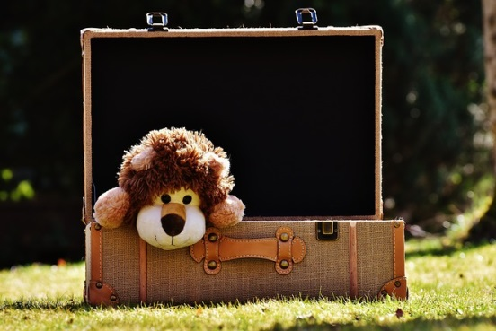

**DAY CAMPERS Please Bring:**

*Pack daily in an easy-to-to carry bag or backpack.*

• Bathing Suit

• Towel

• Flip-Flops (for pool)

• Rain Jacket/Poncho

• Sweatshirt

• Backpack

• Reusable Water Bottle

• Extra set of dry clothes

*Optional:*

→ Writing supplies (paper, envelope, stamp)

→ Inexpensive camera

→ Fishing Pole (for Fishing)

→ Sunscreen and insect repellant *(staff can assist with spray/pump dispensers, not lotions)*

**OVERNIGHT CAMPERS Please Bring:**

*Pack in an easy-to-to carry duffel bag or suitcase.*

→ Sheets for a single mattress

→ Sleeping Bag or Blanket

→ Pillow and Pillow Case

→ Towels and Washcloth

→ Socks and Underwear

→ Shirts

→ Sweatshirt or Jacket

→ Shorts and Long Pants

→ Pajamas

→ Raincoat/Poncho

→ Bathing Suit

→ Flip-Flops (for the pool/shower, only)

→ Reusable Water Bottle

→ Closed-toed Shoes or Sneakers

→ Soap and Shampoo

→ Hairbrush or Comb

→ Toothbrush and Toothpaste

→ Deodorant and chapstick

→ Flashlight with Extra Batteries

*Optional:*

→ Writing supplies (paper, envelope, stamp)

→ Inexpensive camera

→ Book to Read

→ Snacks *(healthy, non-melting, nut-free encouraged)*

→ Hiking Boots (for Backpacking)

→ Fishing Pole (for Fishing)

→ Sunscreen and insect repellant *(staff can*

*assist with spray/pump dispensers, not lotions)*

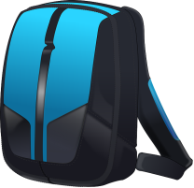

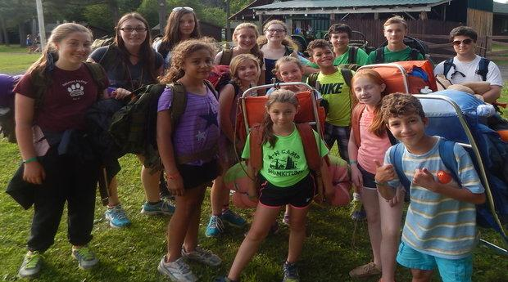

***Note:***

*Campers who bring any of these items to camp will be asked to surrender them to the camp staff, and may face further disciplinary action. Camp is not responsible for confiscated items.*

**DO NOT BRING:**

→ Electronics of any kind - phones, music players, kindles, games, etc.

→ Weapons of any kind – Knives, hatchets, etc.

→ Flammable items of any kind – candles, lanterns, matches, etc.

→ Expensive items of any kind - clothing, jewelry, etc.

→ Illegal items of any kind - drugs, alcohol, etc.