Lectures and Programs

http://blogs.cornell.edu/campusclub/programs/

All lectures and programs are open to the public,
regardless of gender.

Sustainable Landscapes, Secret Gardens:
Cornell Campus Walking Tour
Roberta Moudry, ‘81
Architectural Historian
Sept 12, 2023, rain date Sept 14, 2023
Meet at 1:30 at the Bailey Plaza

Earth Source Heat and the Borehole Observatory
Nov 2023 (date TBA)
4:00 PM
Kendal Auditorium

In the Shadows:
The Wonder, Beauty, and Science of Eclipses
“Space Lady” Zoe Learner Ponterio
Manager, Spacecraft Planetary Image Facility
Tues. Jan 30, 2024 at 6:30 PM via ZOOM

Gayogo̱hó:nǫʔ Learning Project
Spring Program, Details TBD

Program details and updated information will be posted on our website and social media, as well as announced via our member listserv.
Go to our Website and FB page using the
QR codes below.

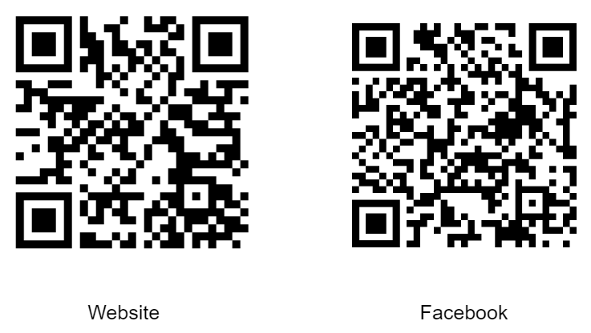
Campus Club Executive Board
President Ellen Harrison
Vice President Alice Kops
Treasurer Suzanne Aigen
Secretary Janie Leff
Activities Wendy Wolfe
Membership Liz Elser/Beata Lopez
Programs Sharon Anderson
Social Zoe Leonard/Jeani Parr
Publicity Carolyn Belle
Past President Misao Johnson

To contact board members directly, please send an
email to campusclubatcornell@gmail.com addressing
the email to the individual you wish to contact.

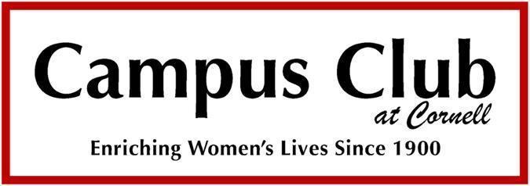

2023 – 2024

Since 1900, the Campus Club has been promoting friendship among women, providing a welcoming community for newcomers, and serving as a venue for the social and cultural interests of women.

Social Events

Fall Open House and Activity Group
Registration

Thursday, September 7, 2023
11:00 AM – 1:00 PM
Ithaca Farmers Market
545 3rd St, Ithaca, NY 14850

Open to all women!

Winter Social
Saturday, January 13, 2024
2:00 PM – 4:00 PM
Moakley House
213 Warren Rd., Ithaca, NY 14850

Open to members only.

June Social
June, 2024
TBD

We welcome all women who want to meet new friends and participate in our activities.
Find out more on our website!

http://blogs.cornell.edu/campusclub/

Activity Groups
Detailed descriptions of activities are posted on the
Campus Club website:
http://blogs.cornell.edu/campusclub

Bird Study Tuesdays, 8:30 AM
Winter TBD
Ann Manzano (F, S) am225@cornell.edu
Leni Hochman (F) lenihochman@gmail.com
Carol Cedarholm (F) ccedarho@gmail.com
Linda Uhll (S) luhll@yahoo.com
F(Fall) S(Spring)

Book Group I 3rd Monday, 2 PM
Marcia Jacobson marcia.jacobson@gmail.com
Melanie Kalman melanie.kalman@gmail.com

Book Group II 2nd Thurs., 1:30 PM*
Dodie Kunz dodiekunz3@gmail.com

Book Group III 3rd Monday, 8 PM
Laura Andolina andolina@aol.com

Bridge (Intermediate) Wed., 9:30 AM - Noon
Pat Holmes pholmes2@twcny.rr.com
Barbara Armstrong barb368@yahoo.com

Caregivers 3rd Wednesday, 7 PM*
Linda Glabach lindaglabach@yahoo.com
Rochelle Woods rewoods112@gmail.com

Cyclists - Waterfront Trail Thursdays, 1 PM
9 AM Summer
Jan McCarrick janithaca@gmail.com
Ruth Hopkins ruthenid@gmail.com
Kathy Hopkins kathy1122@gmail.com

Friendship Group 3rd Friday, 3:00-5:00 PM
1st Wednesday, 7:30 PM*
Raf Chew rafchew@yahoo.com
Linda Glabach lindaglabach@yahoo.com

Games Tues., 10 AM
Raf Chew rafchew@yahoo.com

Garden Group 4th Friday, 11 AM
Ellen Lane ellenelizlane@yahoo.com

(Activity Groups cont.)

Gourmet Diners’ Group Monthly, TBD
Alice Kops portia95@amklegal.com
Drucy Glass glassdrucy@gmail.com

Hiking/X-Country Skiing Mondays, 9:20 AM
Barbara Nussbaum barbnussb@gmail.com
Emily Tracy emilytracy@hotmail.com

Just Coffee Fridays, 10 AM
Raf Chew rafchew@yahoo.com

Mah Jong (Intermediate) Mondays, 1:00-3:30 PM
Ayako Timmons ayakotimmons@gmail.com

Paddlers Monthly (TBD)
Sandra Greene seg6@cornell.edu
Chris Santospirito csantos1@twcny.rr.com

Performers Group 3 Programs, TBD
Jane Dieckmann dickjane201@gmail.com
Charette Wheelis charette1042@gmail.com

Quilting Group 1st Wednesday 1-3PM
Sarah Hatcher sshatcher@gmail.com

Spanish Conversation Mondays, 3:00-4:30 PM
Janie Leff janeleff134@gmail.com
Kris Hodges minnswede@gmail.com

Ukulele (Intermediate) Fridays, 3-4:30 PM
Jean McPheeters jeanmcpheeters@gmail.com

Wanderers Several Trips/Year TBD
Raf Chew rafchew@yahoo.com
Misao Johnson misaosj@gmail.com

Wine Explorers Monthly
Alice Kops portia95@amklegal.com
Kathy Ruis sunrisehillbnb@gmail.com

Yoga for Life Wed., 8:30-10 AM*
Kathy Hopkins kathy1122@gmail.com
Ayako Timmons ayakotimmons@gmail.com

* meeting is on ZOOM

Service Group

English as a Second Language
Meetings TBD
Anita Christiansen - anitag99@gmail.com
Anna Roberts - asroberts05@gmail.com

Social Media

Facebook
https://www.facebook.com/campusclubatcornell/

Membership

Campus Club Membership is open to women in the Ithaca area. Dues are $35 annually, and may be paid by PayPal through our website, at the Fall Open House by cash or check. Membership entitles participation in activity groups and social events, and is valid from Sept 1 to Aug 31.

Fill out our online form at: https://blogs.cornell.edu/campusclub/membership/.
You can then choose to send us a check or pay through
Paypal, in which case you will receive an invoice.

If unable to attend our Open House on Sept 7, or register online, please contact our membership chair, Liz Elser at campusclubatcornell@gmail.com. Mail completed paper membership form and check (payable to Campus Club at Cornell) to:

Campus Club at Cornell
P.O. Box 4821
Ithaca, NY 14852

*****
Cornell University is not legally responsible for any risk in activities undertaken by members of the Campus Club at Cornell, nor does the Campus Club Board bear responsibility for any injuries sustained during activities, programs, or events.

