Audio
Use audio to provide feedback, add narration to a ppt, image or b-roll, or an expert interview
Use audio to humanize an asynchronous discussion
Blogs and Wikis
Blogs typically are an individual space for publishing content and allowing users to comment. Good for reflection.
Wikis typically are a collaborative space where content can be added, edited and removed. Good for building a shared resource.
For additional information on blogs vs wikis:
https://sites.google.com/site/sunytoep/discovery/blogswikis
Citation management and social bookmarking
Way to organize content for your course. Also a great way to have learners share and create course resources.
Synchronous Sessions
A great way to humanize your course, create community, and increase engagement. You are required to do two synchronous sessions during your course. You can invite a guest speaker, analyze a case study, role play, demonstrate on the whiteboard and more.
Photo Sharing
Great icebreaker activity-have them share photos of their favorite places; have learner collaboratively write a story around a photo and prompt; use photos for a virtual field trip
Presentations
Resource for engaging presentations http://www.garrreynolds.com/preso-tips/
Students can collaboratively create a presentation and record it or present during a synchronous session.
Video
Use webcam and lecture capture tool such as Panopto. Try the cintiq for drawing/writing.
Wordle, infographic, Webquest, virtual bulletin, shared notebook, digital storytelling,

BB Tools
Course message
Collaborate
Discussion Board
Piazza
Calendar
Blog
Wiki
Assessments
Peer Review (Turnitin)
Peer Assessment
Tests
Surveys
Rubrics (create your own and use)
Question Pools (create your own or use from Instructor manual)
Group assignments

Adding and Deleting Content: Items and Files
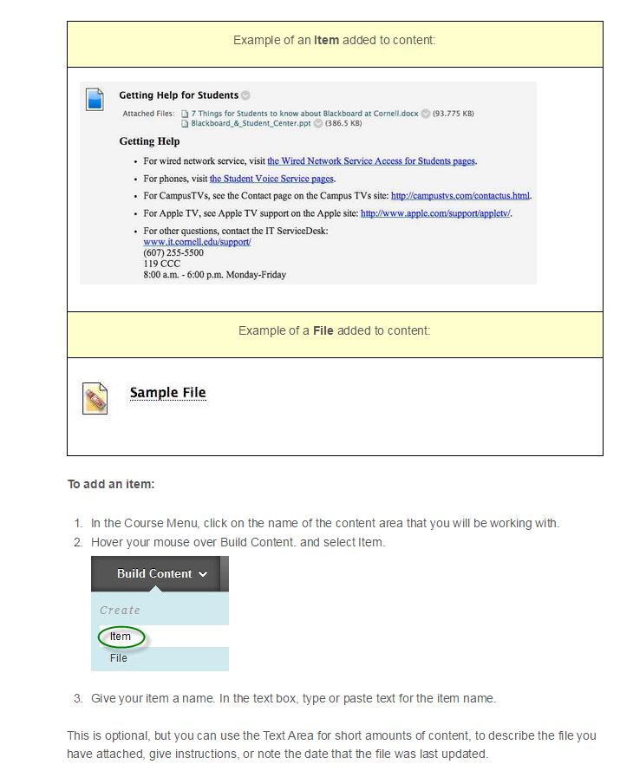
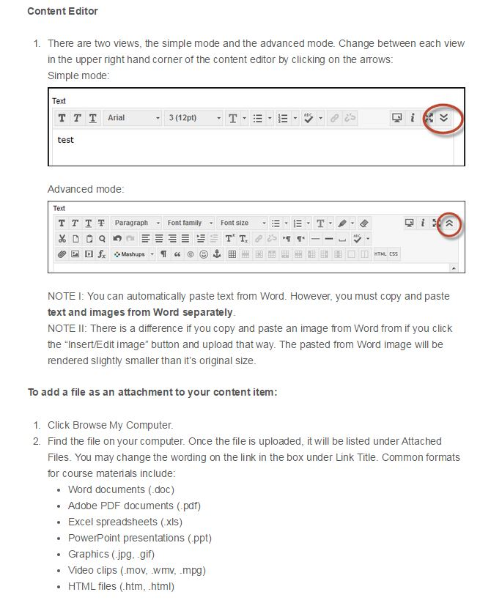
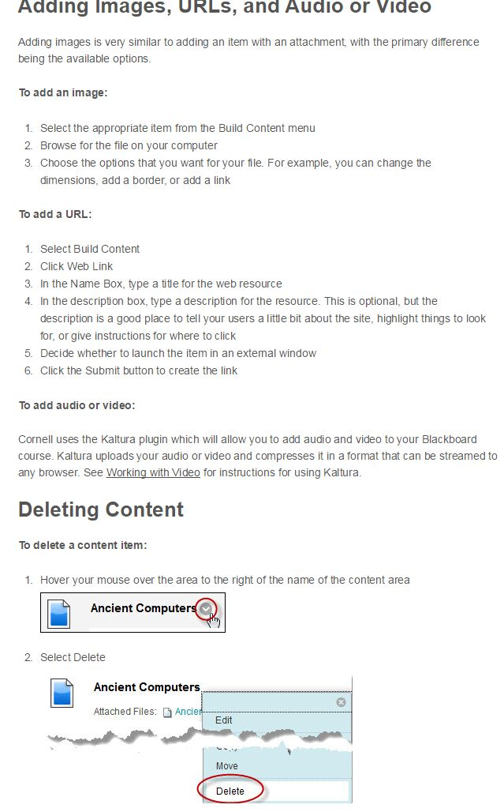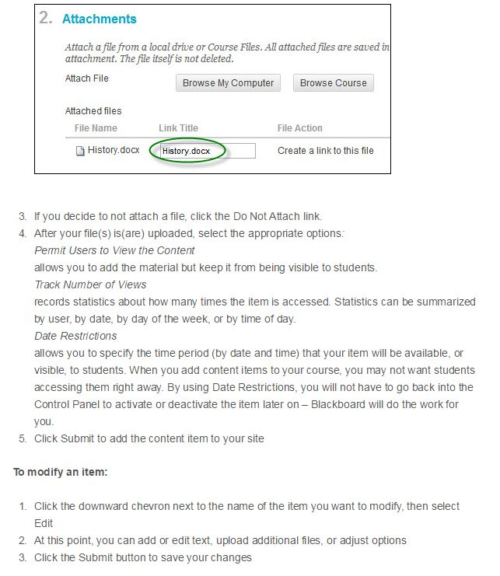

Video Tips

The recommended method for posting media files for instructional uses is through Kaltura.
Advantages of using Kaltura:
- Simplicity. Uploading a file is similar to using YouTube.
- Files are streamed to viewers so you are not distributing copies of the media.
- Currently there is no limit on the number of files you can upload.
- No need to request a media account, all Blackboard courses are set up with the Kaltura Media upload feature
- When used within a Blackboard course, the media files use Kerberos authentication. (When moved outside Blackboard they become publically available.)
- One file can be used in many courses or websites without having to upload it separately for each use.
Issues:
- You cannot generate a link (URL) to a video except when in a Blackboard course. Only the HTML used to embed a file in a page is available.
- Uploaded files need time to be compressed, and are not instantly available. Usually the delay for video files is approximately the running time of the video (e.g. a one hour video will take about one hour to compress). Audio files compress much more quickly.
- It is not yet possible for students in your course to upload videos.
- Only one person has ownership rights to the uploaded file, allowing them to edit, delete, and re-use it. So if your TA uploads files to the course, s/he will own them. It is possible, however, for system admins to transfer ownership.

