Wholesale Market Enables ‘Roots’ of Change
Salvere Farm in Marietta, NY
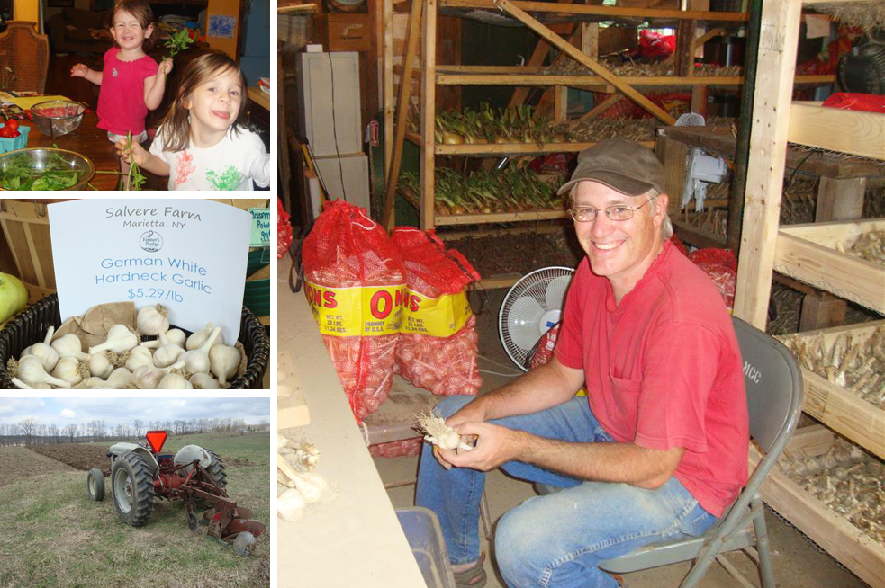
Darren Maum, vegetable and storage crop grower and self-professed “soil nerd”, is owner of Salvere Farm, located 20 minutes southwest of Syracuse, NY.

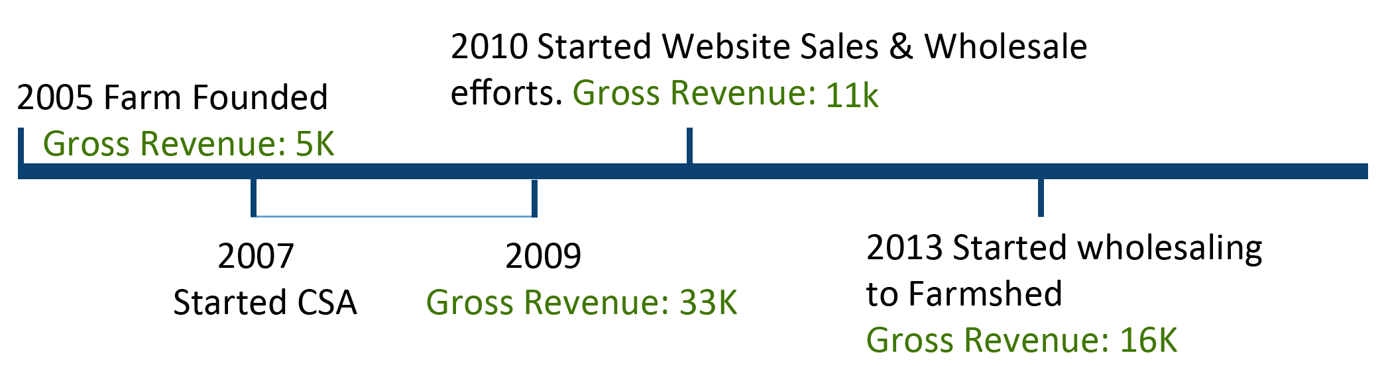
At the business’ start in 2005, Salvere Farm sold a diverse medley of vegetables and herbs, growing up to 80 different products by 2009, including leafy greens, root vegetables, and garlic. Maum’s local CSA and Farmer’s Market customers demanded a wide variety of products, which started to become labor and land intensive. So in 2010, Maum began to seek out wholesale markets that would allow him to sell larger quantities of fewer crops. He narrowed his focus to growing garlic, onions, potatoes, and winter squash, which allowed him to put 4 of his 6 rented acres of land into cover crops. In efforts to establish a wholesale market for his storage crops on his own, Maum solicited business from Syracuse restaurants and co-op groceries, and offered organically certified garlic seed through his farm website, salverefarm.com. He spent a frustrating amount of time on the phone and in the car, rather than in his fields.
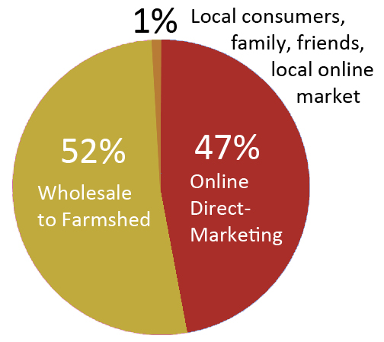
In 2013, Maum began working with Neil Miller, founder and CEO of Farmshed, a Central NY based company dedicated to connecting farmers and consumers under the “buy local” movement. Miller works specifically with small-scale farmers, and Maum describes Farmshed as a “low pressure” entry point to wholesale marketing, since no contract or production quotas are required. Maum gives Miller an estimate of production at the start of the season, and works hard to achieve that number, but his business relationship with Farmshed is not dictated by it. Maum provides Miller with a list of product offerings and Miller contacts buyers, arranging distribution through Regional Access channels. Thus, Farmshed absorbs the fuel costs and communication efforts that Maum found to be the biggest barriers to entering wholesale marketing. Farmshed currently picks up produce from Salvere Farm weekly, transporting Maum’s organic storage crops across NYS, from Saranac Lake to as far south as NYC, providing Maum with a wider customer base than he ever could have achieved on his own.
Current Marketing Channels

The switch to wholesaling has allowed Maum to move away from intensive vegetable production and focus on land management. His silt loam soils are on the sandy side, so low organic matter is one of his growing challenges. Since making the transition into solely growing storage crops, he has been rotating 2 acres of land in production, and 4 acres of land in cover crops of rye, vetch, buckwheat, oats, or clover, which aid in replenishing valuable organic matter to the soil. Financially, the wholesaling model has allowed Maum to invest in a potato digger and to consider additional infrastructure for the future.

